*Florida International University*

*School of Computing and Information Sciences*

CIS 4911 - Senior Capstone Project

Software Engineering Focus

Final Deliverable

Collaborative Platform

Team # 5

**Spring 2014**  **Instructor:**

Henry M. Romero Masoud Sadjadi

Steven S. Sanabria

Lorenzo Sanchez **Mentor:**

Juan Caraballo

**Summer 2014**

Ramon Gomez

Jonathan Santiago

**Fall 2014**

Nicholas Madariaga

Jonathan Sanchez

**Spring 2015**

Adrian Alfonso

Jorge Travieso

**Summer 2015**

Mandiel Lastra

Michael Machin

Copyright © Florida International University 2015. All Rights Reserved. No part of the Collaborative Platform Project or documentation may be reproduced or modified without the express consent of Florida International University. Redistribution or commercial use is strictly prohibited.

***Abstract***

*The Final Deliverable of the Collaborative Platform is meant to provide the reader with all the necessary development information regarding the project. The Collaborative Platform is a website that connects students, employees, professors, and anyone else with a desire to ask questions and learn. The website provides the availability to quickly pose a question, with the system sending automated alerts, allowing for an immediate response. The task of the Collaborative Platform is to add a mentoring module in which there will be three types of mentors that can actively interact with the community of mentees. This will bridge the gap of slow and unreliable information often found online or through waiting at professor’s office hours. Within this document, detailed system design, object design and overall implementation is analyzed and described.*

**Table of Contents**

Introduction .................................................................................................................................... 5

Current System ............................................................................................................................... 5

Purpose of New System ................................................................................................................. 7

User Stories .................................................................................................................................... 9

Implemented User Stories ............................................................................................................ 10

Pending User Stories .................................................................................................................... 27

Project Plan .................................................................................................................................. 28

Hardware and Software Resources .............................................................................................. 28

Sprints Plan .................................................................................................................................. 29

Sprint 1 ......................................................................................................................................... 29

Sprint 2 ......................................................................................................................................... 33

Sprint 3 ......................................................................................................................................... 37

Sprint 4 ......................................................................................................................................... 42

Sprint 5 ......................................................................................................................................... 47

System Design ............................................................................................................................. 50

Architectural Patterns ................................................................................................................... 50

System and Subsystem Decomposition ....................................................................................... 51

Deployment Diagram ................................................................................................................... 59

Design Patterns ............................................................................................................................ 59

System Validation ........................................................................................................................ 60

Glossary …................................................................................................................................... 70

Appendix ...................................................................................................................................... 71

Appendix A - UML Diagrams ..................................................................................................... 71

Static UML Diagrams .................................................................................................................. 71

Dynamic UML Diagrams ............................................................................................................ 88

Appendix B - User Interface Design .......................................................................................... 146

Appendix C - Sprint Review Reports ........................................................................................ 153

Appendix D - Sprint Retrospective Reports .............................................................................. 157

Appendix E - User Manuals for Implemented user stories ........................................................ 159

References .................................................................................................................................. 222

# 

# 

# **Introduction**

The introductory chapter provides a brief overview of what the Collaborative Platform entails. First, the current system is explained, and the issues and limitation of the system is stated. Secondly the new system will be introduced, detailing what improvements will be made to the current system.

## Current System

The Collaborative Platform: Mentoring Module currently allows students, known as mentees, to interact with mentors who can be Personal Mentors, Project Mentors, or Domain Mentors. This interaction is through tickets which are entered into the system by students or by a live Video Conference which any user can schedule as well as invite other users. Tickets created by the different users are initially sent to tier 1 domain mentors. If the ticket is not handled within the time limit the system will automatically reassign the ticket to another tier 1 domain mentor. A tier 1 domain mentor with a pending ticket has the option to defer the ticket to a specific tier 1 or tier 2 mentor or defer the ticket to the system for automatic reassignment. The system allows Mentors to see what tickets belong to them depending on the role that they have in the system (personal, project, domain). New mentors can self-register and apply for the desired mentorship, process that may reduce the amount of data entry performed by the administrator of the system. Video Conference can be scheduled by any user, and it is only that user who can start the conference. On this page users can share their screen as well as a whiteboard where they can draw while other users see it.

The system allows for an integration of three modules into one single collaborative platform. The system allows users to register and log into the site and pick their main functionality. In some cases users can have various roles and thus will have multiple views available within the site. Each user has a profile page and depending on their role, they have a more detailed interaction for their account(s). For example, within the mentoring module there are three mentors: domain, project and personal. All types of mentors are allowed to sync their profile with LinkedIn in order to upload a picture and provide a short bio, as well as any other related information.

The project mentor can see all of the projects they are mentoring and will have the ability to screen share, use a whiteboard, and other functionality that will be taken from the other two modules and be integrated within the mentoring module. They also have the ability to grab the project information directly from the senior project website. The domain mentors are mentors of specific skills. Currently domain mentors are not able to suggest a new domain. They have the functionality to see all tickets assigned, whether answered, dropped, or pending. From here, they can answer the questions, append comments, and in some cases they can delegate it to all other tier 1 mentors of that domain. They can also communicate within the internal mail service to other mentors.

The system allows self-registration for users and provides self-serve mentorship applications. These applications provide options for manually selecting preferred choices and the option to defer selection to the system. Submitted applications will be vetted by an admin. The admin is able to approve/deny what he chooses and also send counter-offers back to the mentor.

The system allows the reporting of mentees, mentors and tickets. Those reports are available to the administrator in order to gather as much insight of the data as possible. Additionally the system provides the administrator with a way of making a quantitative analysis of the utilization of the system via a dashboard. The utilization dashboard includes the following reports: Amount of tickets created, Amount of tickets closed, Average duration of a ticket, Average time a mentor takes to answer a ticket, Amount of tickets currently open, Amount of tickets that are currently closed. Also, as part of the analysis, the system is able to analyze and pull the most frequent type of questions that mentees may ask.

The limitation that the current platform has is that it lacks basic functionalities like giving the user the option to turn their webcam on and off during a videoconference to conserve bandwidth as well as for privacy reasons. Also it lacks the functionality of editing a scheduled videoconference in case the user wants to reschedule or invite more users to the conference. A second screen for screen sharing will be beneficial to users so that a user can “present” while other users user the whiteboard and/or the other screen sharing capability. The system has several bugs such as when users try to register on their own, when using the forgot password option to reset their password, and synchronization issues when joining a videoconference. Giving the user a clean, user friendly, and bug-free system is essential and it is something we focus on during this term.

The current system lacks a significant amount of ticket and mentor management. The current system allows for a mentee to designate their tickets priority, but the system makes no usage of this feature. No matter the urgency (selected priority) of the ticket, a ticket will stay in the to do box of a mentor indefinitely. This causes the mentee to unnecessarily wait on a ticket that has made no progress without any recourse available to the mentee. Also the system lacks functionality to be able to track mentors who are out of office and have set their email address to automatically reply to incoming emails with an “out of office response”. The system needs to correctly display timestamps for all the ticket events related to the ticket. The system also does not include any information of the ticket on the email sent to mentors when they are assigned a ticket, this causes them to have to log into the system and try to track down the new ticket they are assigned without any information. This further complicates their ability to “reject” the ticket or reassign the ticket to another mentor if they are unable to work on it. The way tickets are assigned also needs to be improved, the current system will assign all tickets to the first available mentor until their inbox is full before a ticket is assigned to another available mentor.

## Purpose of New System

The system will match the tickets created by mentees to the most appropriate domain mentors – those with the most expertise in that specific skill, and which mentor of the appropriate skill is next in the order of round robin. The system will send an email notification to the assigned mentor that will include: the subject, the description, the time limit the mentor has before reassignment, a link that will take the mentor to view the ticket, and a link that will automatically assign the ticket to a new mentor. If the system notices the inactivity on one of the ticket and notices that the last comment added to the ticket was not made by the assigned mentor, it proceeds to rank it to another mentor in the same tier. If this situation happens a set number of consecutives times, set by the system administrator, for the same ticket, the system will have automatically notified the administrator for immediate resolution. The system administrator will also be able to set the time frames that will be used to detect the lack of activity. Besides being able to append comments to tickets, the mentees will be able to attach files. Once these tickets have been answered, the mentees will be allowed to close the ticket or reject the answer provided.

The system will also be able to receive emails, currently for the purpose of detecting out of office emails. An email server will be constructed on the server hosting the platform, and the system will be able to read these emails and detect out of office replies. This will ensure that tickets are not assigned to mentors who are unavailable, as well as reassign a set number of tickets to new mentors that were assigned to the mentor who is out of office. The selection criteria for the reassigned tickets will be set by the system administrator.

In order to facilitate the interaction mentor-mentee, the system will support video conferences where the mentor and mentee can meet face to face and collaborate with tools such as screen sharing, whiteboard and chat without synchronization issues. Those video conferences can be scheduled from tickets or from the video conference page. Video conferences for the current day will be displayed on user’s homepage so that they can be easily and quickly accessed.

The system will provide users with a second screen-share option when in a videoconference. This will allow attendees to share their screen in one section and on the other share for example the notes being taken during the conference or a Mingle board, etc. The system will allow users to edit a video conference in case the user needs to reschedule the conference, edit the notes, or invite more users. The system will also provide users with a clean and user friendly environment and at the same time as bug-free as possible.

**User Stories**

In this section we will talk about the user stories requested by our product owner as well as the ones defined by us throughout this semester. We will also note the user stories that were implemented during the semester and the ones that are still pending (if any).

User stories:

1. Allow users to turn their webcam on/off
2. Bug: Allow for users to register
3. Bug: Allow users to reset their password using Forgot Password option
4. Allow users registered by an administrator to change their password
5. Allow users to edit a video conference’s information
6. Allow users to join a conference without synchronization problems
7. Provide users with a second screen sharing window
8. Allow users to have a robust Video Conference room
9. Do not auto assign tickets to unavailable mentors
10. Learn the subsystems
11. Send an email to the mentor signifying their unavailable status
12. Refine project documentation.
13. Mentors on list are selected by round robin in domain
14. Tickets are reassigned after a set time of no mentor response
15. Set mentors as available upon receiving available email.
16. Set mentors as unavailable upon receiving an Out of Office reply.
17. Allow mentor to reject a ticket from their email.
18. Allow the system admin to set and change reassign rules.
19. Send information of ticket through email
20. Emails sent through the system are verified.
21. Allow mentors to remove themselves from the away list.
22. Allow system admin to manage away mentors.
23. Display reassignments on ticket events
24. Provide users with a chat feature
25. Allow users to join a conference and receive both screens if shared
26. Allow users to invite others by name when creating or editing a conference
27. BUG: Tickets cannot have an uploaded file
28. Write UML Diagrams for past user stories
29. Allow system administrator to add to away list using the user’s name
30. Allow the ticket creator to assign their ticket to a new mentor
31. BUG: Personal mentors are not being registered correctly
32. Adding to the away list uses autocomplete
33. Only the administrator can manually assign a ticket to a mentor
34. Allow users to access Past/Canceled Video Conferences
35. Improve Usability of the System
36. Re-Assign tickets that were assigned to an unavailable mentor
37. BUG: Timestamp is not displaying properly in events
38. Sort the tickets in the ticket list views
39. Improve the usability of the system
40. User is able to suggest a new domain
41. Finalize Project Documentation
42. Only allow to disable users
43. Senior Project website integration (Manual)
44. Provide user with a tool to take notes
45. BUG: System Admin should be able to delete tickets
46. Senior Project website synchronization (Automatic)

## Implemented User Stories

**User Story #1 - Allow users to turn their webcam on/off**

**Description**: As a mentor/mentee I want to be able to turn my webcam on/off while in a video conference so that I can conserve bandwidth as well as for privacy reasons.

**Acceptance Criteria**:

* During a video conference a switch for turning the webcam on/off is available to the user and is working as expected.

**Status**: Done **Priority**: Must **Points**: 24 **Owner**: Mandiel Lastra

**User Story #2 - Bug: Allow for users to register**

**Description**: As a mentor/mentee I would like to be able to register on the Collaborative Platform system so that I can use the system and take advantage of all its functionalities.

**Acceptance Criteria**:

* Users will have the option to register available to them.
* System will allow users to register without returning any error.

**Status**: Done **Priority**: Must **Points**: 8 **Owner**: Mandiel Lastra

**User Story #3 -Bug: Allow users to reset their password using Forgot Password option**

**Description**: As a user I want to be able to when I forget my password reset it through a forgot password option. Currently that functionality returns an error.

**Acceptance Criteria**:

* When user clicks on Forgot Password and type in their email the system should send them an email with a temporary password.

**Status**: Done **Priority**: Must **Points**: 8 **Owner**: Mandiel Lastra

**User Story #4 - Allow users registered by an administrator to change their password**

**Description**: As a mentee I want to be able to change the password that is generated when I am registered by an administrator so that I can create my own password, one that is easier to remember and even more secure.

**Acceptance Criteria**:

* Users have the option to change their password available to them.
* Users are able to click the “change password” option and prompted for old password as well as new password.
* After the required information is entered and validated, user’s password is updated.

**Status**: Done **Priority**: Must **Points**: 4 **Owner**: Mandiel Lastra

**User Story #5 - Allow users to edit a video conference’s information**

**Description**: As a user I want to be able to edit a Video Conference’s information so that in case the conference has to be rescheduled I don’t have to delete the current conference and create a new one. Also I don’t have to invite all the participants all over again.

**Acceptance Criteria**:

* User has the option of editing a video conference’s information available to them.
* User clicks on this option and he/she is able to change the time the conference is scheduled for as well as invite more people to the conference.

**Status**: Done **Priority**: Must **Points**: 16 **Owner**: Mandiel Lastra

**User Story #6 - Allow users to join a conference without synchronization problems**

**Description**: As a user I want to be able to join a video conference without synchronization problems so that we can see and hear each other no matter who joins first.

**Acceptance Criteria**:

* User enters conference and is provided with all the tools our system offers.
* There is no synchronization issues with video and/or audio.

**Status**: Done **Priority**: Must **Points**: 4 **Owner**: Mandiel Lastra

**User Story #7 - Provide users with a second screen sharing window**

**Description**: As a user I want to have the option of being able to share a second screen while on a conference so that other users can also share their screen separate from the main shared window. This will allow participants to for example look at this window and see the notes being taken by another invitee to avoid misunderstandings.

**Acceptance Criteria**:

* Users in the conference have this window available to them.
* Users can click on the share screen option and they are prompted to select the screen they’ll like to share.
* Screen is successfully shared among users in this window.

**Status**: Done **Priority**: Must **Points**: 40 **Owner**: Mandiel Lastra

**User Story #8 - Allow users to have a robust Video Conference room**

**Description**: As a user I want to have a robust and organized video conference room so that it is convenient for me to use without bugs or glitches.

**Acceptance Criteria**:

* Users can share their screen without having the user currently sharing his/her screen hit stop sharing.
* When users leave the conference room their username is removed from the page.
* When I am waiting on the meeting organizer I want the system to notify me.
* When I view the video that’s being shared in full screen and then exit full screen I want the video to be displayed how it was before going full screen.

**Status**: Done **Priority**: Must **Points**: 24 **Owner**: Mandiel Lastra

**User story #9 - Do not auto assign tickets to unavailable mentors**

**Description:** As a student/mentee, I would like for my ticket to not be assigned to an unavailable mentor when I allow the system to auto select a mentor for me. This way I would not wait on an unavailable mentor.

**Acceptance Criteria:**

* The system would never assign a ticket to a mentor indicated as unavailable in the system.

**Status:** Done **Priority:** Must **Points:** 4 **Owner:** Michael John Machin

**User story #10 - Learn the subsystems**

**Description:** As a developer I need to read and understand the subsystems of the currently implemented product Collaborative platform. So that I can start developing new subsystems that will not harshly interact with the currently operational ones.

**Acceptance Criteria:**

* The system is understood well enough to begin development.
* The system’s capabilities are examined to know what needs refining, and what is already available

**Status:** Done **Priority:** Must **Points:** 8 **Owner:** Michael John Machin

**User story #11 - Send an email to the mentor signifying their unavailable status**

**Description:** As a mentor I would like to receive an email signifying that I have been set as unavailable on the system. So that I will be informed that I will no longer be assigned tickets, that the ticket assigned that prompted my unavailable status has been assigned to another mentor, and what I need to do to set myself as available.

**Acceptance Criteria:**

* The system sends an automated email to the mentor’s email informing them they are registered as unavailable.
* The system disables itself from sending any further emails to the mentor until the mentor signifies they are once again available.

**Status:** Done **Priority:** Must **Points:** 8 **Owner:** Michael John Machin

**User story #12 - Refine project documentation.**

**Description:** As a developer, I need to copy over the pertinent documentation from the previous version of the software to our current documentation for the version we are working on.

**Acceptance Criteria:**

* New Documentation has all the information it needs from the previous version.

**Status:** Done **Priority:** Must **Points:** 4 **Owner:** Michael John Machin

**User story #13 - Mentors on list are selected by round robin in domain**

**Description:** As a mentee, I would like for my tickets to be assigned to mentors in a round robin fashion. That is as tickets are assigned to mentors they are rotated upon, in a list of three mentors A,B,C the tickets are assigned like so 1 A, 2 B, 3 C, 4 A and so on. This is so tickets are distributed more evenly as well as allowing functionality to be added for tickets to be reassigned after a set time of inactivity.

**Acceptance Criteria:**

* In a list of available mentors, two tickets are not assigned to the same mentor twice in a row.
* No mentor is completely ignored, All available mentors should be assigned to before a mentor is assigned another ticket.

**Status:** Done **Priority:** Must **Points:** 12 **Owner:** Michael John Machin

**User story #14 - Tickets are reassigned after a set time of no mentor response**

**Description:** As a mentee I would like my tickets to be reassigned after a set period of time, depending on urgency, when there has not been a response from a mentor. This is so I am not needlessly waiting on a mentor who is unable to respond to my ticket.

**Acceptance Criteria:**

* The tickets are reassigned once they pass a certain time limit determined by the stated urgency of the ticket.
* The ticket is not reassigned to the same mentor.
* The tickets are not reassigned once a mentor has begun their responses to the ticket, as in there has been some responses but there has been a period of time without a response.

**Status:** Done **Priority:** Must **Points:** 16 **Owner:** Michael John Machin

**User story #15 - Set mentors as available upon receiving available email.**

**Description:** As a mentor I would like to be able to email the system to inform the system that I am no longer unavailable. So that I am able to once again be assigned tickets.

**Acceptance Criteria:**

* The system receives and scans an email from a mentor registered as away.
* The system detects it as a Back in office notification.
* The system removes the mentor from the list of unavailable mentors

**Status:** Done **Priority:** Must **Points:** 8 **Owner:** Michael John Machin

**User story #16 - Set mentors as unavailable upon receiving an Out of Office reply.**

**Description:** As a mentor I would like to be set as unavailable when my email automatically responds, with an Out of Office reply, to the email I receive when I am assigned a ticket. So that I will not be assigned more tickets that I am unavailable to respond to.

**Acceptance Criteria:**

* The system receives an automated email from a mentor’s email address.
* The system detects it as an Out of Office reply.
* The system logs the mentor as away removing the mentor from the list of possible mentors to be assigned tickets to.

**Status:** Done **Priority:** Must **Points:** 8 **Owner:** Michael John Machin

**User story #17 - Allow mentor to reject a ticket from their email.**

**Description:** As a mentor, I would like to be able to click a link, provided in the email I receive, that automatically reassigns my ticket to another available mentor. This way without logging into the site I am able to pass the ticket along to another mentor that is able to handle the ticket.

**Acceptance Criteria:**

* The ticket is reassigned to an available mentor when the page is loaded.
* The system will not reassign the ticket if the current user is not the current mentor for the ticket.
* The mentor is notified of the ticket’s reassignment and the ticket is no longer in their in box.

**Status:** Done **Priority:** Must **Points:** 8 **Owner:** Michael John Machin

**User story #18 - Allow the system admin to set and change reassign rules.**

**Description:** As the administrator, I would like to be able to set the rules when it comes to reassigning tickets without going into the code of the system. The rules include: how long the away mentor is on the away list, when an away mentor is found tickets assigned less than this many hours ago will be re assigned, and how many out of time reassigns will a ticket receive before being given to the administrator. This is so the system admin will not have to go into the code of the system to change these rules, they can change them from an interface on the website.

**Acceptance Criteria:**

* The system administrator, and only the system administrator is able to change the settings of the rules.
* The system administrator is not able to delete or create new rules.
* The way tickets are reassigned, and how long the mentor is on the away list, is reflected by the changing of the rules.

**Status:** Done **Priority:** Must **Points:** 8 **Owner:** Michael John Machin

**User story #19 - Send information of ticket through email**

**Description:** As a mentor, I would like to have the information of the ticket I was assigned be in the email I receive when I am assigned a ticket. This way without going to the site I can judge whether or not I will be able to handle the ticket, I would also like a link to be able to view the ticket.

**Acceptance Criteria:**

* The email sent out to a mentor when a ticket is assigned(or reassigned) has the information the mentor needs to evaluate the ticket
* The mentor is able to go straight to the ticket by clicking a link provided in the email.

**Status:** Done **Priority:** Must **Points:** 4 **Owner:** Michael John Machin

**User story #20 - Emails sent through the system are verified.**

**Description:** As a Mentor/Mentee user, I would like the emails that come from the system to not be falsely flagged as spam. This is so that the emails that come from the system will not be ignored or unseen because they go to the spam folder.

**Acceptance Criteria:**

* Emails sent from the system have a return email address that the system can read received emails from.
* Emails sent from the system are not likely to be flagged as spam automatically by the receiving email.

**Status:** Done **Priority:** Must **Points:** 8 **Owner:** Michael John Machin

**User story #21 - Allow mentors to remove themselves from the away list.**

**Description:** As a mentor, I would like to be able to remove myself from the away list by either clicking on a link in the email that I received informing me that I am away, or on my homepage clicking a button that removes me from the away list. This is so I that I am able to start receiving tickets again without waiting the number of days that I would normally be on the away list or sending an email to the system to remove me from the away list.

**Acceptance Criteria**

* The mentor’s homepages notifies the mentor of their “out of office” status if and only if they are away.
* A button, that once clicked removes the away status from the mentor, displays if the mentor is away.
* A mentor that clicks the button is now available to receive tickets again.
* A link is provided, in the email that was used to notify the mentor that they are now considered out of office, that once clicked removes them from the away list and allows them to receive tickets again.

**Status:** Done **Priority:** Must **Points: 12** **Owner:** Michael John Machin

**User story #22 - Allow system admin to manage away mentors.**

**Description:** As an administrator, I would like to be able to manage the away mentor list. So that if I know that a mentor is/ or is not away I can add/remove them from the list.

**Acceptance Criteria**

* System administrator is able to view list of all mentors that are currently away.
* The list of mentors is searchable by username
* The system administrator is able to add a mentor to the away list by username.

**Status:** Done **Priority:** Must **Points:** 8 **Owner:** Michael John Machin

**User story #23 - Display reassignment on ticket events/**

**Description:** As any user, I would like to see the reassignments that has occurred on the ticket. I would like this notification to be displayed in ticket events. As a mentee, I would like to see this so I know when my ticket has been reassigned to a new mentor and will know that the new mentor has been informed they have a new ticket. As a mentor, I would like to see this so I know that I may not be the first one to view this ticket. As a administrator I would like to see this so I can know how many times this ticket has been reassigned so I can intervene if necessary. As a developer, I need this because I know how many times the ticket has been reassigned by viewing it on the website and now directly know how the previous mentors and the number of reassigns is tracked for any future developments.

**Acceptance Criteria**

* The ticket events are displayed with the correct previous mentor and new mentor.
* The system is able to use the information from these events when it is selecting a new mentor to assign this ticket to.
* The system never assigns a ticket that is on a event for the ticket as the “previous” mentor.

**Status:** Done **Priority:** Must **Points:** 12 **Owner:** Michael John Machin

**User Story #24 - Provide users with a chat feature**

**Description**: As a user, when on a video conference, I want to have the option to chat with other users in the conference so that if there is a microphone problem I can still communicate. Also if there is a website users have to visit or the name of a book for example I can use the chat to provide this information. I also want to be able to hide the chat when I am not using it to better utilize the space of the page.

**Acceptance Criteria**:

* Users have the chat feature available to them.
* Users type a message and when they hit enter the message is sent to all the users currently in the conference.
* Users click on the chat header and the chat hides. Users click the header again and the chat appears.

**Status**: Done **Priority**: Must **Points**: 12 **Owner**: Mandiel Lastra

**User Story #25 - Allow users to join a conference and receive both screens if shared**

**Description**: As a user I want to be able to join a video conference and if screens were already being shared, display both screens (right on right and left on left) so that it is not required for everyone to be on the conference before it can start.

**Acceptance Criteria**:

* User joins and receive all the video feeds.
* User joins and if right screen is being shared, user is able to see the right screen on his side.
* User joins and if left screen is being shared, user is able to see the left screen on his side.

**Status**: Done **Priority**: Must **Points**: 16 **Owner**: Mandiel Lastra

**User Story #26 - Allow users to invite others by name when creating or editing a conference**

**Description**: As a user I want to be able to invite other users to a conference by their name instead of their email so that I don’t have to remember their email or go look for it.

**Acceptance Criteria**:

* User starts typing name of invitee and he/she gets a list of all names matching the entered criteria.
* User selects invitee and he/she gets the video conference invitation. Invitee gets email notification

**Status**: Done **Priority**: Must **Points**: 8 **Owner**: Mandiel Lastra

**User Story #27 - BUG: Tickets cannot have an uploaded file**

**Description**: When a file is attached to a ticket to be uploaded, a permission denied error occurs resulting in no uploaded file and no created ticket.

**Acceptance Criteria**:

1. Ticket creator is able to upload the file to the system.
2. Ticket viewer is able to download the file to the system.

**Status**: Done **Priority**: Must **Points**: 2 **Owner**: Michael John Machin

**User Story #28 - Write UML Diagrams for past user stories**

**Description**: As a developer, I need to update the documentation for this product and include new uml diagrams showcasing the new work I have done.

**Acceptance Criteria**:

* All value adding uml diagrams for previous completed user stories are in the documentation of the project.

**Status**: Done **Priority**: Must **Points**: 12 **Owner**: Michael John Machin

**User Story #29 - Allow system administrator to add to away list user the user’s name**

**Description**: As an administrator, I would like to be able to use the user’s Last-name, First-name to be able to add them to the away list. This way I only need to know their name to be able to add them to the away list.

### Acceptance Criteria:

### The system accepts the input using the mentor’s name.

### The system finds the user with the name

### The system adds the user id number of that user to the away mentor list.

**Status**: Done **Priority**: Must **Points**: 4 **Owner**: Michael John Machin

**User Story #30 - Allow the ticket creator to assign their ticket to a new mentor**

**Description**: As an mentee, I would like to be able to assign my ticket to a new mentor if I am unsatisfied with the way the current mentor is handling my ticket, something that no automatic process would reliably be able to judge. This is so that, while the system is able to find tickets and assign them to new mentors on easily verifiable metrics, the mentee is able to try a new mentor who will attempt to solve their ticket.

### Acceptance Criteria:

### Mentee user is able to assign their created ticket to a new mentor

**Status**: Done **Priority**: Must **Points**: 4 **Owner**: Michael John Machin

**User Story #31 - BUG: Personal mentors are not being registered correctly**

**Description**: When a personal mentor application is accepted the mentor that submitted the application is not considered the mentee’s personal mentor by the system. They cannot view the tickets of the mentee and they are not listed on their profile as one of their mentees.

### Acceptance Criteria:

### The mentor can submit and application to be accepted as a personal mentor

### When the application is approved the system recognizes the mentor as the personal mentor of the mentee

### When a mentor has a personal mentee the mentor can view all the tickets the mentee has created.

**Status**: Done **Priority**: Must **Points**: 12 **Owner**: Michael John Machin

**User Story #32 - Adding to the away list uses autocomplete**

**Description**: As an administrator, I would like for the field in the create away_mentor page to auto complete what I am typing. This is so I do not have to remember the full name of the user i wish to set as AWAY, the system can list the users that have a name close to what I am typing.

### Acceptance Criteria:

### The system populates a list of users that match what the administrator has entered into the field

### The system uses either what was fully entered into the field by the administrator, or what was inserted into the field by the auto complete to add a user to the away_mentor table

**Status**: Done **Priority**: Must **Points**: 12 **Owner**: Michael John Machin

**User Story #33 - Only the administrator can manually assign a ticket to a mentor**

**Description**: As an administrator, Only I should be able to manually select a mentor for a ticket to be assigned to, all other users should only be able to allow the system to assign to the next mentor on the respective queue.

### Acceptance Criteria:

### The ticket creator and the current mentor are still able to reassign the ticket.

### The ticket creator and the current mentor are only able to select “Automatic Selection by system” so the system can assign the ticket to the best available mentor

### The Administrator is able to either allow the system to automatically assign it or pick from a list populated by the system to assign it to a specific mentor.

**Status**: Done **Priority**: Must **Points**: 4 **Owner**: Michael John Machin

**User Story #34 - Allow users to access Past/Canceled Video Conferences**

**Description**: As a user I want to be able to access past and canceled video conferences so that I can always go back and have a history of video conferences I created or was invited to.

**Acceptance Criteria**:

* User has a link available to them to access this new page.
* User is able to see, search, sort, and filter video conferences he/she has created or has been invited to and were canceled.

**Status**: Done **Priority**: Must **Points**: 4 **Owner**: Mandiel Lastra

**User Story #35 - Improve Usability of the System**

**Description**: As a user I want to be able to interact with the system in such a way that it is easier for me to navigate through it so that I don’t spend my time looking for different functionalities when they should be made available in a clear way.

**Acceptance Criteria**:

* User’s interaction with the system is clear and system is easier to use and navigate.

**Status**: Done **Priority**: Must **Points**: 4 **Owner**: Mandiel Lastra

**User Story #36 - Re-assign tickets that were assigned to an unavailable mentor**

**Description**: As a Mentee/student I would like for my ticket to be re-assigned to a different mentor when my ticket is originally assigned to a mentor who is unavailable. So that i will not have to wait on a mentor who is out of office.

**Acceptance Criteria**:

* When the system receives an Out of Office reply, and registers that mentor as unavailable, the system will re-assign the ticket to an available mentor.

**Status**: Done **Priority**: Must **Points**: 4 **Owner**: Michael John Machin

**User Story #37 - BUG: Timestamp is not displaying properly in events**

**Description**: The timestamp is not displaying properly in events. All times for ticket events is being displayed as some hour :06

**Acceptance Criteria**:

* Timestamp is displayed correctly in the ticket events list on the ticket view page

**Status**: Done **Priority**: Must **Points**: 2 **Owner**: Michael John Machin

**User Story #38 - Sort the Tickets in the ticket list views**

**Description**: As a mentor/mentee I would like my tickets sorted in a way that brings the ticket I need to look at first to the top of the list. For Project/Personal Mentors tickets that are not assigned to the mentor but are created by the mentees are sorted by the order of their creation from newest to oldest. For Mentors/Mentees tickets should be sorted from oldest to newest in their to do list. The To Do list will also allow the user to sort the tickets to their desire. The To Do list should also display the latest event and the event date on the ticket. This is to present useful information to the user.

**Acceptance Criteria**:

* All relevant tickets are still displayed on the respective pages
* Tickets are put in a designed order
* The order the tickets are placed in is obvious and useful.

**Status**: Done **Priority**: Must **Points**: 8 **Owner**: Michael John Machin

**User Story #39 - Improve the usability of the system**

**Description**: As a user I want to be able to interact with the system in such a way that it is easier for me to navigate through it so that I don’t spend my time looking for different functionalities when they should be made available in a clear way

**Acceptance Criteria**:

* User’s interaction with the system is clear and system is easier to use and navigate.

**Status**: Done **Priority**: Must **Points**: 24 **Owner**: Michael John Machin

**User Story #40 - User is able to suggest a new domain**

**Description**: As a prospective mentor I would like to be able to suggest a new domain for system administrator’s approval.

**Acceptance Criteria**:

* The prospective subject matter expert is able to create a new suggestion.
* The system administrator is able to see these new suggestions.
* The system administrator is able to accept these suggestions and the new domain or subdomain is created depending on what the system administrator feels appropriate
* The system administrator is able to reject the suggestion and the suggestion will have the status rejected.

**Status**: Done **Priority**: Must **Points**: 16 **Owner**: Michael John Machin

**User Story #41 - Finalize Project Documentation**

**Description**: As a developer I need to finalize the project documentation for our final sprint review.

**Acceptance Criteria**:

* The documentation is presentable, complete, and follows UML standards.

**Status**: Done **Priority**: Must **Points**: 12 **Owner**: Michael John Machin

## Pending User Stories

**User Story #42 - Only allow to disable users.**

**Description**: As an administrator I want to only allow to disable users, so that I can have the information there all the time.

**User Story #43 - Senior Project website integration (Manual).**

**Description**: As an administrator I want to be able to schedule a system synchronization with the Senior Project Website so that the projects information on the CP is automatically created and/or created

**User Story #44 - Provide user with a tool to take notes.**

**Description**: As a user I want to have a tool that will allow me to take notes while on a video conference so that I don’t have to navigate away from the page the conference is being held on or use another application and then be able to save the notes to my computer.

**User Story #45 - BUG: System Admin should be able to delete tickets.**

**Description**: As a system administrator I would like to be able to delete tickets that are old, insignificant, or unused. So that the database is not overfilled with tickets that provide no value to any user. Currently the administrator is given the option to delete but an error is found, the system needs to delete everything related to the ticket on the database before deletion.

**User Story #46 - Senior Project website synchronization (Automatic)**

**Description**: As an administrator I want to be able to schedule Cron jobs to synchronize the CP with the Senior Project website so that the projects information on the CP is automatically created and/or created.

# **Project Plan**

This section describes the project plan which includes the project organization, in the software development process. The following sections include the hardware and software resources and also the identification of task, milestone and user stories implemented in each sprint.

Hardware and Software Resources

Provide a comprehensive list of the hardware and software you will use to develop the system. For each software resource (OS, programming language, framework, development tool, etc) briefly specify the reason for your selection.

**Hardware Resources**

* Personal computer

**Software Resources**

* Apache v.2.4.10
* MySQL v5.5.42
* PHP v5.6.7
* phpMyAdmin
* phpMyStorm
* Yii Framework
* Linux
* Google Chrome
* StarUML
* SourceTree
* MySQL Workbench

The main components of the system are the Apache and MySQL environment hosted on a Linux operating system. The Yii framework environment is using apache to execute, and contains our various artifacts used in development (Model, View, and Controller). The models are mapped to tables in the MySQL environment setup on the same machine. The browser on the client’s machine communicates with the server using HTTP.

We decided to use phpMyAdmin to have an interface with the database and better understand the structure of the different tables. We chose phpMyStorm as our IDE for editing the code as it provides autocompletion for code allowing us to develop our application faster. Google Chrome was used as our prefered browser as it is the most compatible with the RTCMulticonnection library used for the video conference module. We used StarUML in order to quickly create static and dynamic diagrams to represent functionalities. SourceTree was used to provide us with an interface to github and update the repository. Finally we used MySQL Workbench to run queries on both the development and the production server because it made it more convenient as it stored the connections to the servers.

## Sprints Plan

### Sprint 1

(05/18/2015 - 05/29/2015)

**User Story #1 - Allow users to turn their webcam on/off**

***Tasks***

* #426 - Allow users to have the option to turn webcam on/off.
* #427 - Research RTCMulticonnection API and documentation.
* #428 - Edit documentation.

***Acceptance Criteria***

* During a video conference a switch for turning the webcam on/off is available and is working as expected.

**User Story #2 - Bug: Allow for users to register**

***Tasks***

* #430 - Troubleshoot the issue to find the problem.
* #429 - Allow users to register on their own.
* #430 - Edit documentation.

***Acceptance Criteria***

* Users will have the option to register available to them.
* System will allow users to register without returning any error.

**User Story #3 - Bug: Allow users to reset their password using the Forgot Password option**

***Tasks***

* #431 - Troubleshoot the issue to find the problem.
* #425 - Allow users to reset their password using the forgot password option.
* #432 - Edit documentation.

***Acceptance Criteria***

* When user clicks on Forgot Password and type in their email the system should send them an email with a temporary password.

**User Story #4 - Allow users registered by an administrator to change their password**

***Tasks***

* #434 - Make ‘change password’ option available to the user.
* #435 - Edit documentation.

***Acceptance Criteria***

* Users have the option to change their password available to them.
* Users are able to click the “change password” option and prompted for old password as well as new password.
* After the required information is entered and validated, user’s password is updated.

**User Story # 9 - Do not auto assign tickets to unavailable mentors**

***Tasks***

* Test to ensure away mentors are not selected
* Disable away mentors from being assigned to
* Get list of all away mentors

***Acceptance Criteria***

* The system would never assign a ticket to a mentor indicated as unavailable in the system.

**User Story # 10 - Learn the subsystems**

***Tasks***

* Read the final report
* Examine the code

***Acceptance Criteria***

* The system is understood well enough to begin development.
* The system’s capabilities are examined to know what needs refining, and what is already available.

**User Story # 1 - Send an email to the mentor signifying their unavailable status**

***Tasks***

* Test to ensure mentor is receiving emails
* Notify away mentor about reassigned tickets
* Create email template.

***Acceptance Criteria***

* The system sends an automated email to the mentor’s email informing them they are registered as unavailable.
* The system disables itself from sending any further emails to the mentor until the mentor signifies they are once again available

**User Story # 15 - Set mentors as available upon receiving available email**

***Tasks***

* Write user guides and other documentation
* Create an algorithm that scans emails for back in office status
* Test to ensure mentor can be assigned new tickets

***Acceptance Criteria***

* The system receives and scans an email from a mentor registered as away.
* The system detects it as a Back in office notification.
* The system removes the mentor from the list of unavailable mentors

**User Story # 16 - Set mentors as unavailable upon receiving an out of office reply**

***Tasks***

* Create a way of automating the process
* Write user guides and other documentation
* Create a way to keep track of mentors that are away
* Create an algorithm that scans email information for away status
* Research possible integration
* Test to ensure that mentors are being set as away
* Create an email listener

***Acceptance Criteria***

* The system receives an automated email from a mentor’s email address.
* The system detects it as an Out of Office reply.
* The system logs the mentor as away removing the mentor from the list of possible mentors to be assigned tickets to.

**User Story # 36 - Reassign tickets that were assigned to an unavailable mentor**

***Tasks***

* Write documentation
* Research means of implementation
* Create an algorithm that finds all tickets assigned to away mentor within the last 24 hours and reassigns them.
* Test to make sure ticket has been reassigned

***Acceptance Criteria***

* When the system receives an Out of office reply, and registers that mentor as unavailable, the system will re-assign the ticket to an available mentor.

***Modeling***

Diagrams: AS.1, AS.3, AS.6, Mentoring Module: Version 6 UC2, Mentoring Module: Version 6 UC1, AD.12

### Sprint 2

(06/01/2015 - 06/12/2015)

**User Story #5 - Allow users to edit a video conference’s information**

***Tasks***

* #439 - Research database and code for implementation.
* #440 - Implement edit video conference feature.
* #441 - Edit documentation.
* #449 - Notify users via email.

***Acceptance Criteria***

* User has the option of editing a video conference’s information available to them.
* User clicks on this option and he/she is able to change the time the conference is scheduled for as well as add/remove attendees.

**User Story #6 - Allow users to join a conference without synchronization problems**

***Tasks***

* #485 - Fix synchronization problem.
* #458 - Edit documentation.

***Acceptance Criteria***

* User clicks on join conference.
* User enters conference and is provided with all the tools our system offers.
* There is no synchronization issues with video and/or audio.

**User Story # 15 - Set mentors as available upon receiving available email**

***Tasks***

* Write user guides and other documentation
* Create an algorithm that scans emails for back in office status
* Test to ensure mentor can be assigned new tickets

***Acceptance Criteria***

* The system receives and scans an email from a mentor registered as away.
* The system detects it as a Back in office notification.
* The system removes the mentor from the list of unavailable mentors

**User Story # 16 - Set mentors as unavailable upon receiving an out of office reply**

***Tasks***

* Create a way of automating the process
* Write user guides and other documentation
* Create a way to keep track of mentors that are away
* Create an algorithm that scans email information for away status
* Research possible integration
* Test to ensure that mentors are being set as away
* Create an email listener

***Acceptance Criteria***

* The system receives an automated email from a mentor’s email address.
* The system detects it as an Out of Office reply.
* The system logs the mentor as away removing the mentor from the list of possible mentors to be assigned tickets to.

**User Story # 12 - Refine project document**

***Tasks***

* Copy over pertinent information from previous developers document

***Acceptance Criteria***

* New Documentation has all the information it needs from the previous version.

**User Story # 13- Mentors on list are selected by round robin in domain.**

***Tasks***

* Bug: Members who have never been assigned a ticket are ignored (fixed)
* Find all cases in which the round robin selection should be used and add the algorithm to its selection criteria
* Write user guide for this story
* Test to ensure mentors are being selected correctly
* Create an algorithm to select mentors on round robin bases
* Research possible means of implementation

***Acceptance Criteria***

* In a list of available mentors, two tickets are not assigned to the same mentor twice in a row.
* No mentor is completely ignored, All available mentors should be assigned to before a mentor is assigned another ticket.

**User Story # 14 - Ticket are reassigned after a set time of no mentor response**

***Tasks***

* Create a way for automating this process
* Create a new page for the administrator to adjust the time frames of the reassignment
* Write user guide and documentation
* Test to ensure the correct tickets are found and reassigned
* Create an algorithm that finds and reassigns all “idle” tickets
* Research means of implementation

***Acceptance Criteria***

* The tickets are reassigned once they pass a certain time limit determined by the stated urgency of the ticket.
* The ticket is not reassigned to the same mentor.
* The tickets are not reassigned once a mentor has begun their responses to the ticket, as in there has been some responses but there has been a period of time without a response.

**User Story # 36 - Reassign tickets that were assigned to an unavailable mentor**

***Tasks***

* Write documentation
* Research means of implementation
* Create an algorithm that finds all tickets assigned to away mentor within the last 24 hours and reassigns them.
* Test to make sure ticket has been reassigned

***Acceptance Criteria***

* When the system receives an Out of office reply, and registers that mentor as unavailable, the system will re-assign the ticket to an available mentor.

***Modeling***

Diagrams: AS.1, AS.3, AS.6, Mentoring Module: Version 6 UC2, Mentoring Module: Version 6 UC1, AD.01, AD.02, AD.03, AD.04, AD.05, AD.11, AD.12, AD.13, AD.22, AD.23

### 

### 

### Sprint 3

(06/15/2015 - 06/26/2015)

**User Story #7 - Provide users with a second screen sharing window**

***Tasks***

* #455 - Implement front-end.
* #456 - Implement back-end.
* #457 - Edit documentation.
* #490 - Rearrange webcams.

***Acceptance Criteria***

* Users in the conference have this window available to them.
* Users can click on the share screen option and they are prompted to select the screen they’ll like to share.
* Screen is successfully shared among users in this window.

**User Story #8 - Allow users to have a robust Video Conference room**

***Tasks***

* #483 - Notify users when waiting on meeting organizer.
* #484 - Allow users to share screen when it is already being shared by another user.
* #489 - Fix issue of sharing screen.
* #527 - Fix issue of viewing video in fullscreen.

***Acceptance Criteria***

* Users can share their screen without having the user currently sharing his/her screen hit stop sharing.
* When users leave the conference room their username is removed from the page.
* When I am waiting on the meeting organizer I want the system to notify me.
* When I view the video that’s being shared in full screen and then exit full screen I want the video to be displayed how it was before going full screen.

**User Story # 17 - Allow mentor to reject a ticket from their email**

***Tasks***

* Incorporate the round robin selection
* Write documentation
* Test to make sure the ticket is reassigned only once
* Make the page upon loading reassign the ticket
* Create a new page for the mentor to link to

***Acceptance Criteria***

* The ticket is reassigned to an available mentor when the page is loaded.
* The system will not reassign the ticket if the current user is not the current mentor for the ticket.
* The mentor is notified of the ticket’s reassignment and the ticket is no longer in their in box.

**User Story # 37 - Bug: Timestamp is not displaying properly in events**

***Tasks***

* Fix the code involved with the bug
* Discover the bug location

***Acceptance Criteria***

* Timestamp is displayed correctly in the ticket events list on the ticket view page

**User Story # 18 - Allow system admin to set and change reassign rules**

***Tasks***

* Create a model/view/controller for the reassign rules table
* Write documentation
* Test the new features
* Create a table on the database and link processes to the table
* Create an admin page for the reassign rules
* Restrict what the administrator can do on this page
* edit the modify rules page to define rules

***Acceptance Criteria***

* The system administrator, and only the system administrator is able to change the settings of the rules.
* The system administrator is not able to delete or create new rules.
* The way tickets are reassigned, and how long the mentor is on the away list, is reflected by the changing of the rules.

**User Story # 19 - Send information of ticket through email**

***Tasks***

* Pull and send information of ticket
* Test the emails sent
* Edit documentation

***Acceptance Criteria***

* The email sent out to a mentor when a ticket is assigned(or reassigned) has the information the mentor needs to evaluate the ticket
* The mentor is able to go straight to the ticket by clicking a link provided in the email.

**User Story # 20 - Emails sent from the system are verified**

***Tasks***

* Edit documentation
* Change the algorithms for email scanning
* Test to ensure that all emails are being sent and have the correct headings
* Get authority to change the settings.
* Set up the new email server

***Acceptance Criteria***

* Emails sent from the system have a return email address that the system can read received emails from.
* Emails sent from the system are not likely to be flagged as spam automatically by the receiving email.

**User Story #22 - Allow admin to manage away mentors**

***Tasks***

* Edit documentation
* Test the new features
* Manage the deletion process to remove from database
* Manage the creation process to insert into database
* Create a webpage that allows the admin access to the away list

***Acceptance Criteria***

* System administrator is able to view list of all mentors that are currently away.
* The list of mentors is searchable by username
* The system administrator is able to add a mentor to the away list by username.

**User Story #21 - Allow mentors to remove themselves from away list**

***Tasks***

* Edit documentation
* Create model/view/controller for away mentor
* Test the new features
* Create a button that once clicked removes the mentor from the away list

***Acceptance Criteria***

* System administrator is able to view list of all mentors that are currently away.
* The list of mentors is searchable by username
* The system administrator is able to add a mentor to the away list by username.

**User Story #23 - Display reassignments on the ticket events**

***Tasks***

* Edit documentation
* Use the ticket events to determine who to assign tickets to
* Test the new features
* Implement the adding of the ticket event, assigned to user, to the ticket events of a ticket

***Acceptance Criteria***

* The ticket events are displayed with the correct previous mentor and new mentor.
* The system is able to use the information from these events when it is selecting a new mentor to assign this ticket to.
* The system never assigns a ticket that is on a event for the ticket as the “previous” mentor.

### 

***Modeling***

Diagrams: AS.1, AS.3, AS.4, AS.5, AS.6, Mentoring Module: Version 6 UC2, Mentoring Module: Version 6 UC1, AD.04, AD.05, AD.06, AD.14, AD.15, AD.16, AD.17

### 

### Sprint 4

(06/29/2015 - 07/10/2015)

**User Story #24 - Provide users with a chat feature**

***Tasks***

* #541 - Implement front end.
* #542 - Adapt back end to the new chat.
* #543 - Let user hide/show the chat.
* #544 - Edit documentation.
* #551 - Implement chat message counter.

***Acceptance Criteria***

* Users have the chat feature available to them.
* Users type a message and when they hit enter the message is sent to all the users currently in the conference.
* Users click on the chat header and the chat hides. Users click the header again and the chat appears.

**User Story #25 - Allow users to join a conference and receive both screens if shared**

***Tasks***

* #582 - Display screens when user joins.
* #583 - Allow users with no webcam to share their screen.

***Acceptance Criteria***

* User joins and receive all the video feeds.
* User joins and if right screen is being shared, user is able to see the right screen on his side.
* User joins and if left screen is being shared, user is able to see the left screen on his side.

**User Story #26 - Allow users to invite others by name when creating or editing a conference**

***Tasks***

* #579 - Enable users to invite others by their name.
* #580 - Provide autocompletion in the name field.
* #581 - Get names and create invitations through email.

***Acceptance Criteria***

* User starts typing name of invitee and he/she gets a list of all names matching the entered criteria.
* User selects invitee and he/she gets the video conference invitation.
* Invitee gets email notification

**User Story #27 - Bug: Tickets cannot have an uploaded file**

***Tasks***

* Test to ensure that the system is working as intended
* Find and implement a solution for this defect
* Find the cause of this defect

***Acceptance Criteria***

* Ticket creator is able to upload the file to the system.
* Ticket viewer is able to download the file to the system.

**User Story #28 - Write UML diagrams for previously completed user stories**

***Tasks***

* Update documentation with uml diagrams

***Acceptance Criteria***

* All value adding uml diagrams for previous completed user stories are in the documentation of the project

**User Story #29 - Allow system admin to add to away list using the user’s name**

***Tasks***

* Write documentation
* Test the new features
* Use data from user table to add to away mentor table

***Acceptance Criteria***

* The system accepts the input using the mentor’s name.
* The system finds the user with the name
* The system adds the user id number of that user to the away mentor list.

**User Story #30 - Allow the ticket creator to assign their ticket to a new mentor**

***Tasks***

* Write documentation
* Test the new features
* Add the ability to assign the ticket manually

***Acceptance Criteria***

* Mentee user is able to assign their created ticket to a new mentor.

**User Story #31 - Bug: Personal mentors are not being registered correctly**

***Tasks***

* Test to make sure updated system works as intended
* Find and implement a solution for this defect
* Find what is causing the defect.

***Acceptance Criteria***

* The mentor can submit and application to be accepted as a personal mentor
* When the application is approved the system recognizes the mentor as the personal mentor of the mentee
* When a mentor has a personal mentee the mentor can view all the tickets the mentee has created.

**User Story #32 - Adding to the away list uses autocomplete**

***Tasks***

* Write documentation
* Test the new features
* Autocomplete to the “name_search” field in the create away mentor form

***Acceptance Criteria***

* The system populates a list of users that match what the administrator has entered into the field
* The system uses either what was fully entered into the field by the administrator, or what was inserted into the field by the auto complete to add a user to the away_mentor table

**User Story #33 - Only the administrator can manually assign a ticket to a mentor**

***Tasks***

* Write documentation
* Test the new features
* Restrict access to the mentor list to all but the admin

***Acceptance Criteria***

* The ticket creator and the current mentor are still able to reassign the ticket.
* The ticket creator and the current mentor are only able to select “Automatic Selection by system” so the system can assign the ticket to the best available mentor
* The Administrator is able to either allow the system to automatically assign it or pick from a list populated by the system to assign it to a specific mentor.

**User Story #38- Sort the tickets in the ticket list views**

***Tasks***

* Write documentation
* Test the new features
* Tickets can be sorted by latest event
* Change the way tickets are presented on userhome
* Add a relation to the ticket model that allows the system to find the latest event
* Sort the tickets on the separate mentor pages

***Acceptance Criteria***

* All relevant tickets are still displayed on the respective pages
* Tickets are put in a designed order
* The order the tickets are placed in is obvious and useful.
* The user is able to sort the tickets by what they desire.

***Modeling***

Diagrams: AS.1, AS.3, AS.6, Mentoring Module: Version 6 UC2, Mentoring Module: Version 6 UC1, AD.03, AD.04, AD.05, AD.07, AD.08, AD.09, AD.10, AD.17, AD.18

### 

### Sprint 5

(07/13/2015 - 07/24/2015)

**User Story #38 - Sort the tickets in the ticket list views**

***Tasks***

* Write documentation
* Test the new features
* Tickets can be sorted by latest event
* Change the way tickets are presented on userhome
* Add a relation to the ticket model that allows the system to find the latest event
* Sort the tickets on the separate mentor pages

***Acceptance Criteria***

* All relevant tickets are still displayed on the respective pages
* Tickets are put in a designed order
* The order the tickets are placed in is obvious and useful.
* The user is able to sort the tickets by what they desire.

***Modeling***

Refer to UML diagrams in Appendix A that were created or modified to model the functionality that will be implemented in this sprint.

**User Story #39 - Improve the Usability of the system**

***Tasks***

* Add the ability for the users to search completed tickets
* Change how tickets are displayed
* Add proper definitions to the mentor applications
* Add upcoming meetings to the homepage

***Acceptance Criteria***

* User’s interaction with the system is clear and the system is easier to use and navigate

**User Story #40 - User is able to suggest new domain**

***Tasks***

* Write user guide and uml diagrams
* Test the new features
* Have the controller create a new domain or subdomain dependent on the administrator’s input.
* Create a specific view/controller that allows admin to accept or reject a domain
* Create model/view/controller for the new table
* Create a new table on the database.

***Acceptance Criteria***

* The prospective subject matter expert is able to create a new suggestion.
* The system administrator is able to see these new suggestions.
* The system administrator is able to accept these suggestions and the new domain or subdomain is created depending on what the system administrator feels appropriate
* The system administrator is able to reject the suggestion and the suggestion will have the status rejected.

**User Story #41 - Finalize Project Documentation**

***Tasks***

* Clean and organize final document
* Update final diagrams
* Write test cases

***Acceptance Criteria***

* The documentation is presentable complete and follows UML standards.

**User Story #34 - Allow users to access Past/Canceled Video Conferences**

***Tasks***

* #594 - Display past video conferences in this page.
* #593 - Display canceled video conferences.

***Acceptance Criteria***

* User has a link available to them to access this new page.
* User is able to see, search, sort, and filter video conferences he/she has created or has been invited to and were canceled.

***Modeling***

Refer to UML diagrams in Appendix A that were created or modified to model the functionality that will be implemented in this sprint.

**User Story #35 - Improve Usability of the System**

***Tasks***

* #601 - Add calendar widget when creating or editing a conference.
* #600 - Add “Install Plugin” link to the operations menu.
* #599 - Make “Invite People” one button.
* #598 - Have a button to toggle between “Show Screen” and “Show Whiteboard”.
* #597 - Make date and time a required field when creating or editing a conference.
* #596 - Alert users if they don’t have the “Screen Capturing” plugin when joining a conference.

***Acceptance Criteria***

* User’s interaction with the system is clear and system is easier to use and navigate.

***Modeling***

Diagrams: AS.1, AS.3, AS.6, Mentoring Module: Version 6 UC2, Mentoring Module: Version 6 UC1, AD.18, AD.19, AD.20, AD.21

# 

# 

# **System Design**

This section will describe in detail our system architectures for the Collaborative Platform giving an overview of the primary and the secondary architecture patterns. In addition, it will provide a detailed subsystem decomposition description for each of the major subsystems. Also, the hardware and software mapping are defined, with data structures that the system will need to perform the operations required by the client. Finally, some aspects of security and privacy are covered as they are needed for keeping the integrity of the data stored in the database.

## Architectural Patterns

As a result of our understanding of the system, we determined to use the Model View Controller (MVC) architecture, because this architecture will benefit the team at the time of implementation, because we can effectively divide the work, so any change in one of the classes does not need a large alteration, if any, to other classes.

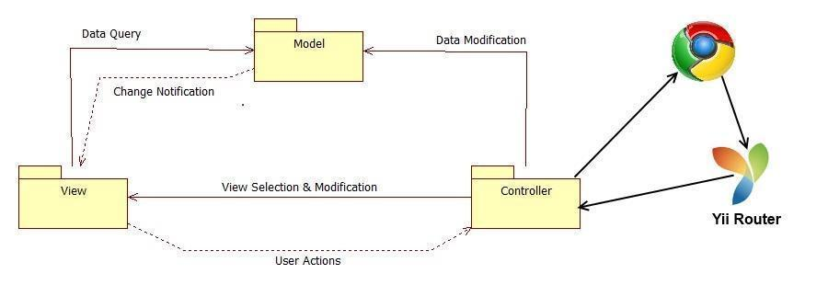

Figure 1.2 Model View Controller

## System Design Overview

As a result of our understanding of the system, we determined that the system would be divided in three major components where the objects and classes have to be independent. By this, the team chose the three tier architecture model; this is because the system architecture allows the system to be divided into three independent layers, as shown in figure 2.1.a

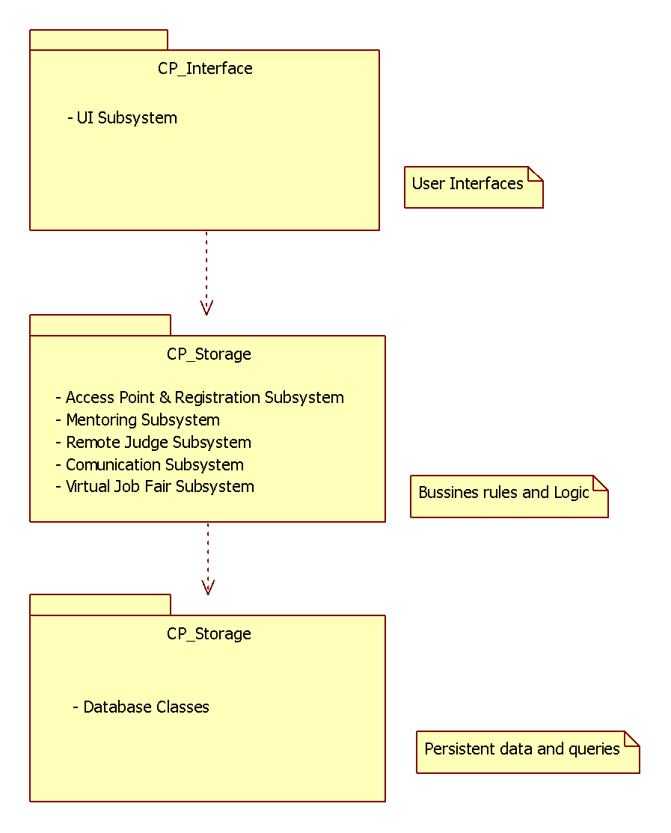

Figure 1.0 Three Tier

In the figure the interface includes all user interfaces that serves as boundaries with the users. The application Logic will serve as an intermediary between the Interface and the Storage. Moreover, this layer ensures that all processing is performed correctly. The Storage contains all the classes needed to perform the queries of the system objects.

System and Subsystem Decomposition

Below we present a description of each of the major subsystems and their respective functional requirements.

**Registration and Access Point Subsystem**

The registration and access point subsystem will be the main entry point for our platform. This will facilitate the process across the user database. Since there will be one login for each individual module, the access point is simplified into one subsystem. This subsystem will also cover the creation of new users and the retrieval of passwords for current users.

* Allow the user to log in.
* Allow the user to log out.
* Allow the user to retrieve forgotten password.
* Allow the admin to register mentors (project/domain/personal)
* Allow admin to edit mentors roles
* Allow mentors to login with credentials provided by admin

**Mentoring Subsystem**

The mentoring subsystem will cover the essentials of the mentoring module. Specifics to the mentoring module are separated into this subsystem. These functionalities include the essential workflow of the ticketing system for issues created by mentees for the different types of mentors.

* Auto assigns the most appropriate domain mentor to a ticket.
* Allow administrator to reassign the ticket to other domain mentor.
* Allow project mentor to retrieve the description of the projects assigned.
* Allow project mentor to retrieve all the mentees for each project.
* Allow project mentor to set up meetings with his/her mentees.
* Allow project mentor to retrieve all the upcoming meetings.
* Allow project mentor to assign ticket to other project mentor.
* Allow project mentor to see the ticket created by their mentees.
* Allow mentees to assign tickets to his/her project mentor.
* Allow user create a ticket.
* Allow user to select a specific domain for a new ticket.
* Allow user to select a specific sub domain.
* Allow user to upload file to a ticket.
* Allow user to download file from a ticket.
* Allow user to append comments to a ticket.
* Allow user to retrieve all the details of the ticket of the ticket that he/she created or was assigned.
* Allow user to close a ticket.
* Allow user to reject a ticket.
* Allow System Administrators (SA) to create new administrators.
* Allow SA to change user profile information and scope.
* Allow SA to manage Domains and Sub-Domains.
* Allow SA to disable and enable users.
* Allow SA to send invitations
* Allow SA to manage projects
* Allow users to edit their availability
* Allow users to edit their photo
* Allow project mentor to select desired projects
* Allow personal mentor to select desired personal mentees
* Allow domain mentors to add domain and expertise ratings
* Allow administrators to view and edit user profiles
* Allow mentees to assign tickets to his/her personal mentor.
* Allow personal mentor to see the ticket created by their mentees.
* Allow personal mentor to comment the ticket created by their mentees.
* Allow Domain mentor in tier 1 to escalate the ticket to a Domain Mentor in tier 2
* Allow user to select a specific priority for a new ticket.
* Allow administrator to change the priority waiting time.
* Allow the system to automatically reassign the tickets.

**Communication and Notification Subsystems**

The communication subsystem is a key subsystem that provides functionality derived from the mentoring module. This communication will be vital to the ticket system as users may frequently send time-sensitive information regarding projects or questions made by mentees.

* Allow users to send a message to another user.
* Allow users to read a message.
* Allow users to delete a message.
* Send ticket due email notification.
* Send new message email notification.
* Send password change email notification.
* Send profile change email notification.
* Send ticket assigned email notification.
* Send comment added to a ticket email notification.
* Send ticket closed email notification.
* Send ticket not available mentor email notification in the Automatic Reassign.
* Send ticket reassigned email notification to admin when the ticket was automatically reassigned three times.
* Send ticket escalated email notification.

**Integration with SPW**

* Allow admin to import data from SPW manually
* Allow the system to import data(students/projects) from SPW automatically
* Allow senior project students to login with their FIU Google login credentials
* Allow system to update reassign projects based on changes made in SPW
* Allow system to update reassign mentors based on changes made in SPW

**Mentor Module: Version 3**

The system shall…

**Self-serve Mentor Registration**

* Allow a potential mentor to register for a mentor account from a new landing page.
* Allow mentors to apply for new mentorships from and all-in-one Mentor Application portal
* Allow mentors to begin their mentorships whenever approved by an admin
* Allow a Project Mentor to apply by selecting projects they like or deferring the decision to the system.
* Allow a Personal Mentor to apply by selecting students they like or deferring the decision to the system.
* Allow a Domain Mentor to apply by selecting topics they’re proficient in.
* Allow a Domain Mentor to suggest new domains.
* Allow Project Mentor to approve/reject projects suggested by admin.
* Allow Domain Mentor to approve/reject topics suggested by admin.
* Allow Personal Mentor to approve/reject mentee suggested by admin.
* Provide user verification for all applications
* Provide client side validation for all forms

**Admin Dashboard**

* Allow admin to view pending applications
* Allow admin to approve/reject Projects in a Project Mentor Application
* Allow admin to propose Projects in a Project Mentor Application
* Allow admin to approve/reject Mentees in a Personal Mentor Application
* Allow admin to propose Mentees in a Personal Mentor Application
* Allow admin to approve/reject Domains in a Domain Mentor Application
* Allow admin to propose Domains in a Domain Mentor Application
* Allow admin to view open invitations/re-invites
* Allow admin to customize the body of the message while sending an invite
* Allow admin to gain insight on site usage through admin dashboard
* Allow admin to gain insight on a particular project
* Allow admin to gain insight on a particular user
* Allow admin to gain insight on a particular domain
* Allow admin to gain insight on a particular subdomain
* Allow admin to view tickets
* Allow admin to manage tickets
* Allow admin to use an advanced search for tickets.

**Mentor Module: Version 5**

* Allow admin to pull reports on mentors.
* Allow admin to pull reports on mentees.
* Allow admin to pull reports on Tickets.
* Allow admin to research on the utilization of tickets created.
* Allow admin to research on the utilization of tickets closed.
* Allow admin to research on the utilization of tickets duration (time opened to closed)
* Allow admin to research on the time that takes mentors to answer.
* Allow admin to research on the tickets that are still open (may or may not be answered).
* Allow admin to get system suggestion on what kind of mentors to find (based on frequent mentee subdomains).
* Allow users to schedule meetings on-demand.
* Allows users to schedule meetings ahead of time.
* Allow mentors to schedule meetings from a ticket.
* Allow users to see/hear each other during videoconferences.
* Allow users to use the chat-room during videoconferences.
* Allow users to have a whiteboard to draw and share it during videoconferences.
* Allow users to share their screens with the other meeting participants.
* Allow users to stop sharing their screens with the other meeting participants.
* Allow users to invitee others during a videoconference.
* Allow invitee to accept a video conference invitation
* Allow invitee to reject a video conference invitation
* Allow moderators to delete their videoconferences.
* Allow moderators to cancel their videoconferences.

**Mentor Module: Version 6**

**The system Shall.**

* Allow users to turn their webcam on/off during a video conference.
* Allow users to reset their password using the forgot password option.
* Allow users to register on their own from the homepage.
* Allow users registered by an administrator to change their password.
* Allow users to have a second screen for screen-sharing.
* Allow users to join a video conference without synchronization problems.
* Allow moderators to edit a video conference’s information such as title, date and time, notes, and invitees.
* Allow users to have a robust video conference room.
* Provide users with a new chat feature, one that they can hide and unhide for convenience.
* Allow users to join a conference after it has started and still receive all the video streams and screens being shared.
* Allow users to invite others by name when creating or editing a video conference.
* Allow users to access past and canceled video conferences.
* Provide users with a calendar widget when creating or editing a conference.
* Alert users if they don’t have the “Screen Capturing” plugin when joining a conference.
* Allow users to be set as away and no longer receive tickets
* Have the system reassign tickets that need to be reassigned automatically
* Allow users to send the system email.
* Allow the mentors to be selected by round robin
* Allow mentors to see all the information of the ticket in the email we send them
* Allow mentor to pass on a ticket through a link in the email
* Allow the admin to manage the mentors who are away, removing them, or adding them by using their name with autocomplete
* Allow mentors to manually remove themselves from being away
* Provide the ability for users to sort their tickets the way they like on their homepage
* Allow prospective mentors to suggest a new domain that fits their area of expertise
* Allow the system administrator to adjust the time limits given to tickets
* Allow users to be able to see the last recorded for each ticket on their home page.
* Allow users to see their upcoming meetings on their home page
* Allow users to look at tickets that are not assigned to them or created by them
* Allow the user to search these tickets by certain criteria.
* Allow the mentor to link directly to the ticket through the email sending them the ticket.
* Notify mentors when their tickets are reassigned

Deployment Diagram

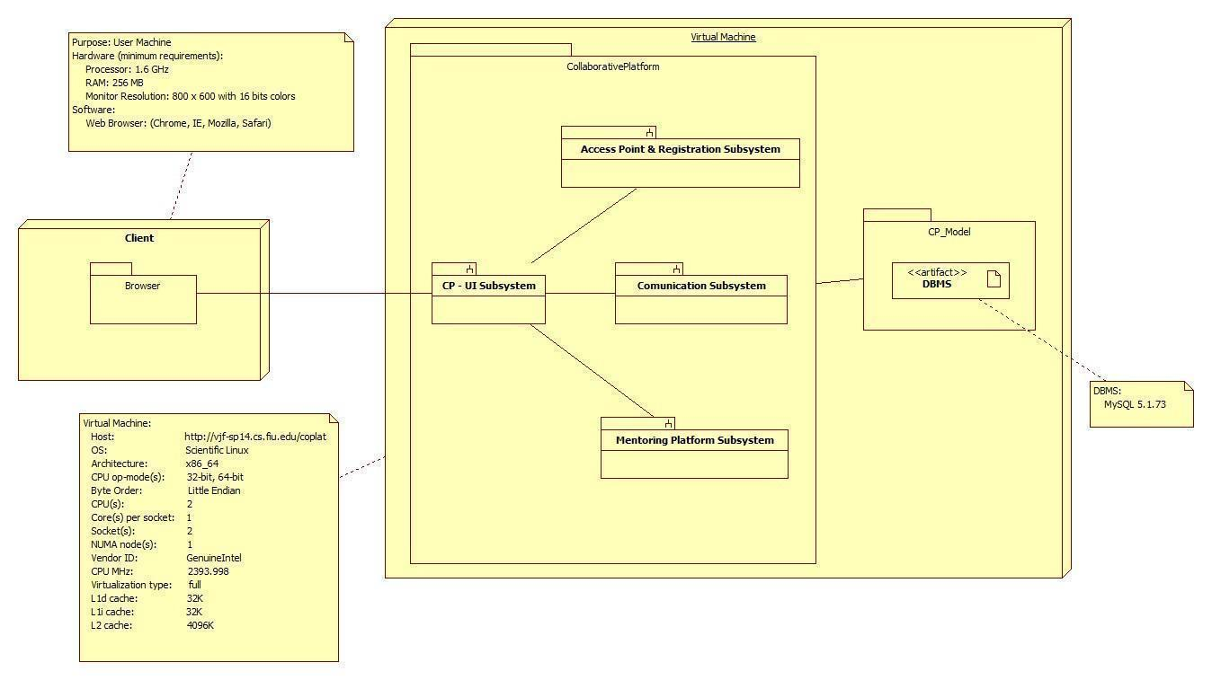

Figure 1.3 Deployment Diagram

## Design Patterns

We have used the unified software process model as the basis for our planning and organization during the design of our software. The model is largely based on the construction of the specific use cases to help formulate and drive the design process. After formulating a set of uses cases, the team can then take those specific use cases and apply them to different UML diagrams to flesh out the design process. For example, class diagrams can show the relationships between different classes within subsystems and how specific subsystems can relate to one another. Sequence diagrams help plan out specific paths of method calls before the team actually begins to code. Finally having carefully specified requirements document allows the team to stay focused and on task as to the purpose of the design.

**System Validation**

The system validation chapter introduces testing to make sure that the project works as was intended.This sections contains use cases that were used to test the different functionalities implemented during this term.

**User Story #2 - Bug: Allow for users to register**

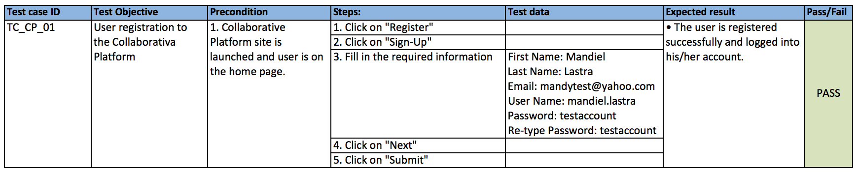

**User Story #4 - Allow users registered by an administrator to change their password**

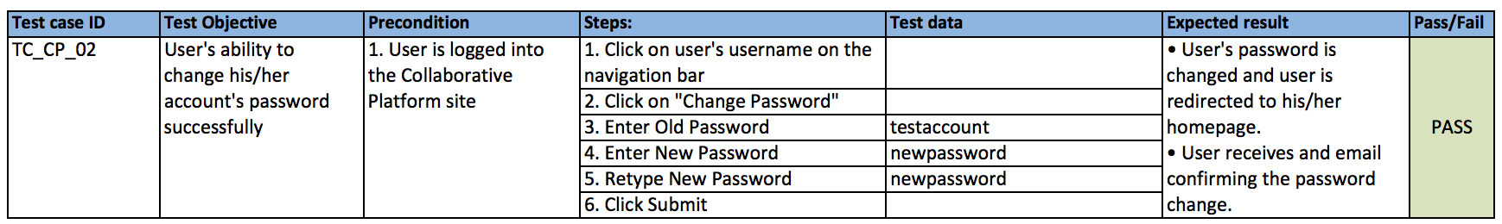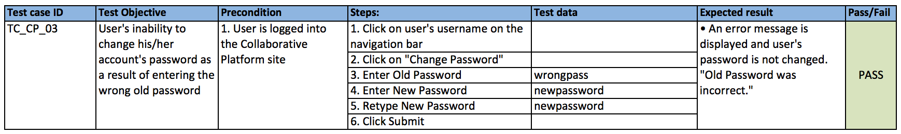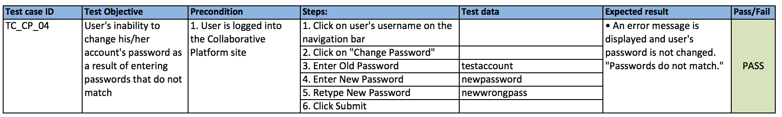

**User Story #3 - Bug: Allow users to reset their password using the Forgot Password option**

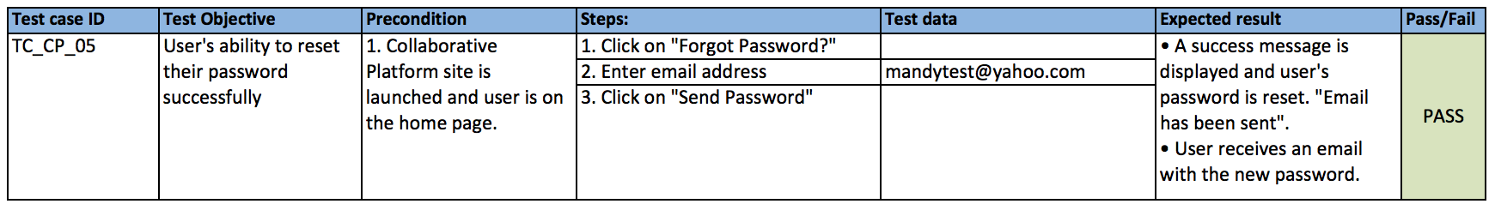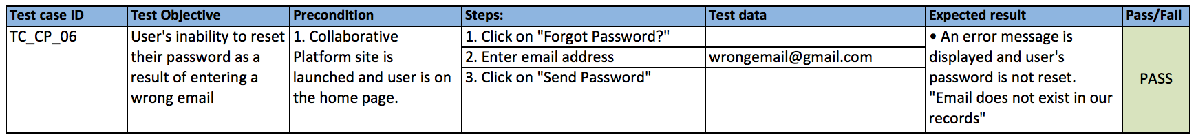

**User Story #1 - Allow users to turn their webcam on/off**

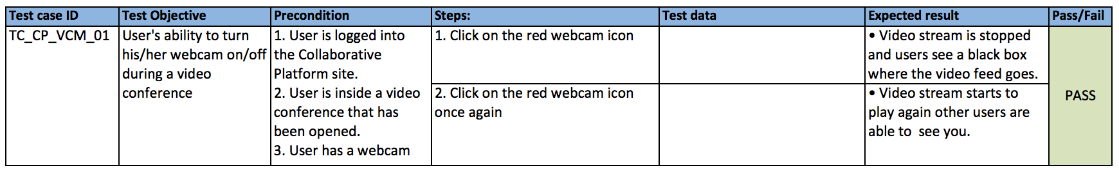

**User Story #5 - Allow users to edit a video conference’s information**

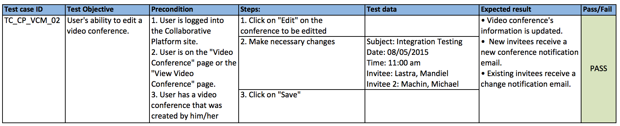

**User Story #6 - Allow users to join a conference without synchronization problems**

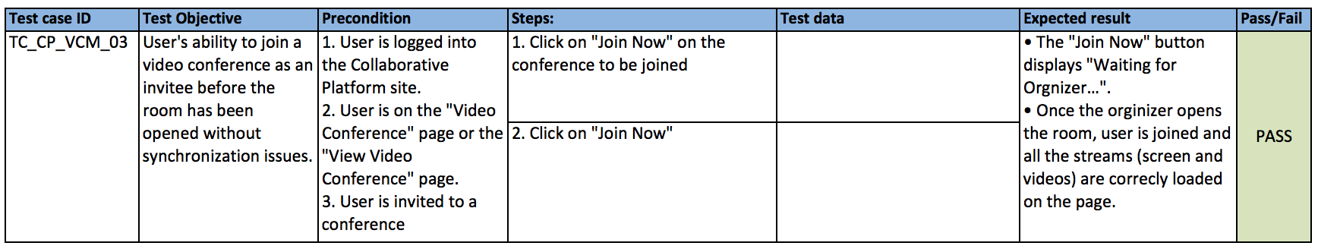

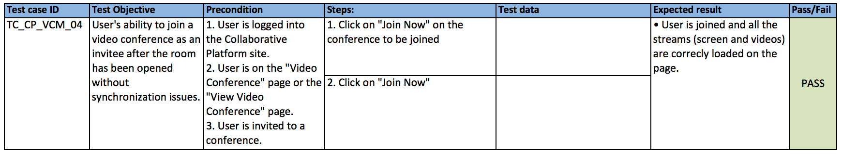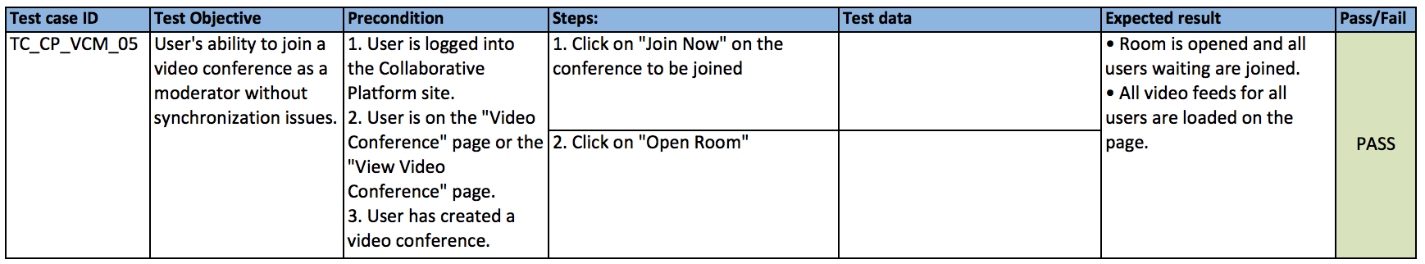

**User Story #7 - Provide users with a second screen sharing window**

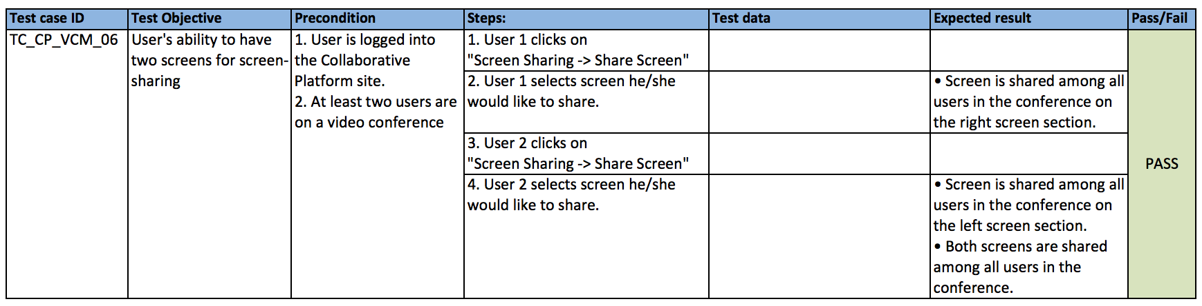

**User Story #8 - Allow users to have a robust Video Conference room**

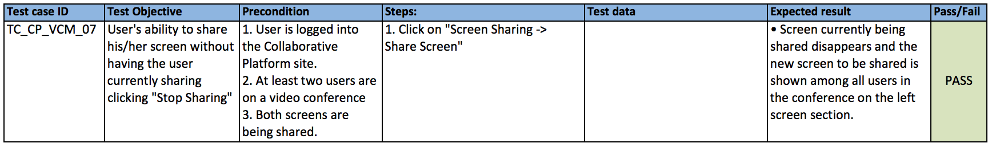

**User Story #35 - Improve Usability of the System**

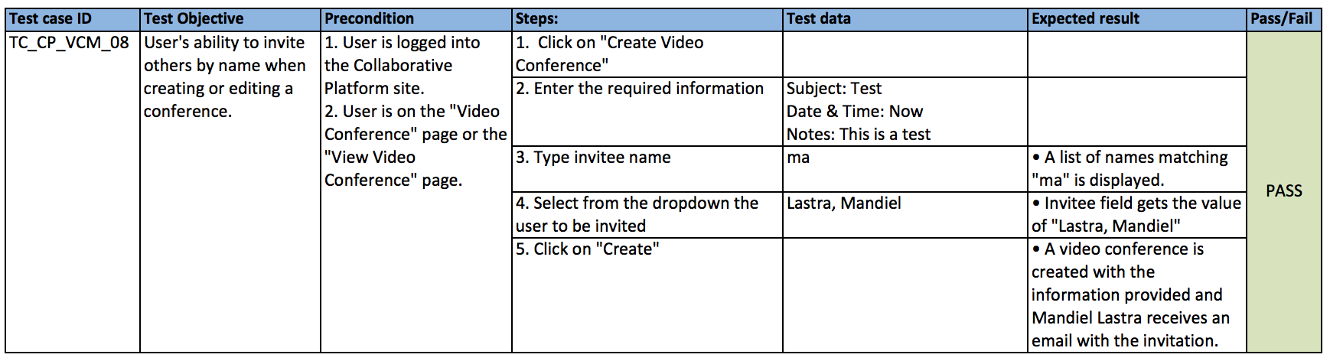

**User Story #34 - Allow users to access Past/Canceled Video Conferences**

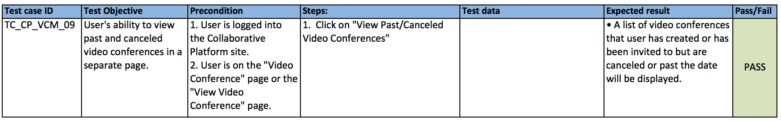

**User Story # 9 - Do not auto assign tickets to away mentors**

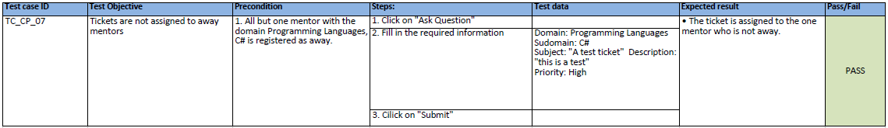

**User Story # 11 - Send an email to the mentor signifying their unavailable status**



**User Story # 13 - Mentors are selected on list by round robin**

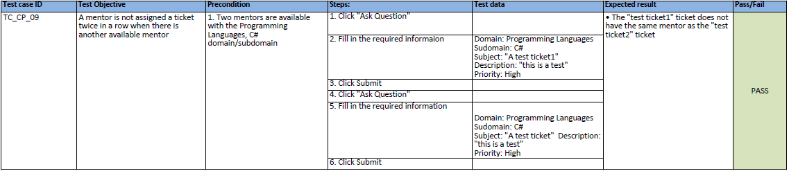

**User Story # 14 - Tickets are reassigned after a set time of no mentor response**

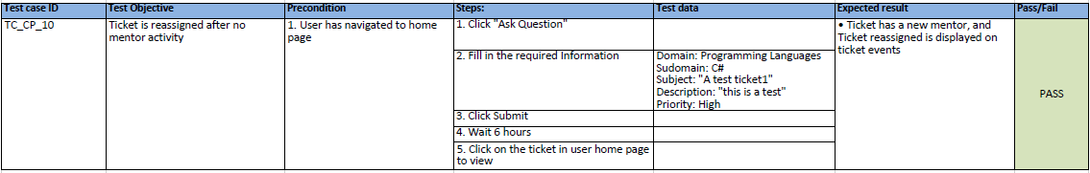

**User Story # 15 - Set Mentors as available upon receiving available email**



**User Story # 11 - Set mentors as unavailable upon receiving an out of office reply**



**User Story # 36 - Re-assign tickets that were assigned to an unavailable mentor**

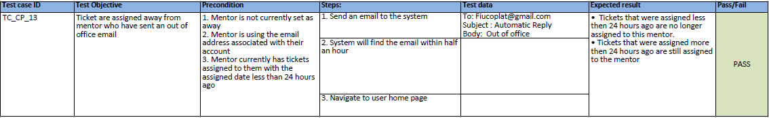

**User Story # 17 - Allow mentor to reject a ticket from their email**

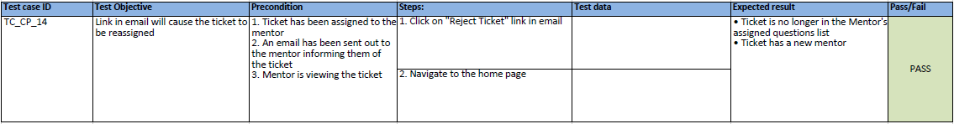

**User Story # 37 - BUG: timestamp is not displaying properly in events**

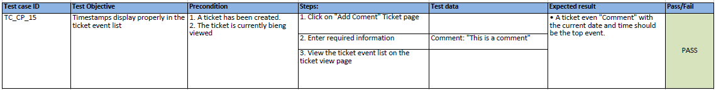

**User Story # 18 - Allow the system admin to set and change reassign rules**

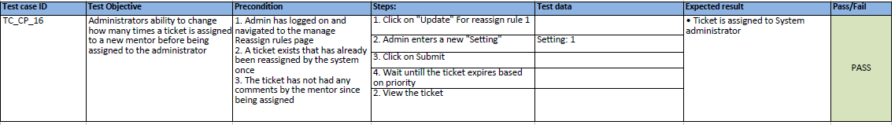

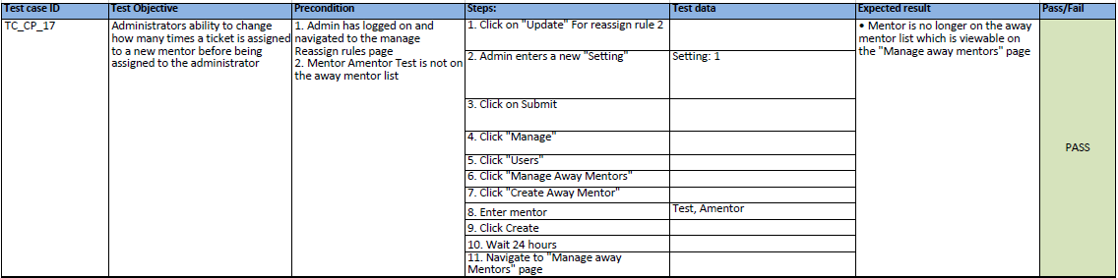

# 

**User Story # 19 - Send information of ticket through email**

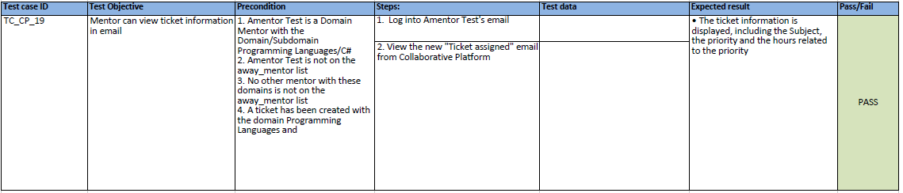

**User Story # 20 - Emails sent from the system are Validated**



**User Story # 22 - Allow system admin to manage away mentors**



**User Story # 21 - Allow mentors to remove themselves from the away mentor list**



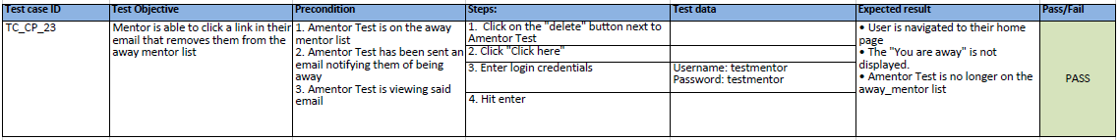

**User Story # 23 - Display Reassignments on ticket events**



**User Story # 27 - Bug: tickets cannot have uploaded file**

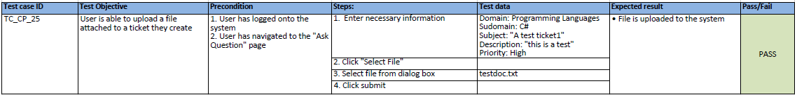

**User Story # 28 - Allow system administrator to add to away list using the user’s name**

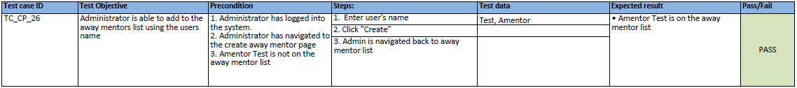

**User Story # 30 - Allow the ticket creator to assign their ticket to a new mentor**

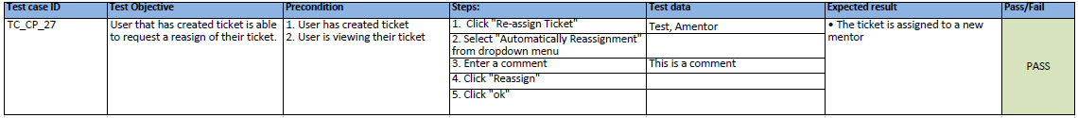

**User Story #31 - BUG: Personal mentors are not being registered correctly**

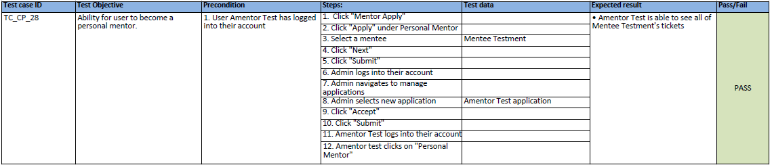

**User Story # 32 - Adding to the away list uses autocomplete**

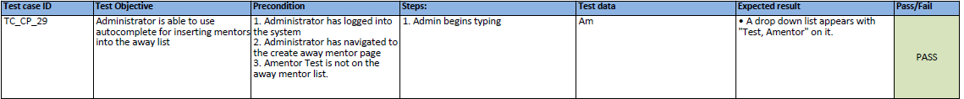

**User Story # 33 - Only the administrator can manually assign a ticket to a mentor**

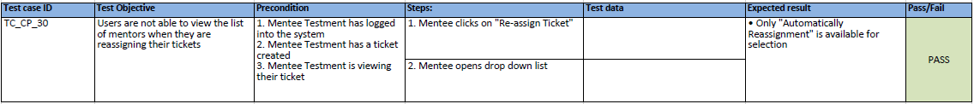

**User Story # 38 - Sort the tickets in the ticket list views**

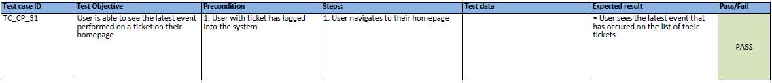



**User Story # 39 - Improve the usability of the system**





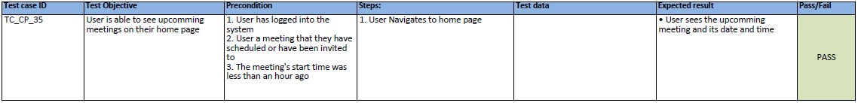

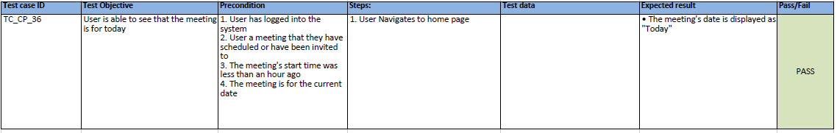

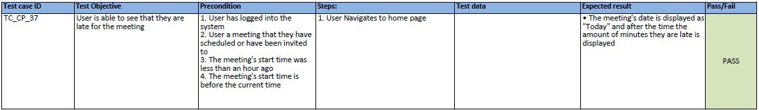

**User Story # 40 - User is able to suggest new domain**







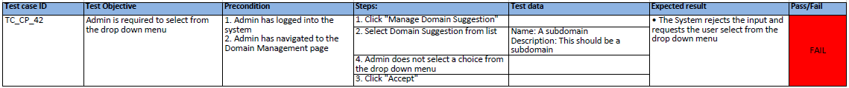

# 

# 

# 

# **Glossary**

Definitions:

* **User** – A generalization given to all user groups.
* **Student** – Individual who is currently enrolled in the senior project class.
* **Mentorship** - is a personal developmental relationship in which a more experienced or more knowledgeable person helps to guide a less experienced or less knowledgeable person.
* **Mentor** - An Individual with a Collaborative Platform account seeking Mentorship.
* **Project** **Mentor** – An individual who is assigned to overlook one or many senior projects.
* **Domain** **Mentor**– An individual with particular knowledge in a certain skill or language(2 Tiers)
* **Personal Mentor** –An individual that mentors only a single person – not limited to career advice.
* **Product owner**–The product owner represents the client and has enough domain knowledge to answer the questions the development team may have about the software product.
* **Mentee** - An individual that may request help or ask a question.
* **Administrator** –An individual assigned with administering the web portal.
* **Application** - A form containing information provided by a Mentor seeking a Mentorship.
* **System Pick** - An automated selection done by the system.

Abbreviations:

* **N/A**

# **Appendix**

## Appendix A - UML Diagrams

### Static UML Diagrams

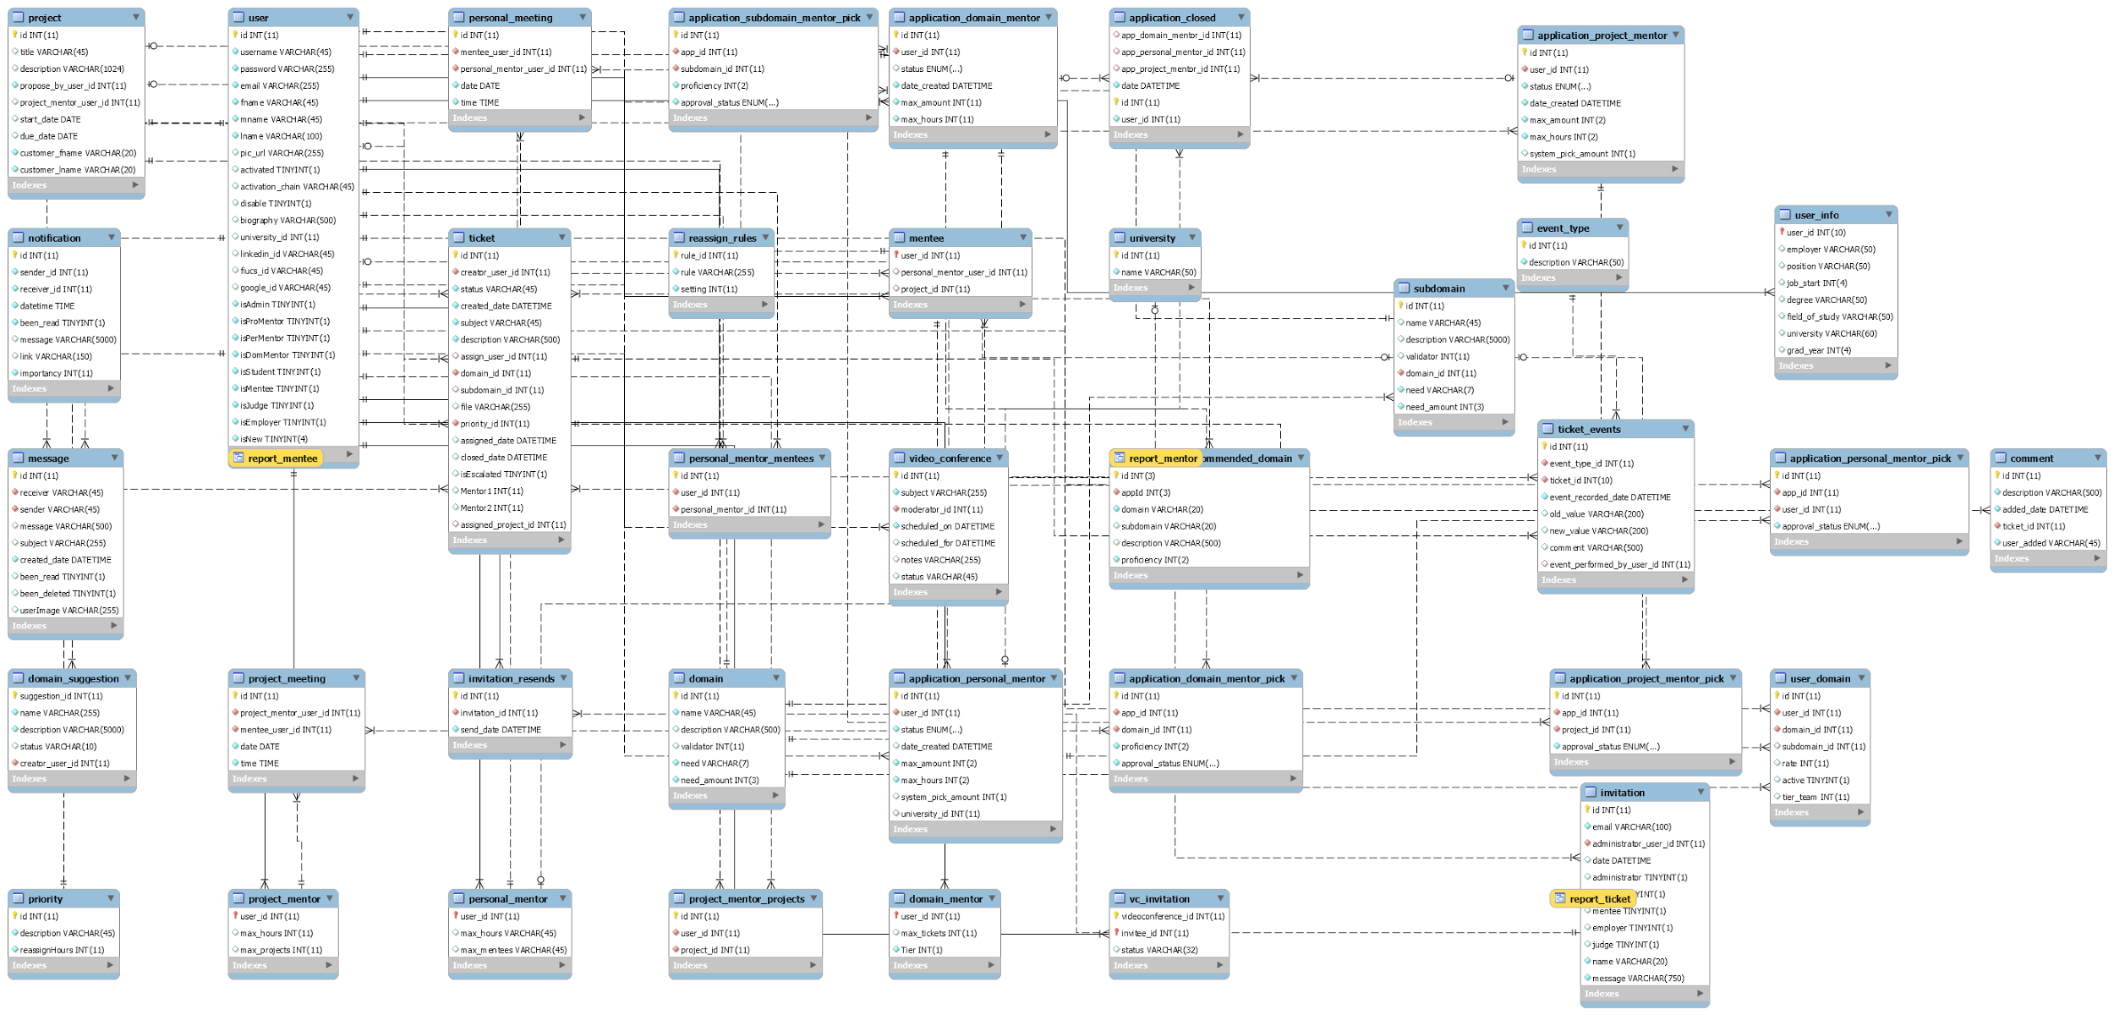

AS.1 Persistent Data Model

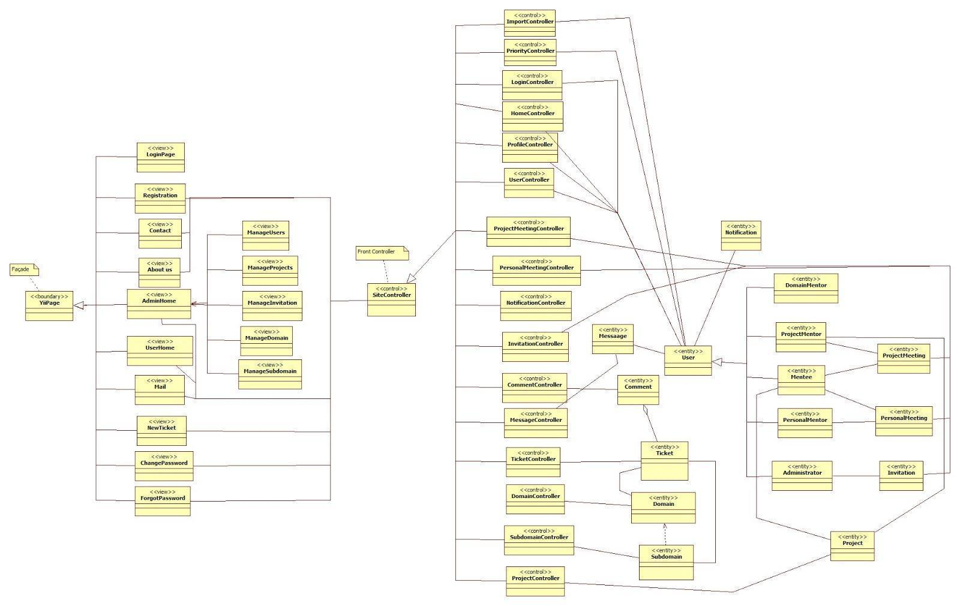

AS.2 Minimal Class Diagram

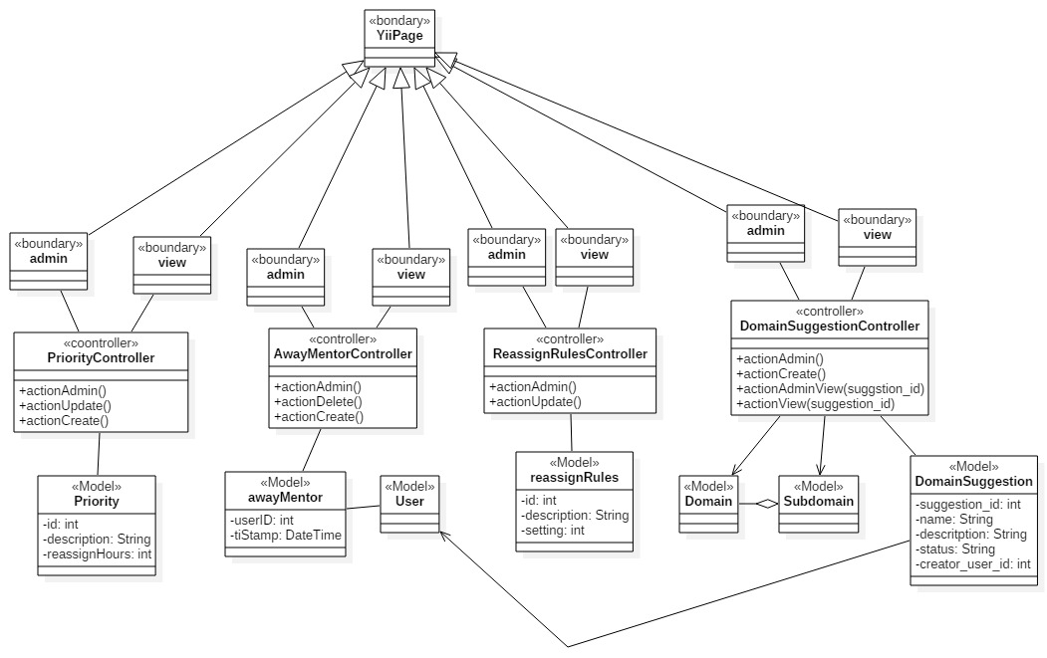

AS.3 New Controllers, Models, And Views For new systems

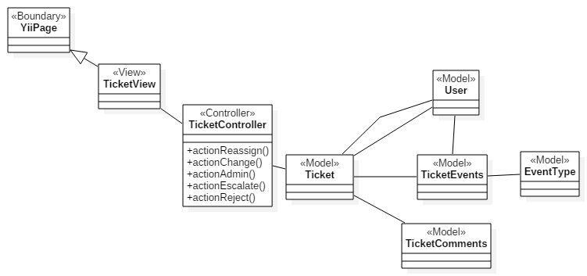

AS.4 New ticket controller and view class interactions

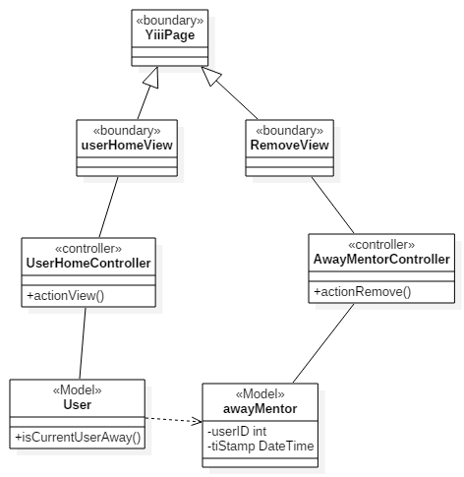

AS.5 New User, UserHome, AwayMentor interactions for user home

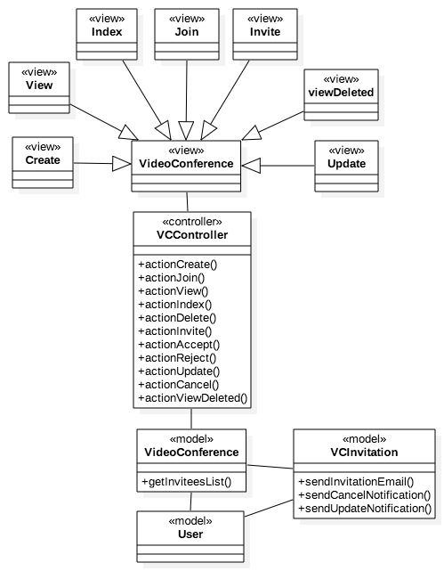

AS.6 Class Diagram for the Video Conference Module

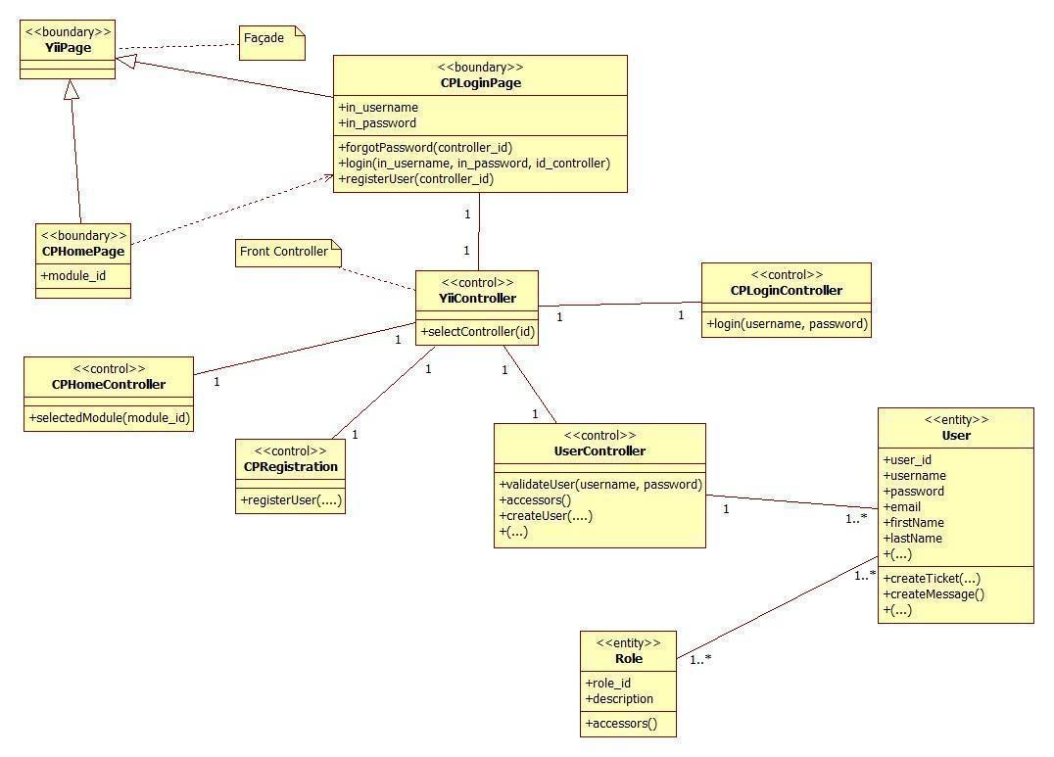

**AS.7 Access Point & Registration Detailed Class Diagram**

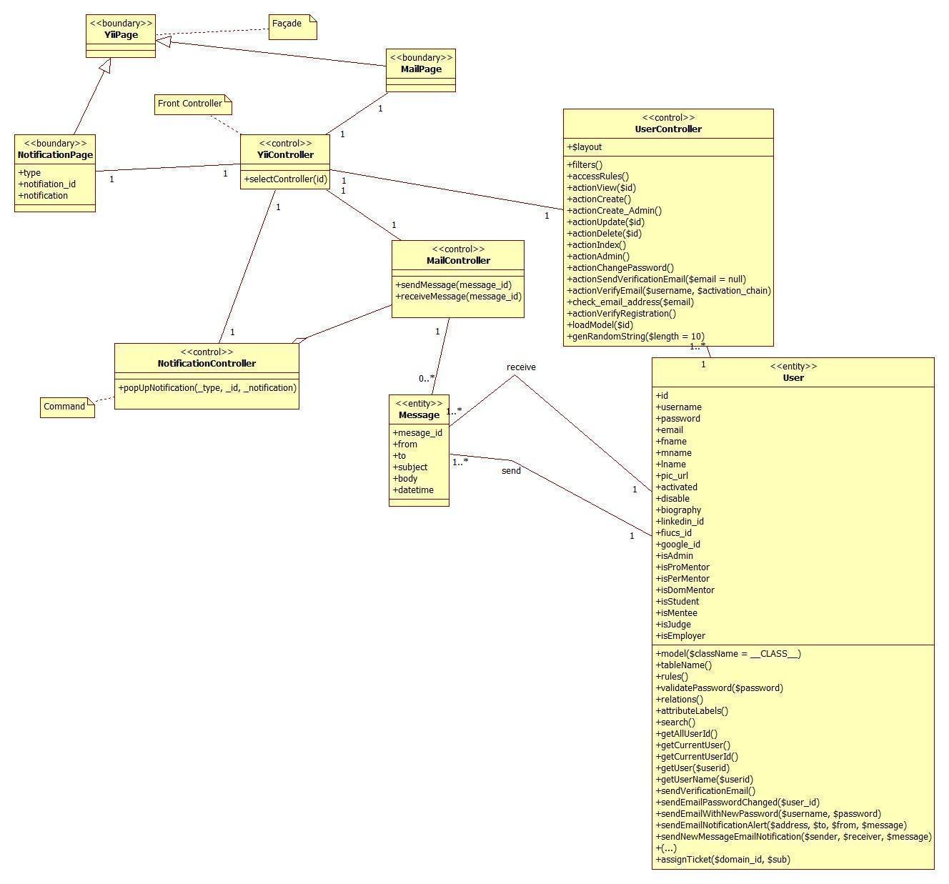

**AS.8 Communication and Notification Subsystem Detailed Class Diagram**

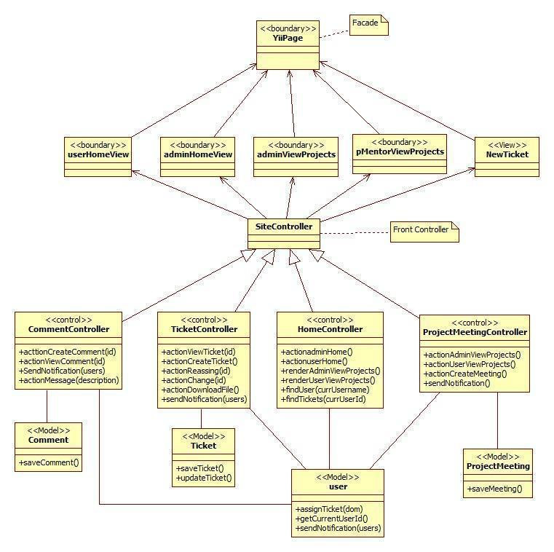

**AS.9 Mentoring Subsystem Detailed Class Diagram**

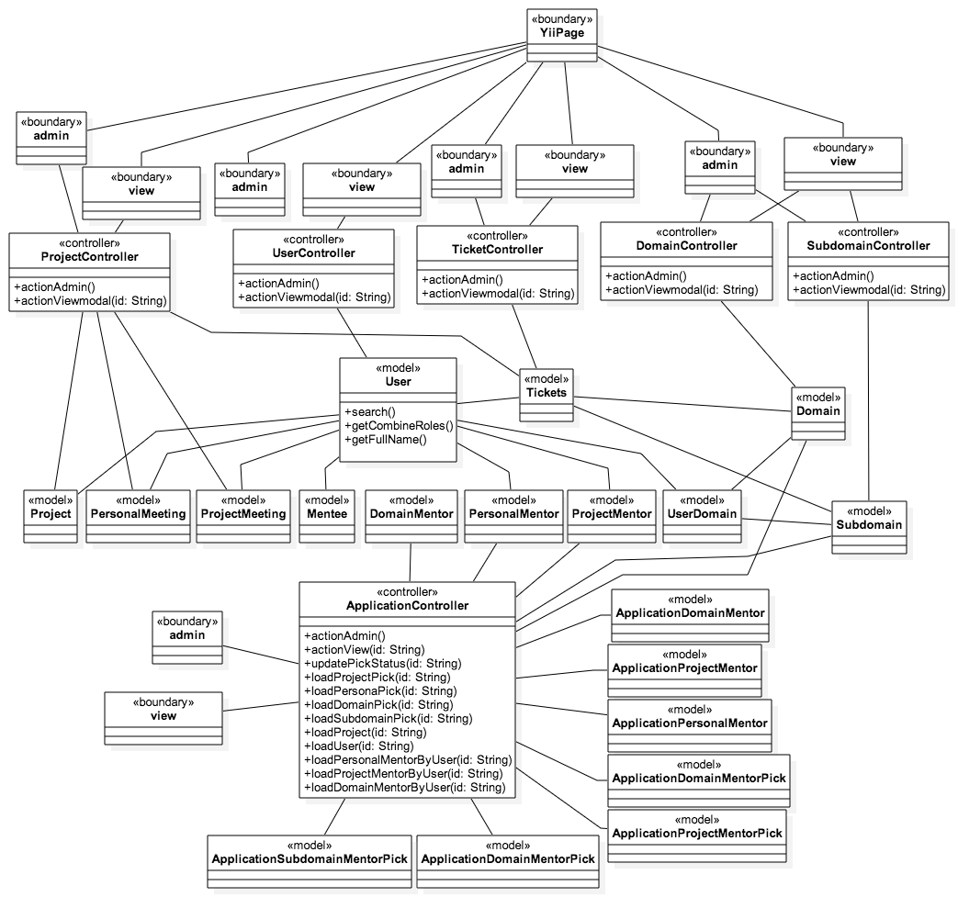

**AS.10: Admin Management Detailed Class Diagram**

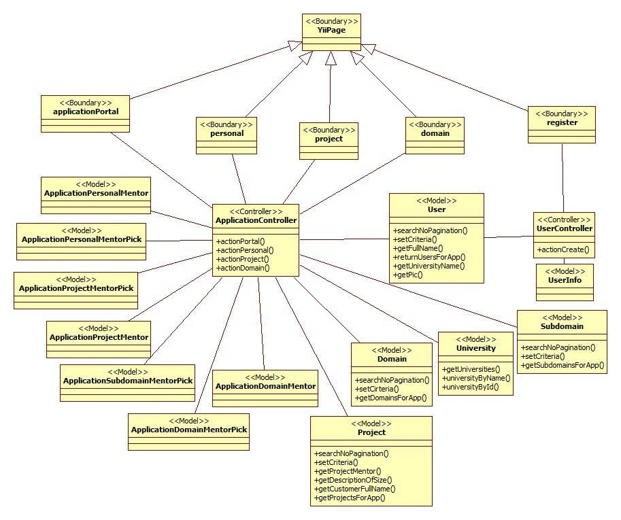

**AS.11: Self-Registration Detailed Class Diagram**

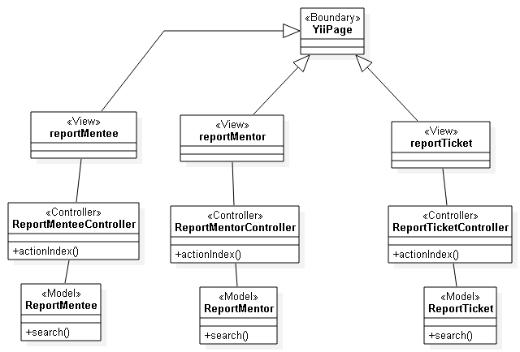

**AS.12: Admin reports Detailed Class Diagram**

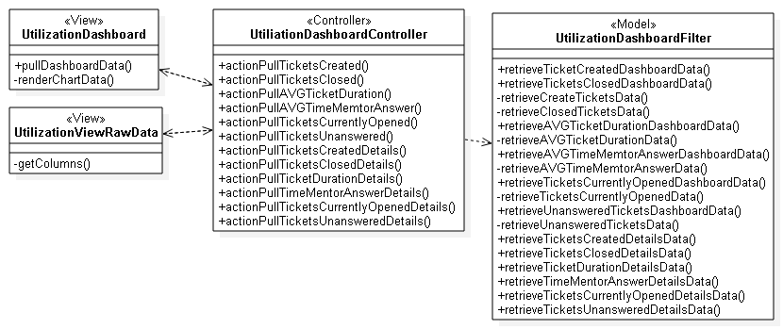

**AS.13: Utilization dashboard Detailed Class Diagram**

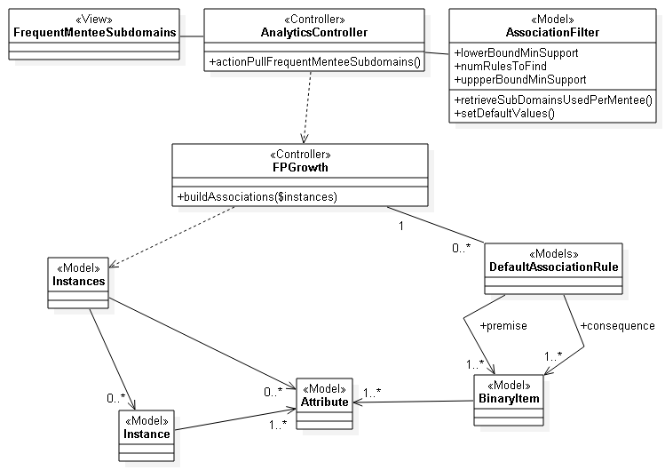

**AS.14: Analytical reporting (Frequent sub-domain questions by mentee) detailed class diagram.**

CPv3-UDC-02: Admin Dashboard

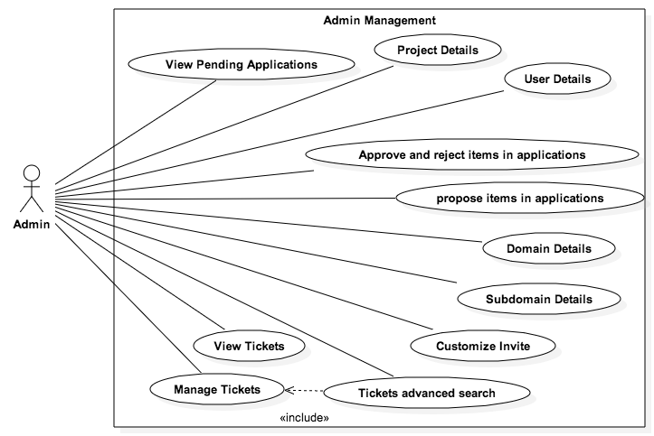

**Mentoring Module: Version 5**

CPv5-UDC-01: Admin Report

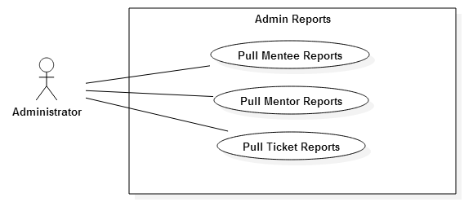

CPv5-UDC-02: Utilization reporting and analytics

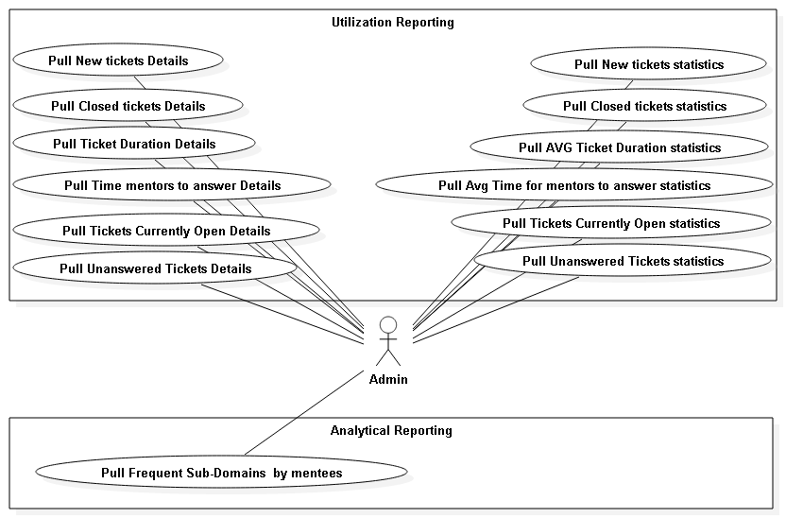

CPv5-UDC-03: Collaborative Tools

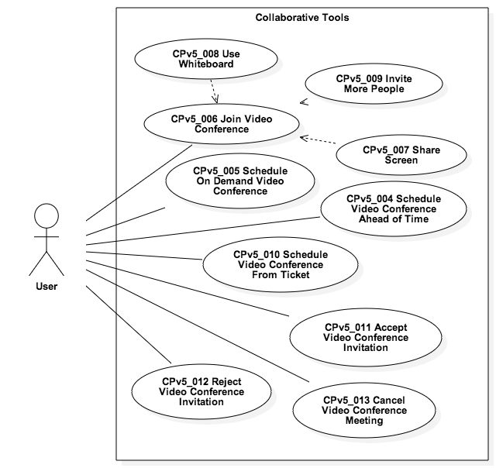

**Mentoring Module: Version 6 UC1**

### 

### 

### 

### 

**Mentoring Module: Version 6 UC2**

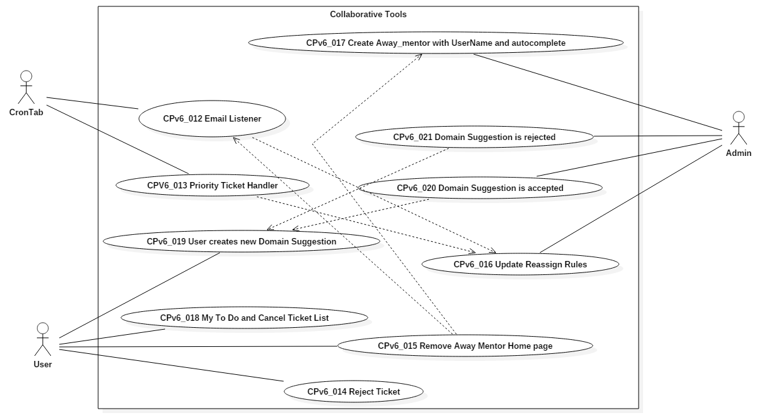

### 

### 

### 

### Dynamic UML Diagrams

**Collaborative tools**

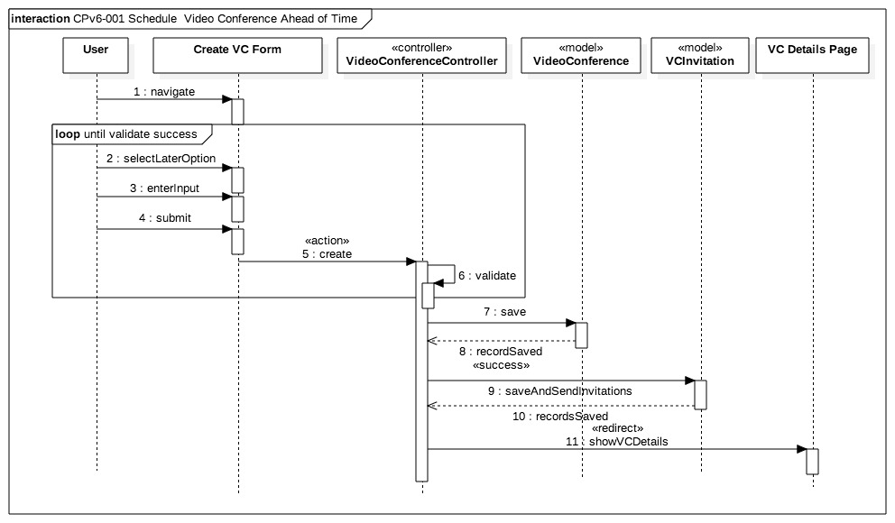

AD.01 Schedule Video Conference Ahead of Time Sequence Diagram

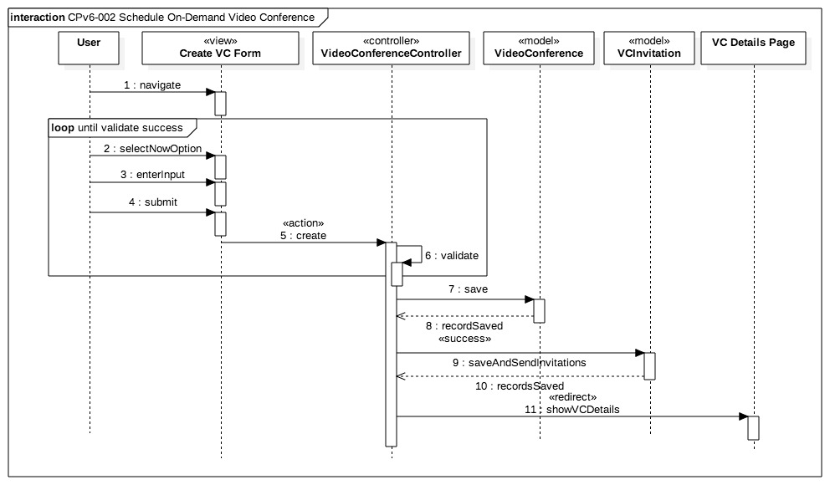

AD.02 Schedule On-Demand Video Conference Sequence Diagram

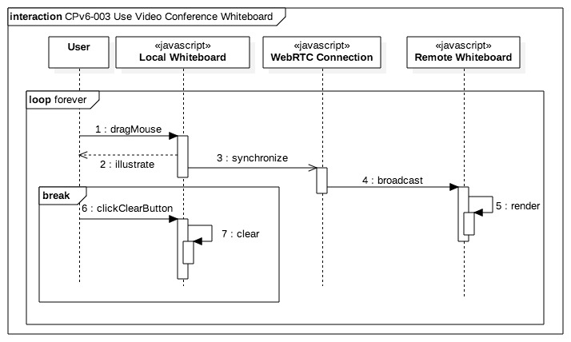

AD.-03 Use Video Conference Whiteboard Sequence Diagram

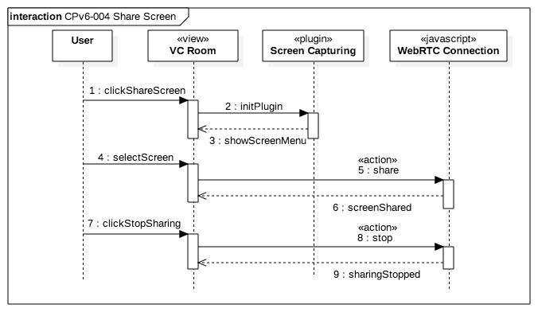

AD.04 Share Screen Sequence Diagram

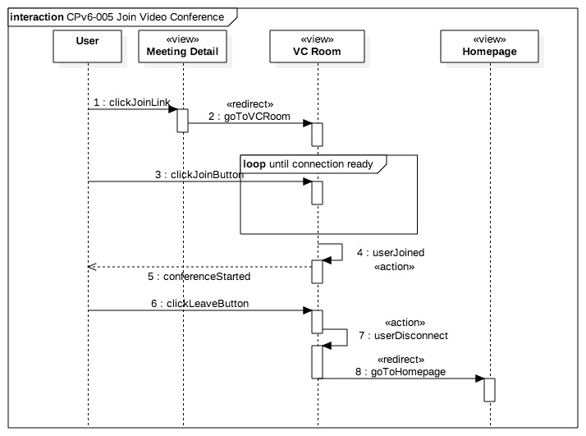AD.05 Join Video Conference Sequence Diagram

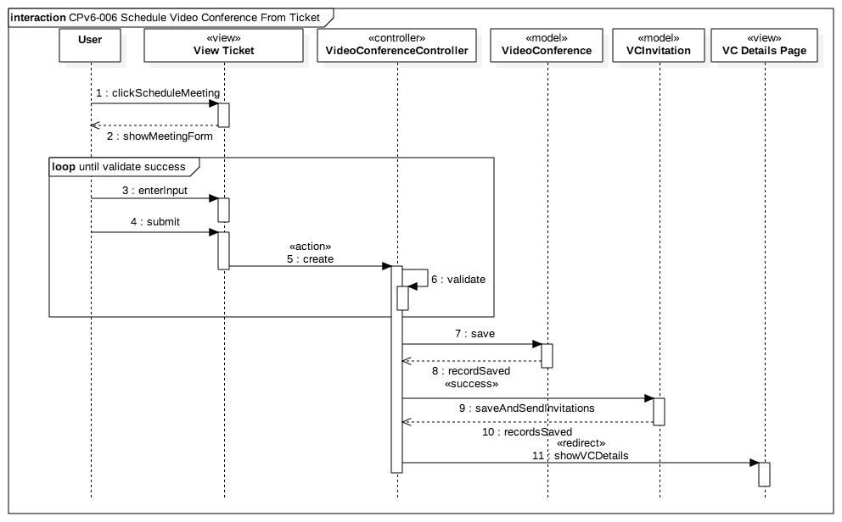AD.06 Schedule Video Conference from Ticket Sequence Diagram

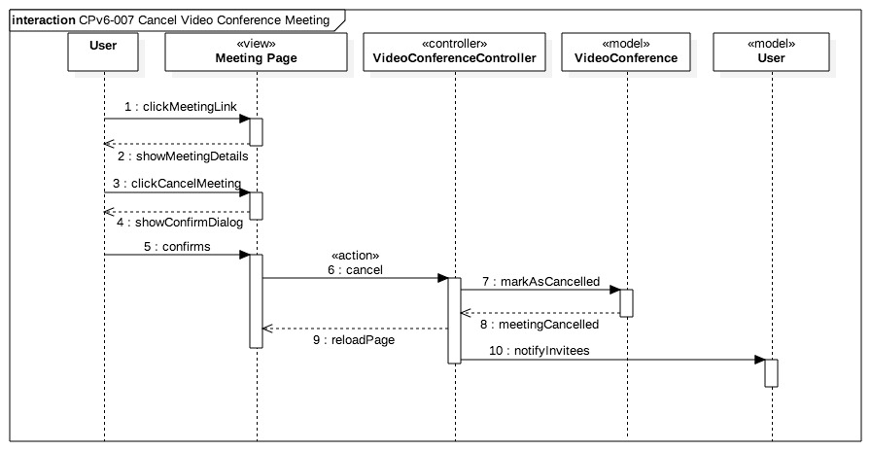

AD.07 Cancel Video Conference Meeting Sequence Diagram

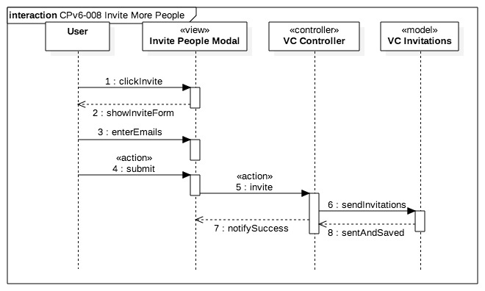AD.08 Invite More People Sequence Diagram

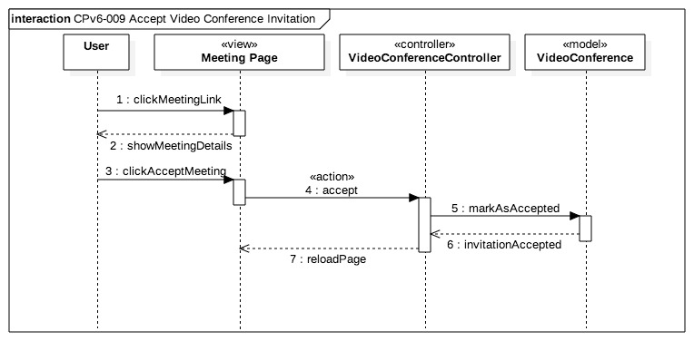

AD.09 Accept Video Conference Invitation Sequence Diagram

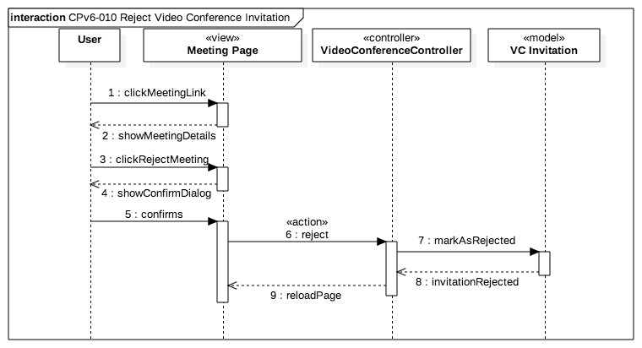AD.10 Reject Video Conference Invitation Sequence Diagram

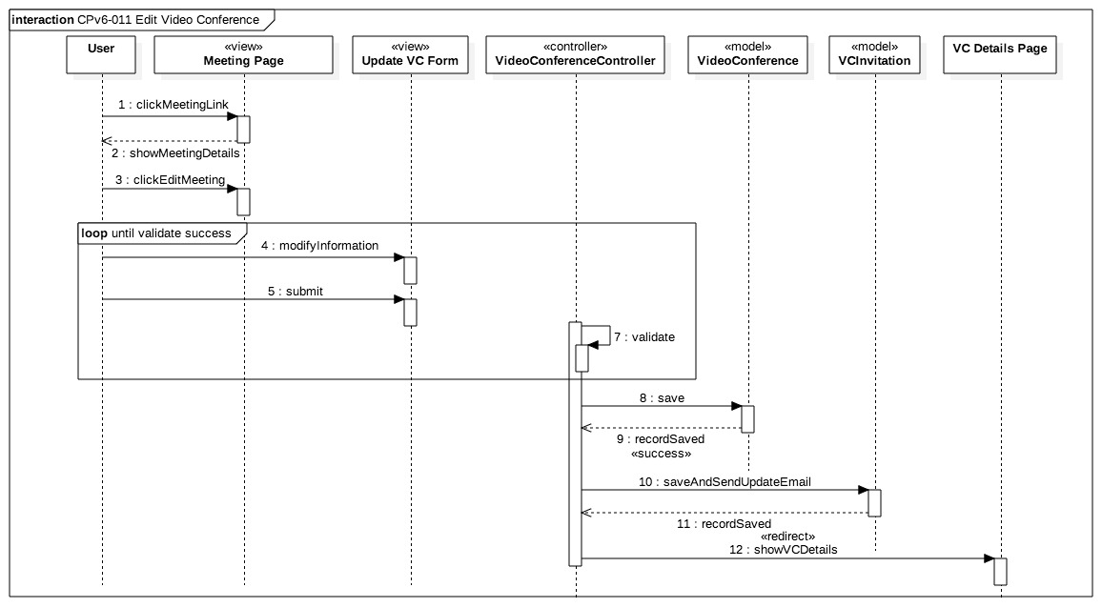AD.11 Edit Video Conference Sequence Diagram

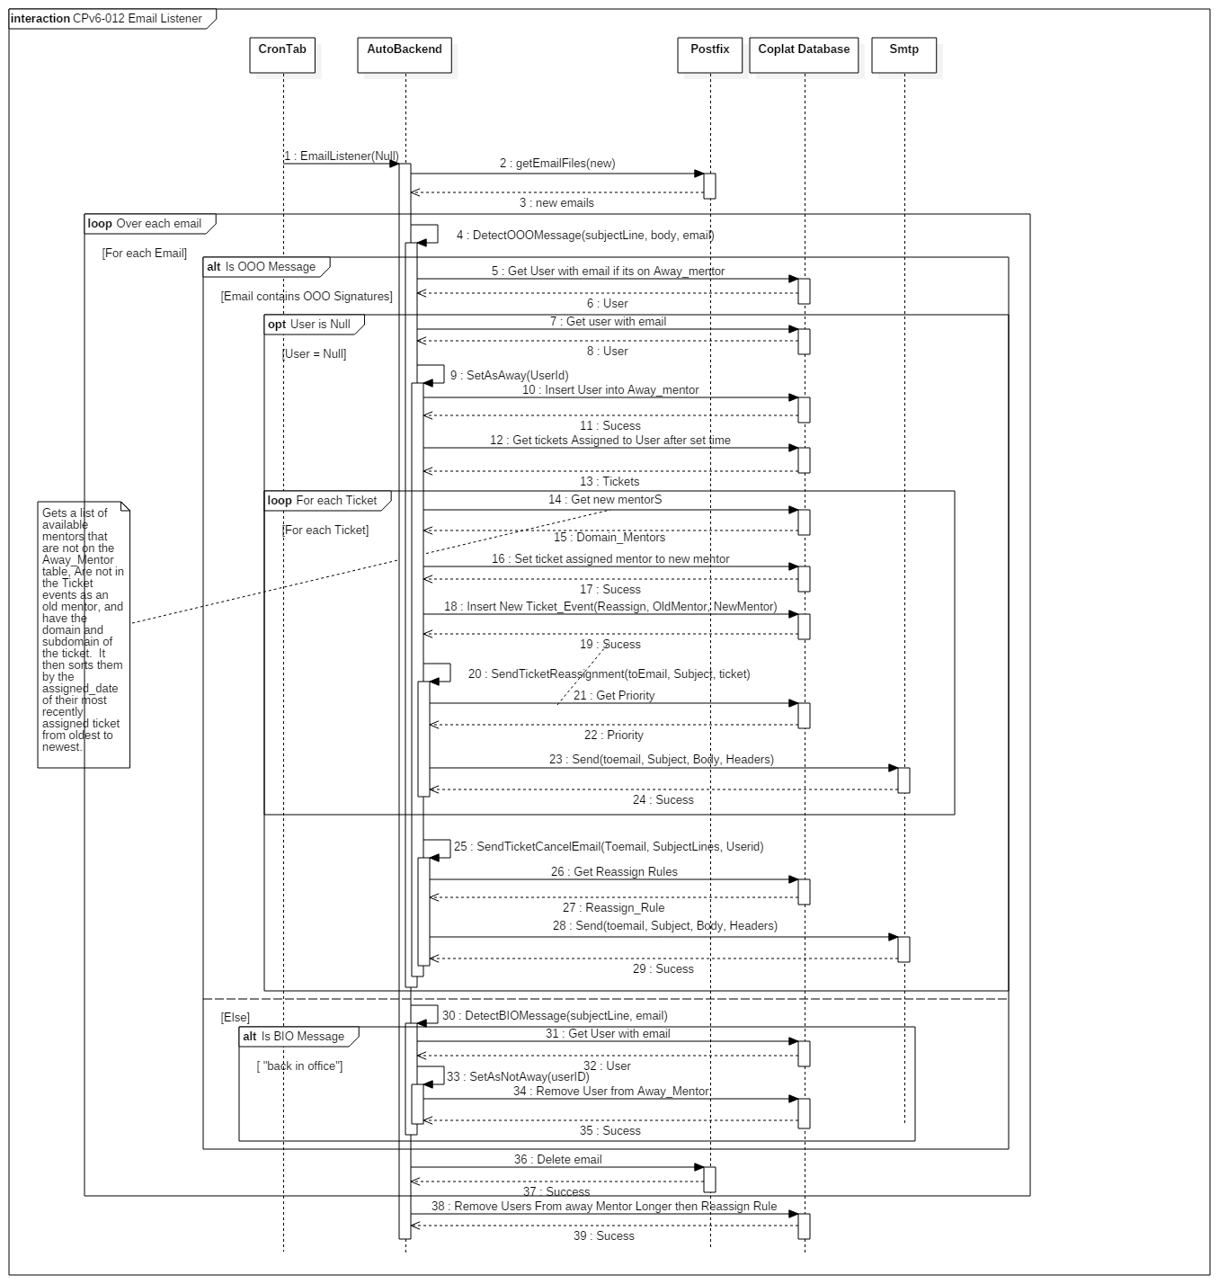AD.12 Email Listener Sequence Diagram

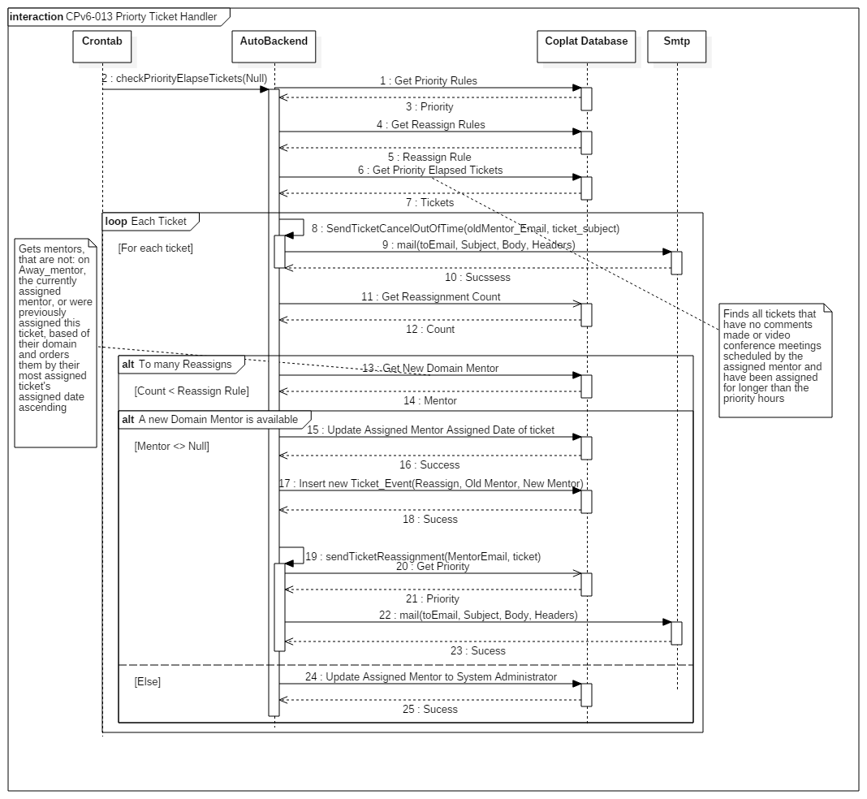

AD.13 Priority Ticket Handler Sequence Diagram

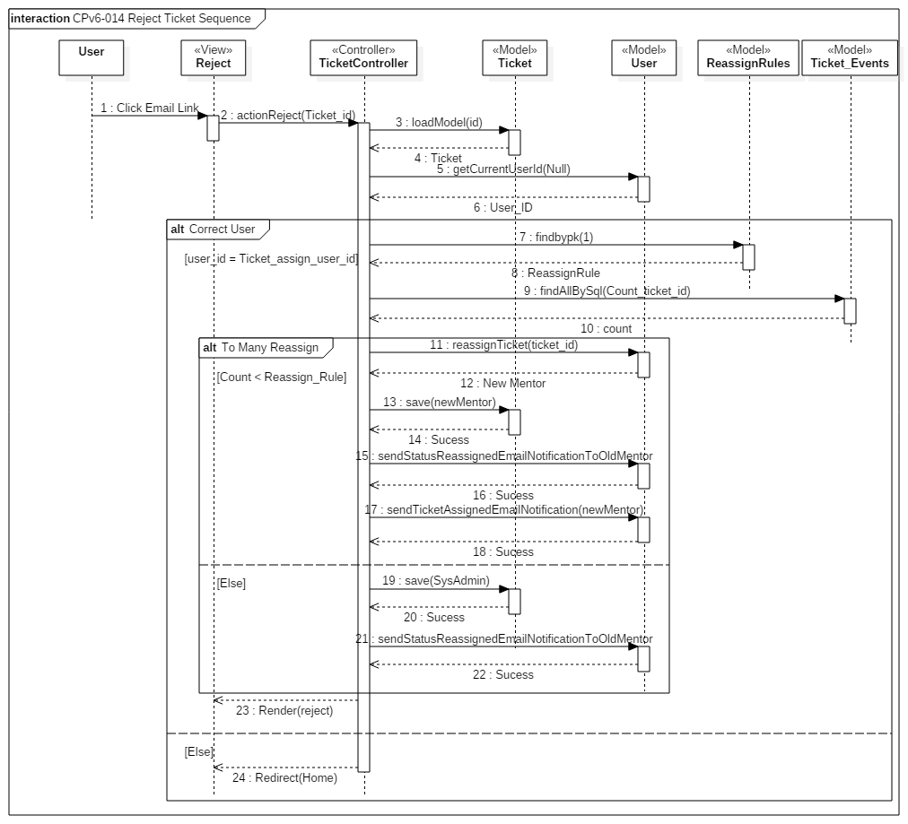AD.14 Reject Ticket Sequence Diagram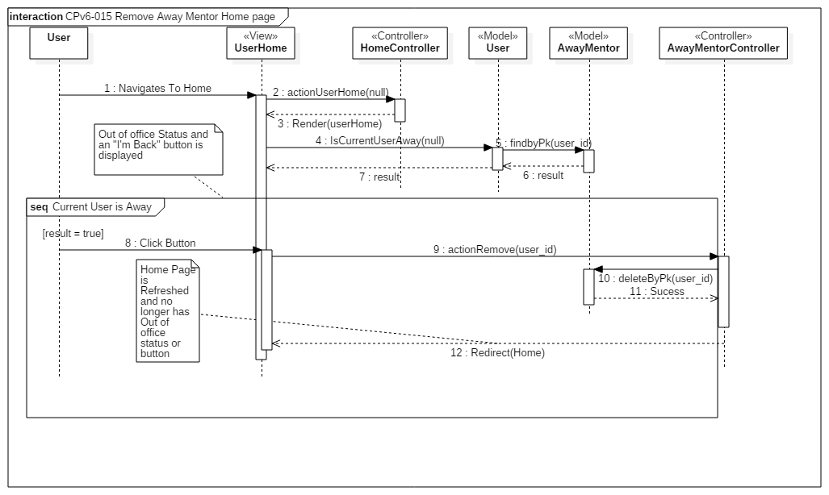

AD.15 Remove Away Mentor Home page Sequence Diagram

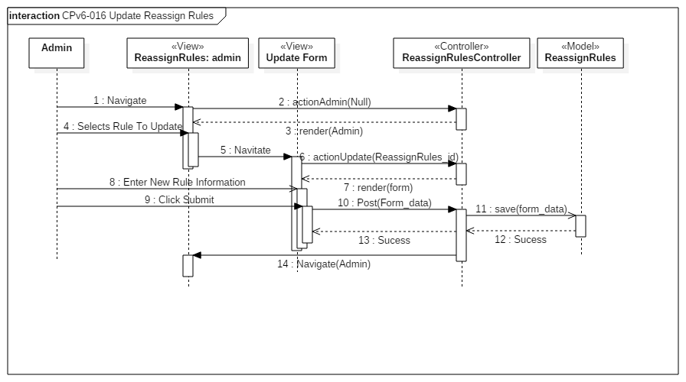AD.16 Update Reassign Rules Sequence Diagram

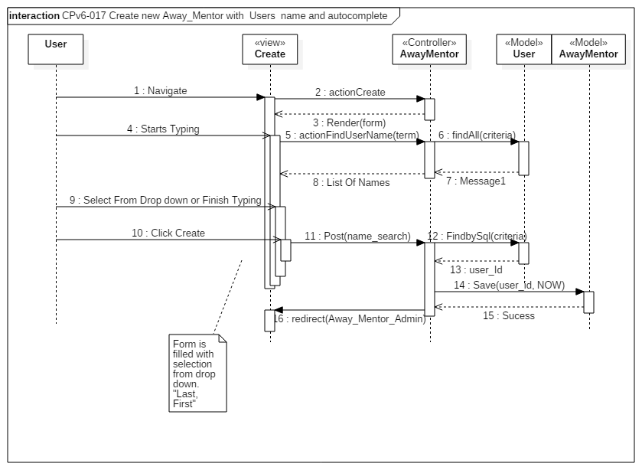AD.17 Create new Away_Mentor with Users name and autocomplete Sequence Diagram

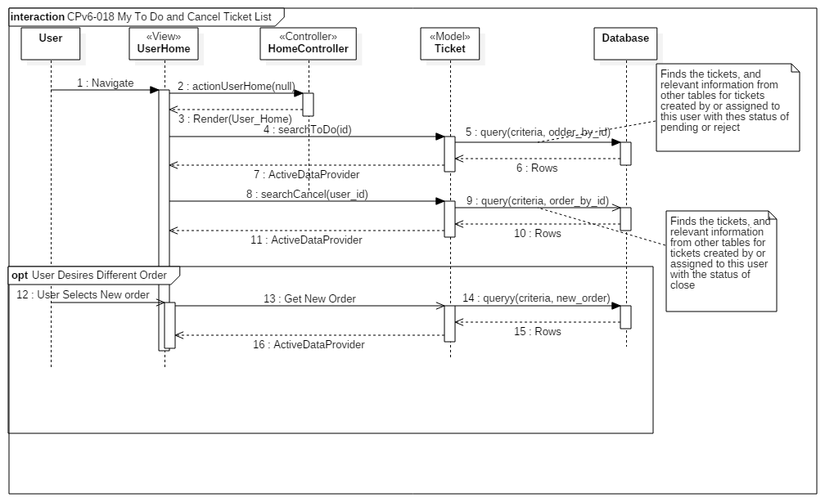AD.18 My To Do and Cancel Ticket List Sequence Diagram

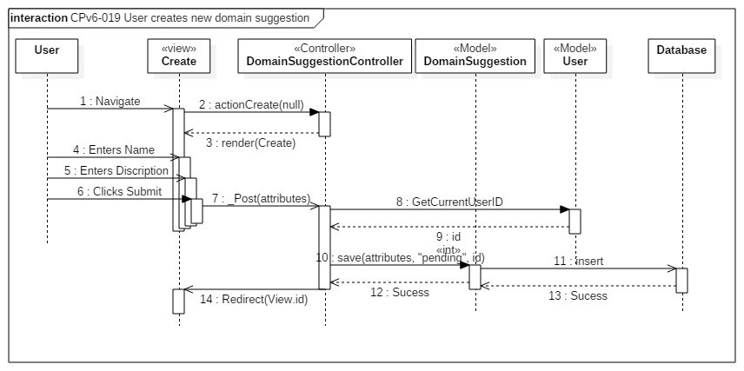AD.19 User creates new domain suggestion Sequence Diagram

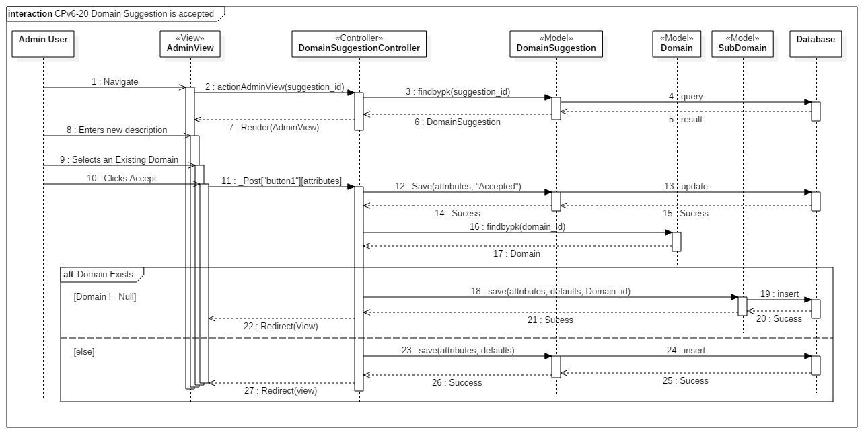AD.20 Domain Suggestion is accepted Sequence Diagram

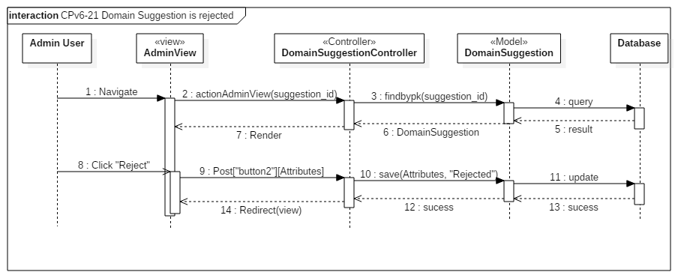AD.21 Domain Suggestion is rejected Sequence Diagram

New Process when selecting a mentor for a new ticket:

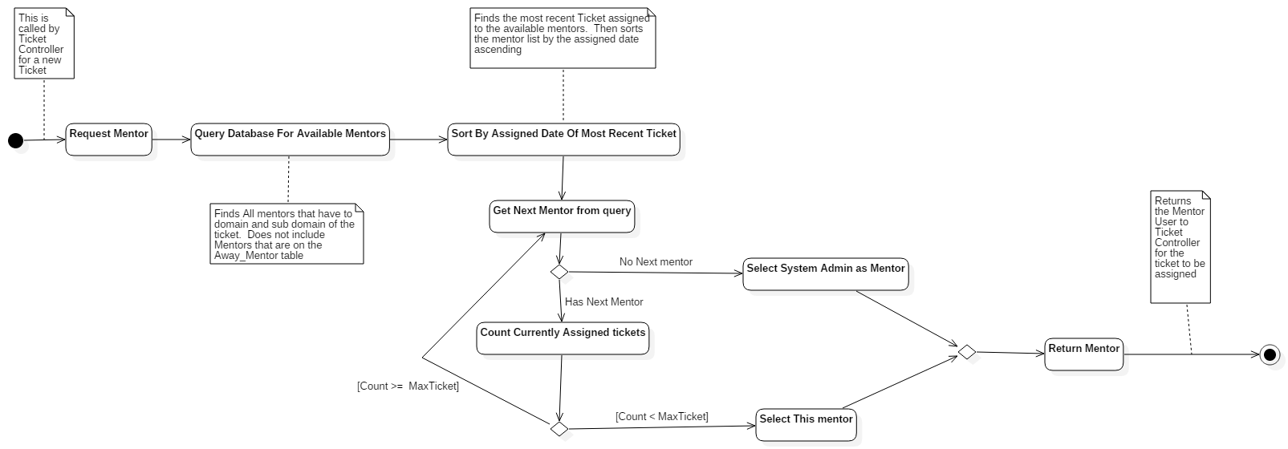AD.22 New Process when selecting a mentor for a new ticket

New Process when selecting a mentor for a ticket that’s being reassigned

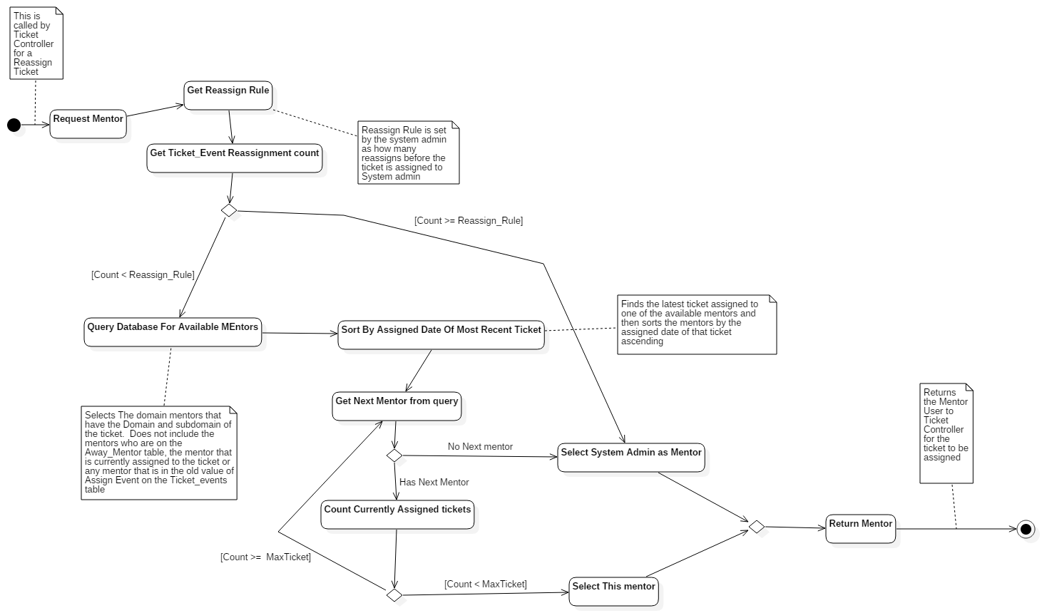

AD.23 New Process when selecting a mentor for a ticket that’s being reassigned

Previous Versions Dynamic Models

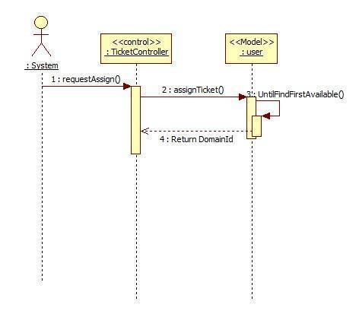

AD.24 Auto Assign Ticket

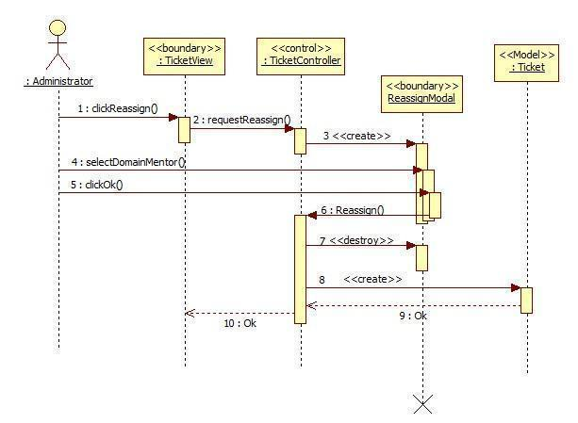

AD.25 MP-Reassign Ticket

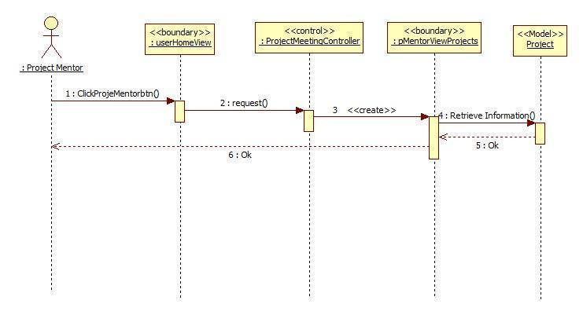

AD.26 MP-Retrieve the project information

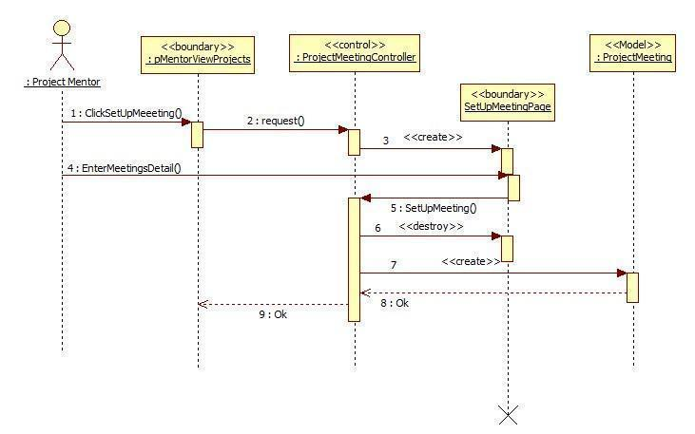

AD.27 MP-Setup Meetings

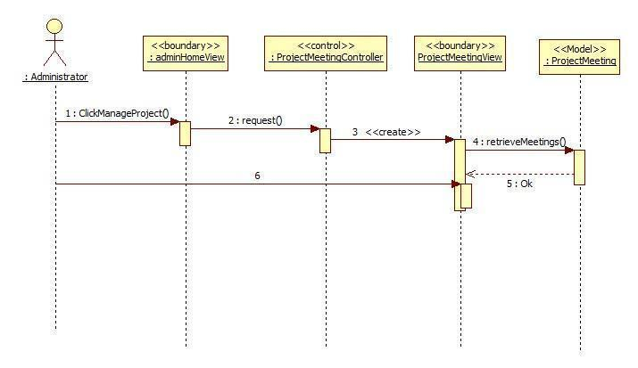

AD.28 MP-Retrieve all the upcoming meetings

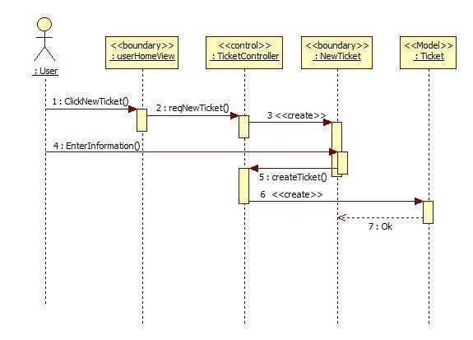

AD.29 MP-Reassign Ticket

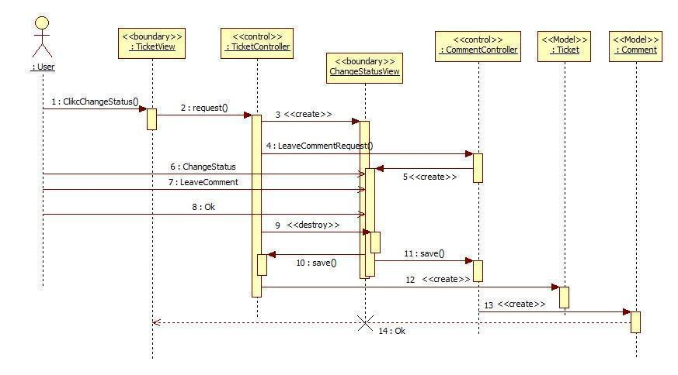

AD.30 MP-Change Status

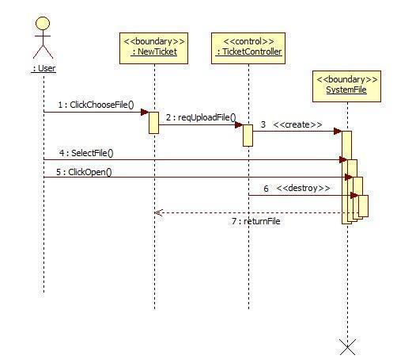

AD.31 MP-Upload File

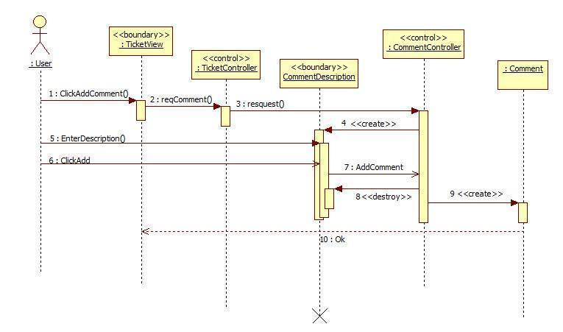

AD.32 MP-Append Comment

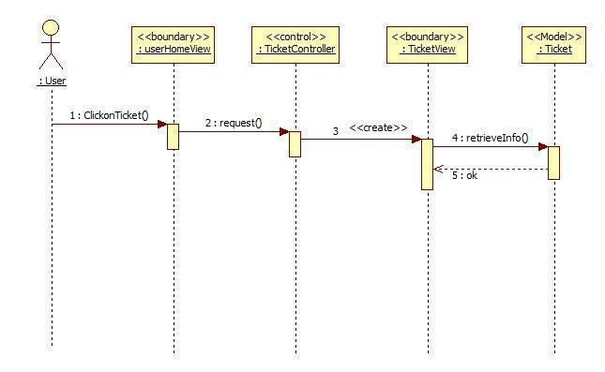

AD.33 MP-Retrieve the ticket detail

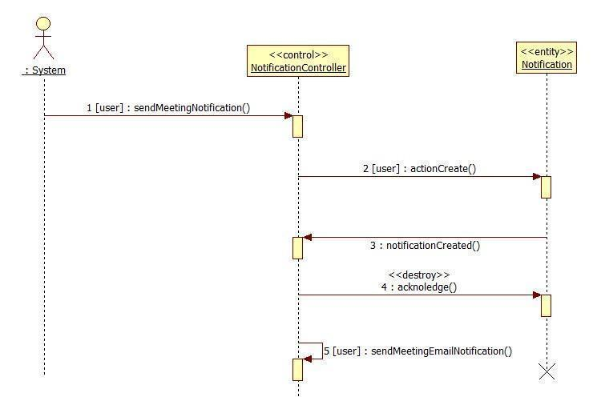

AD.34 New Meeting Notification

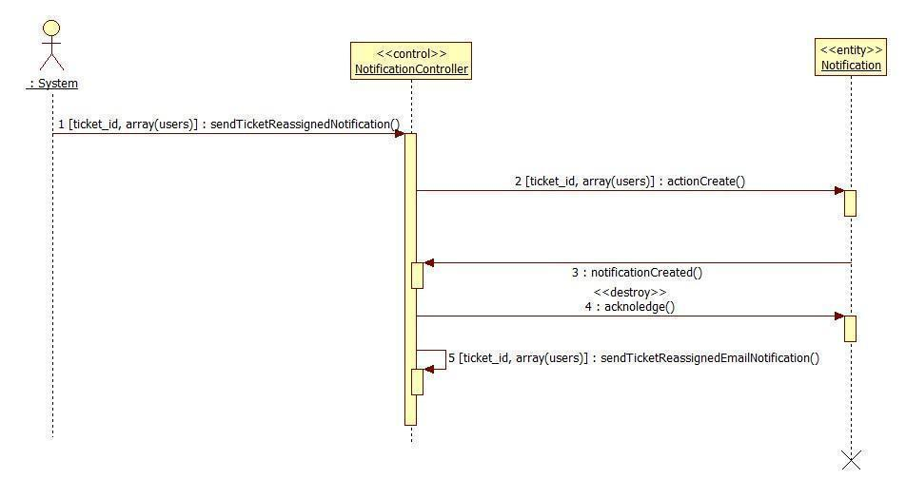

AD.35 Ticket Reassigned Notification

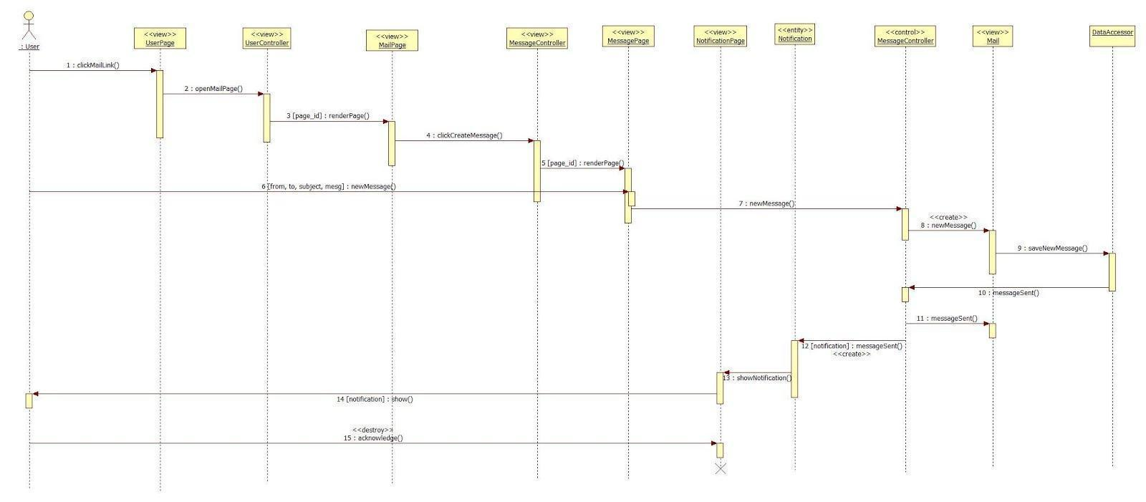

AD.36 Send New Message

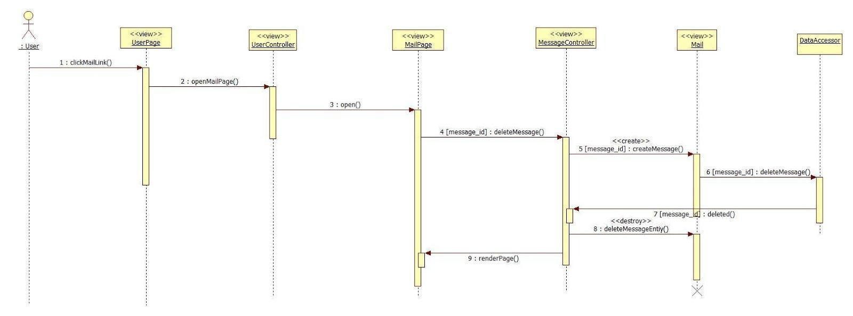

AD.37 Delete Message

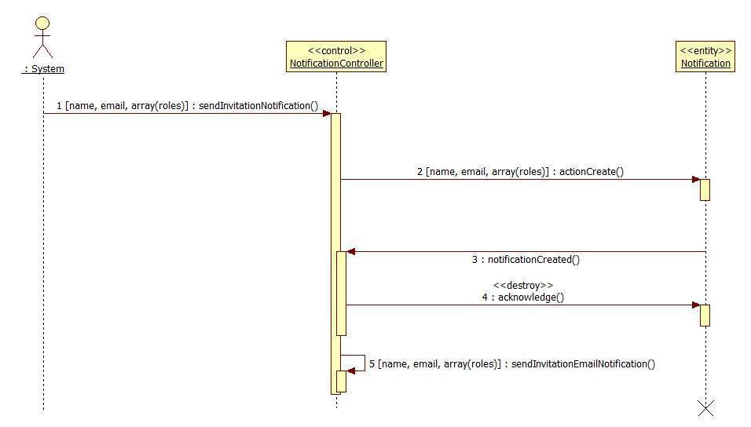

AD.38 Invitation Notification

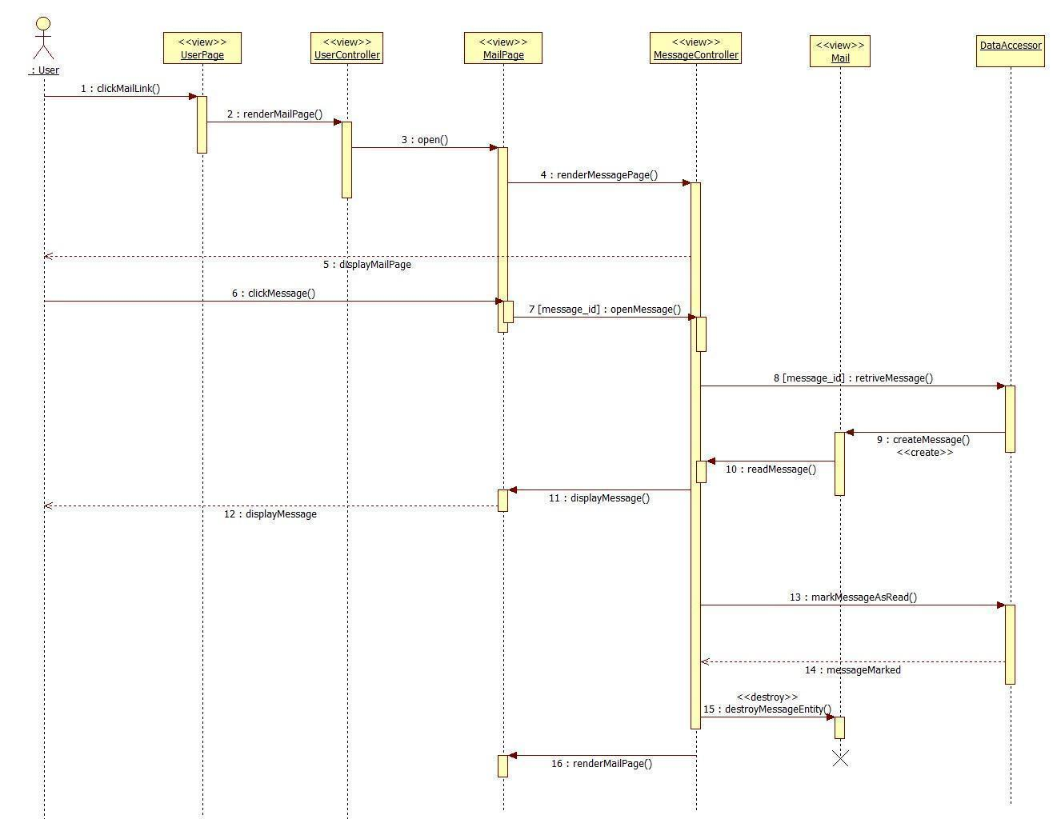

AD.39 Read Message

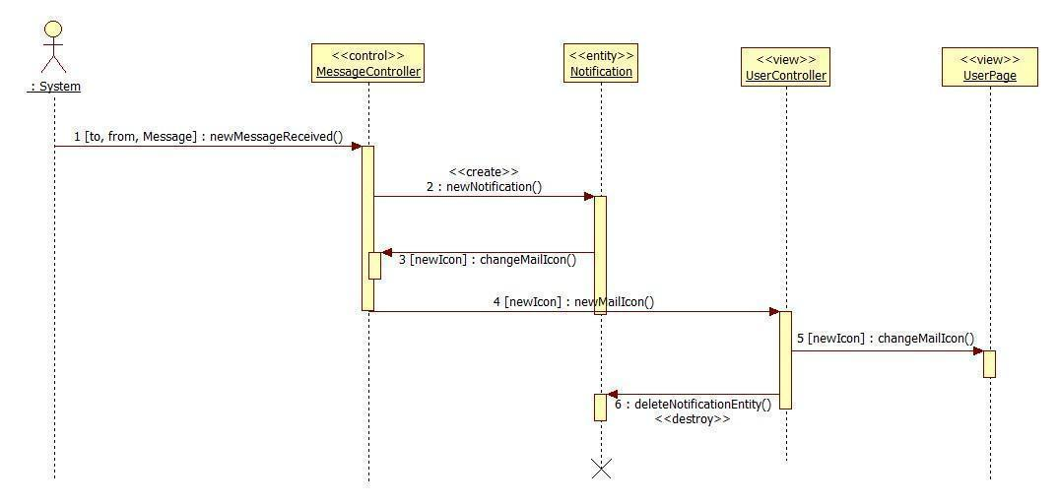

AD.40 New Message Notification

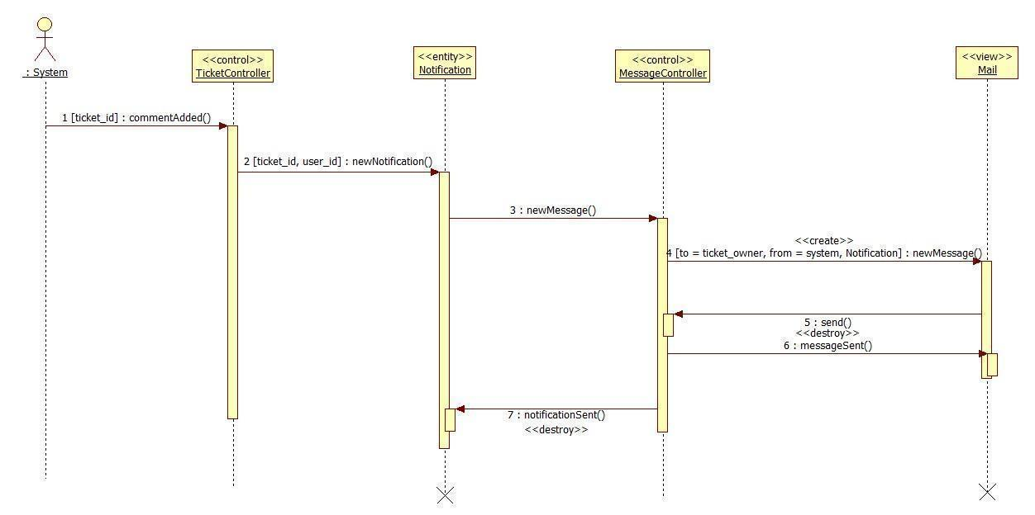

AD.41 Comment Added Notification

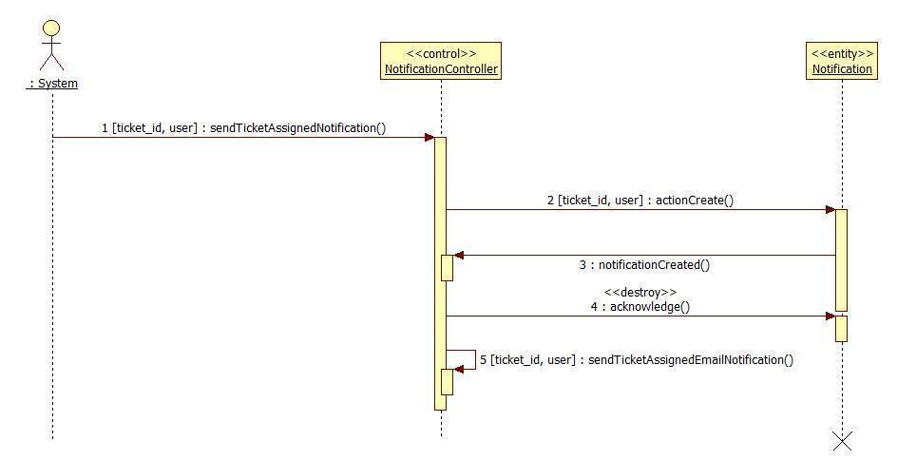

AD.42 Ticket Assigned Notification

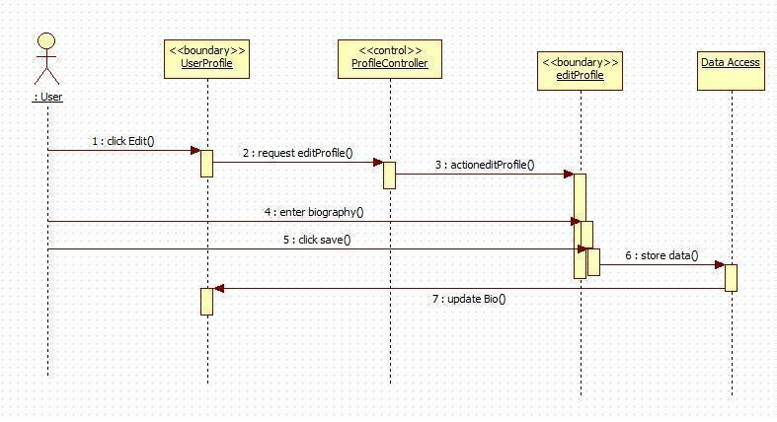

AD.43 Edit Biography

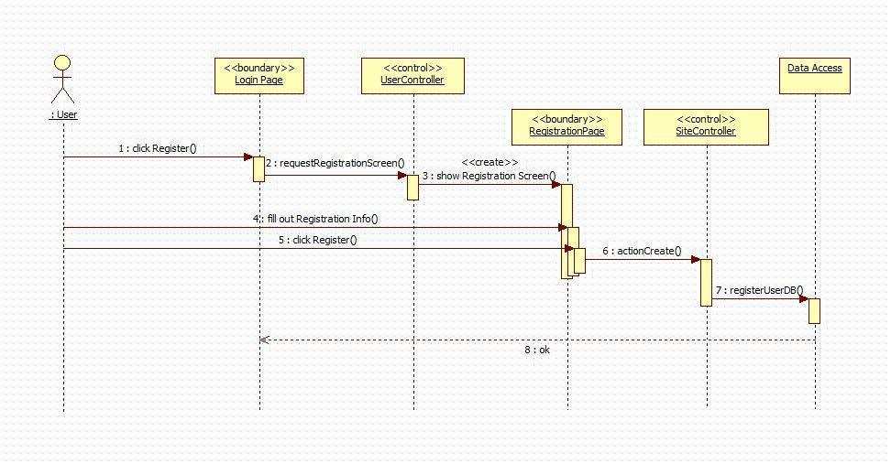

AD.44 Register

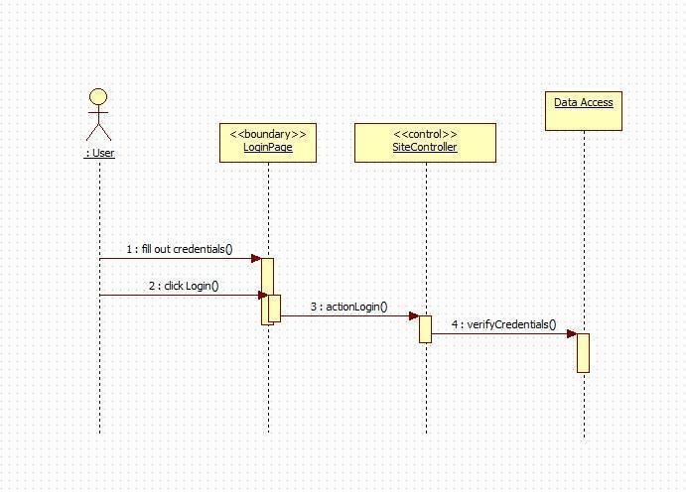

AD.45 Login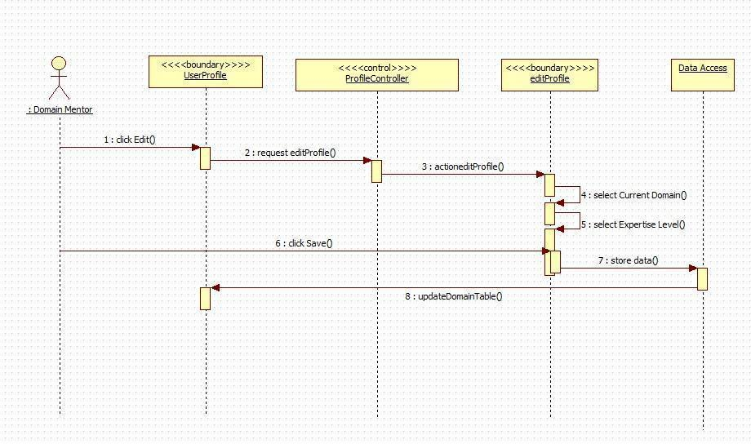

AD.46 Add Domain

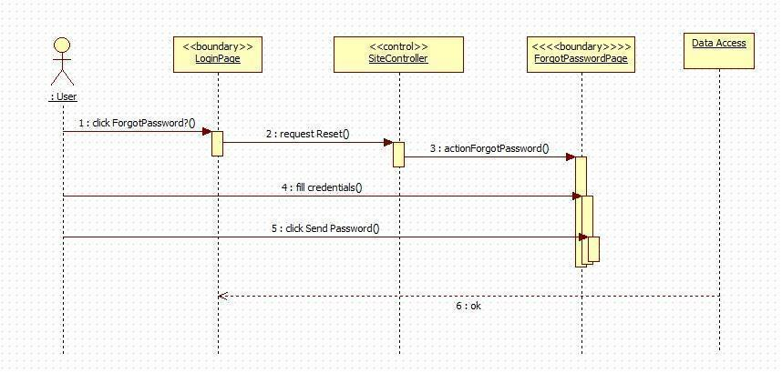

AD.47 Forgot Password

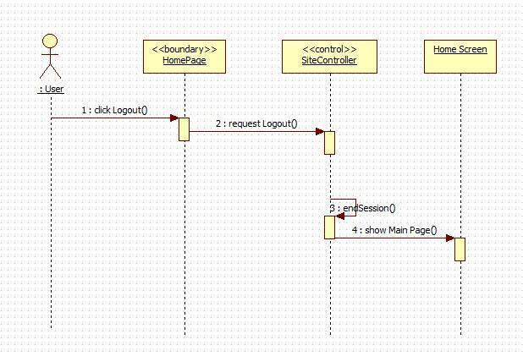

AD.48 Logout

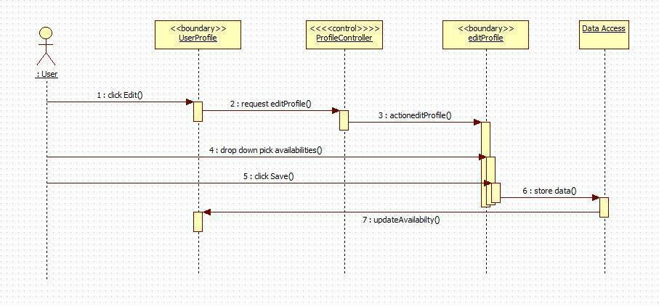

AD.49 Edit Availability

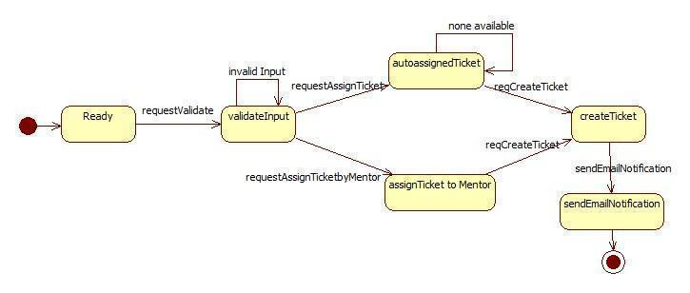

AD.50 Create Ticket

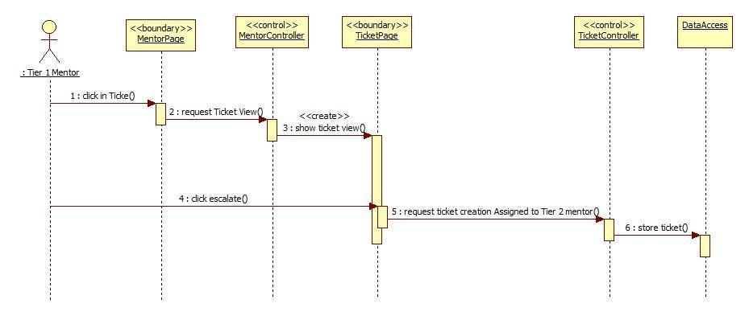

AD.51 MP- Escalate Ticket

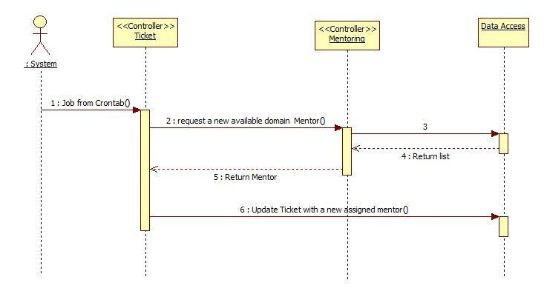

AD.52 MP-Automatically reassign ticket

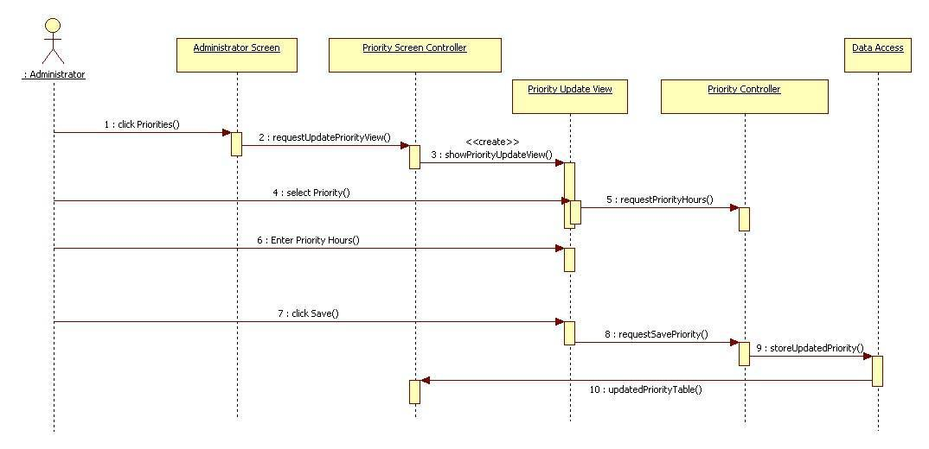

AD.53 MP – Edit Priority

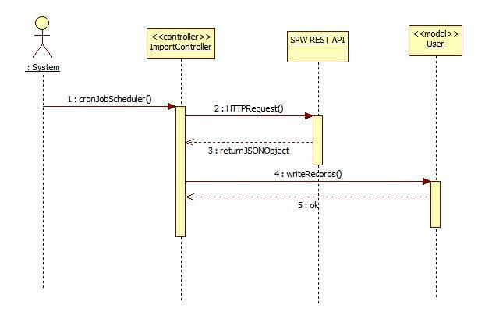

AD.54 MP-Import data from SPW automatically

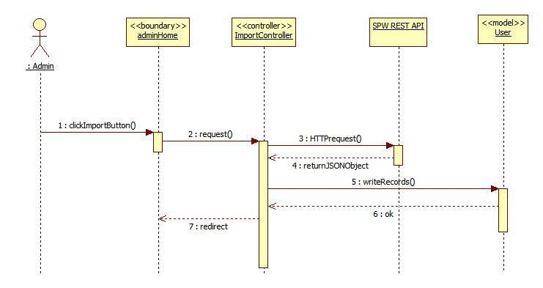AD.55 MP-Import data from SPW Manually

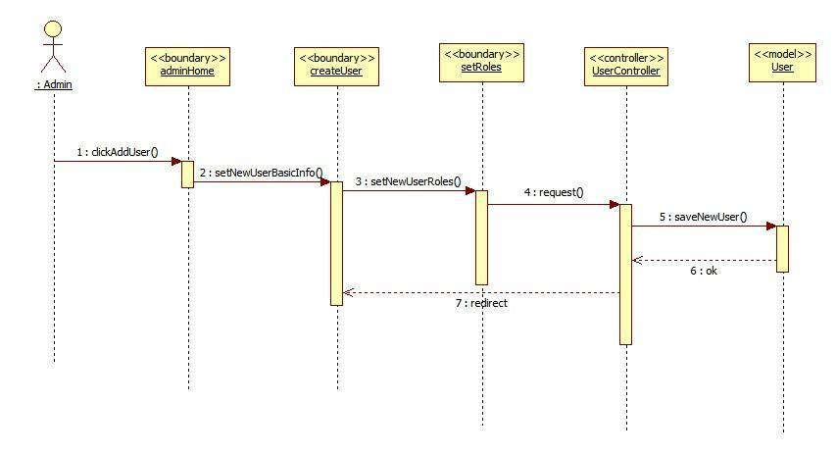AD.56 MP-Allow the admin to register mentors

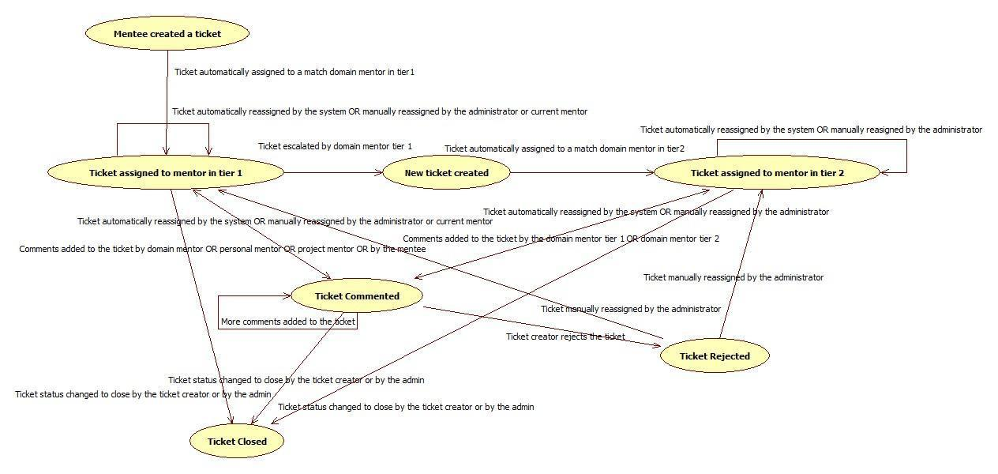AD.57 Workflow (Ticket)

**Mentoring Module: Version 3 - Sequence Diagrams**

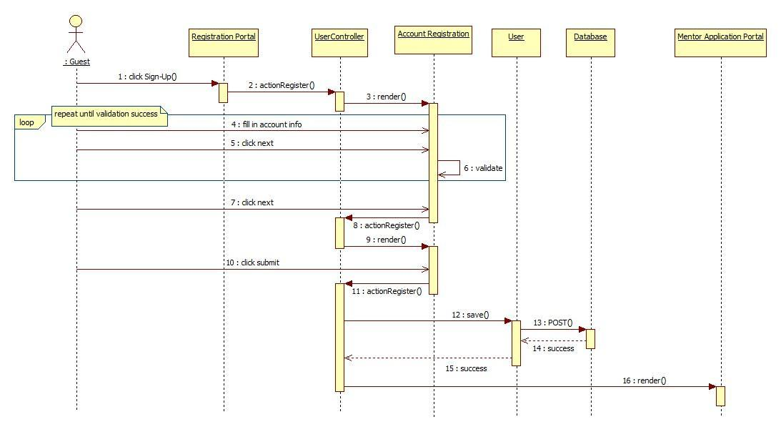

AD. 58 Self Registration for Collaborative Platform

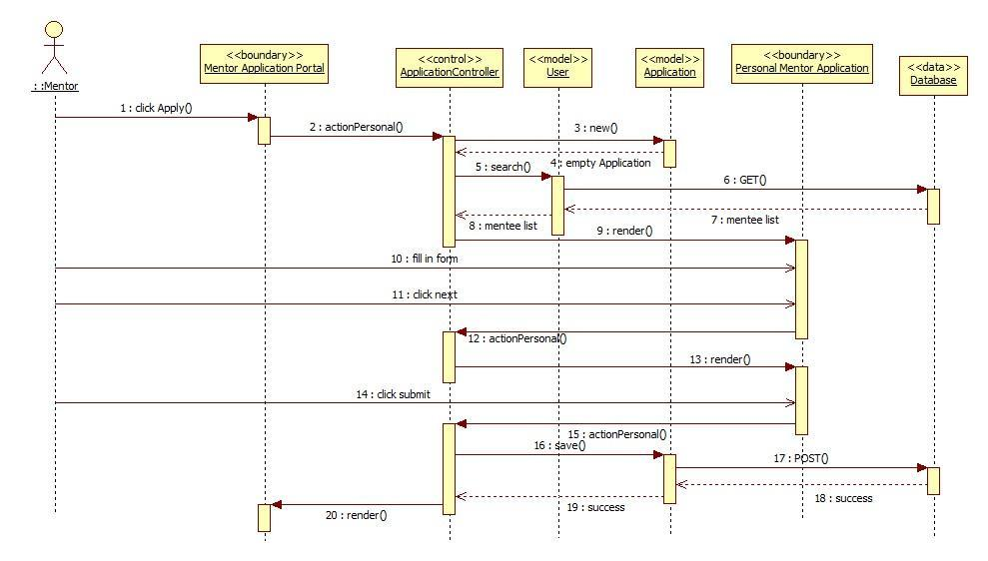AD. 59 Self Registration for Collaborative Platform

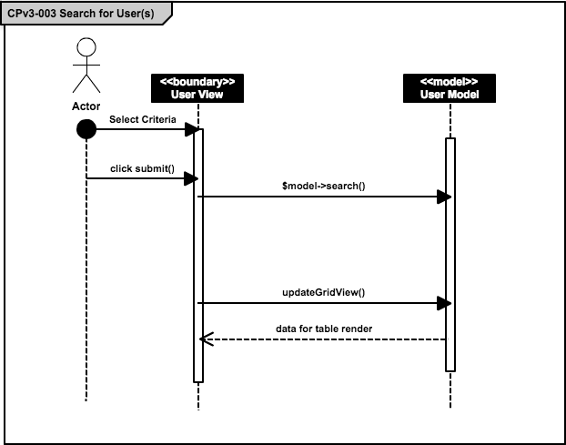

AD. 60 Search for User(s)

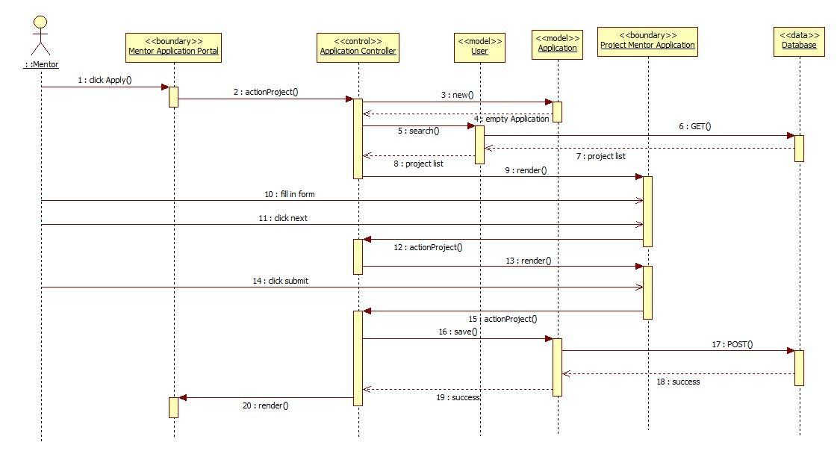AD. 61 Apply for Project Mentorship

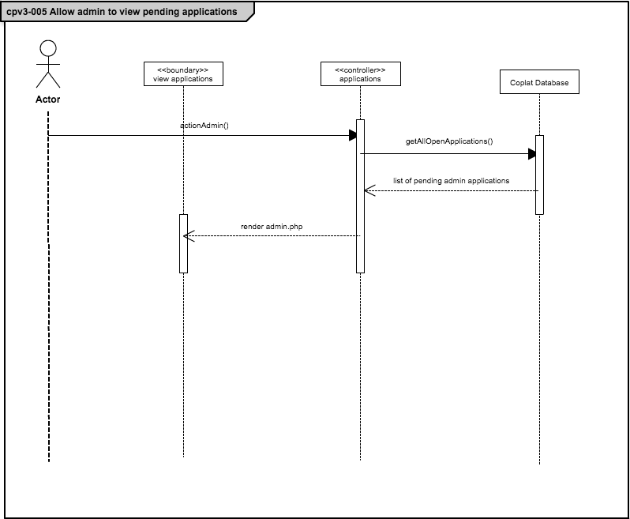

AD. 62 Allow admin to view pending applications

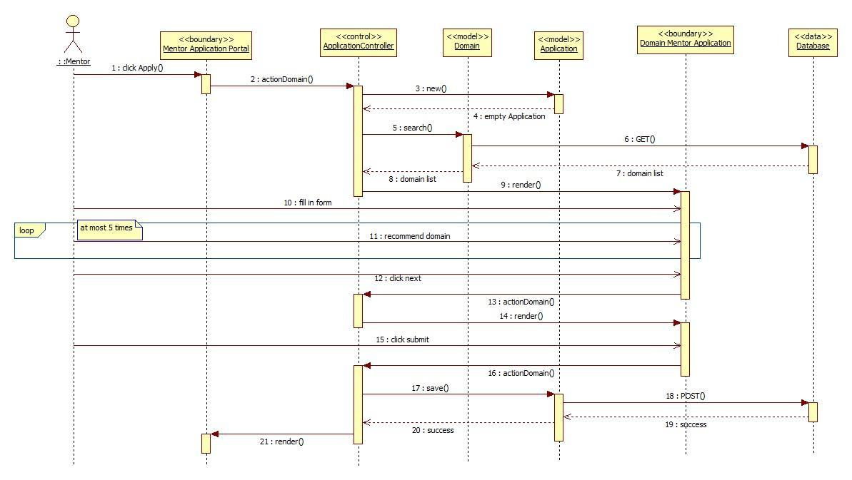

AD. 63 Apply for Domain Mentorship

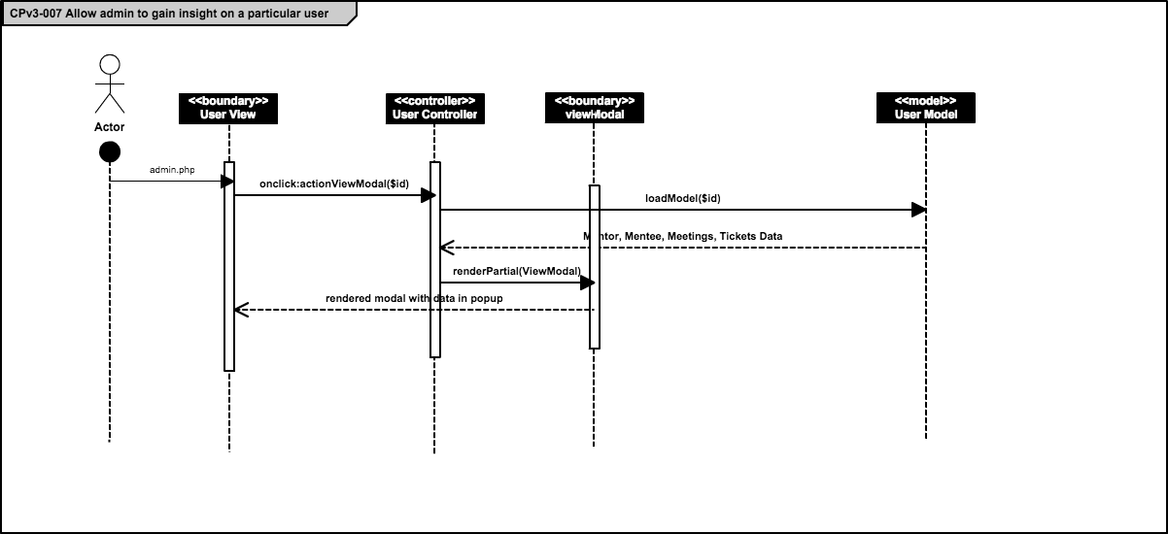AD. 64 Allow admin to gain insight on a particular user

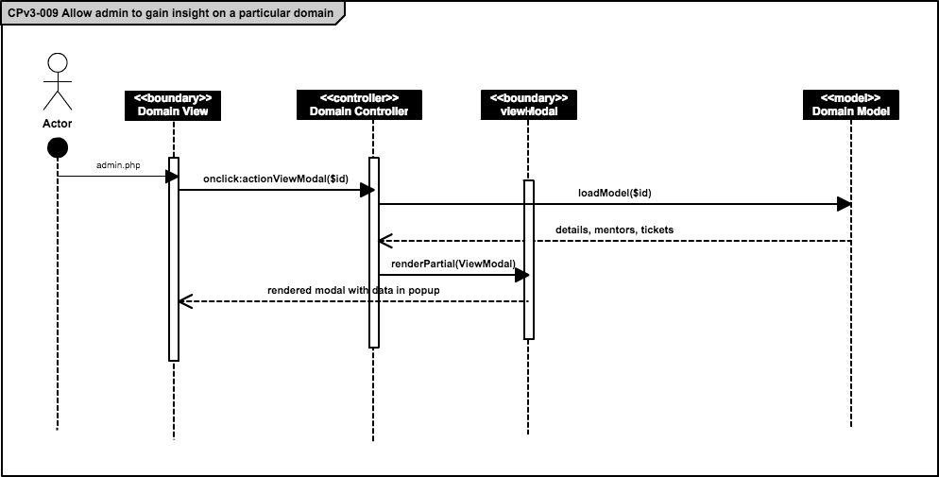

AD. 65 Allow admin to gain insight on a particular domain

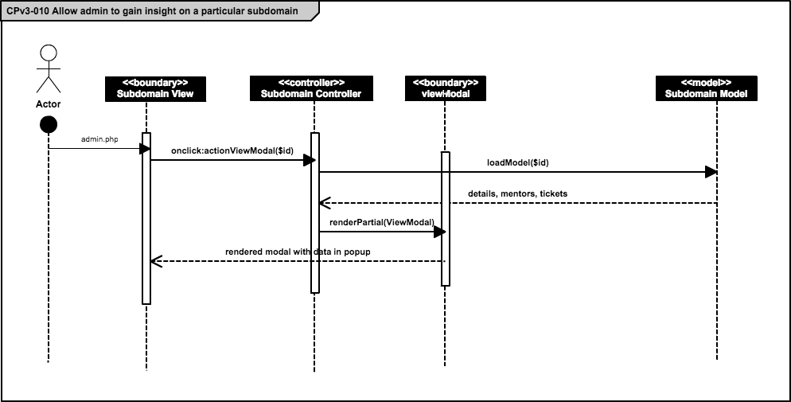AD. 66 Allow admin to gain insight on a particular subdomain

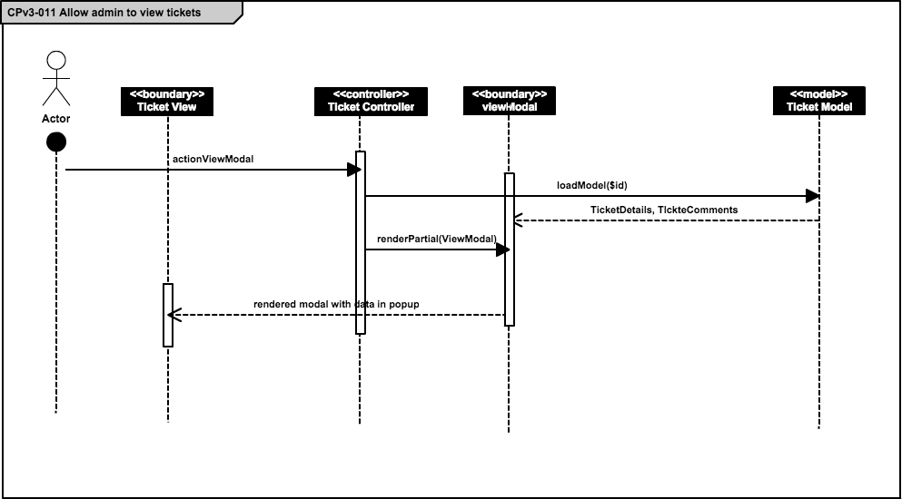

AD. 67 Allow admin to view tickets

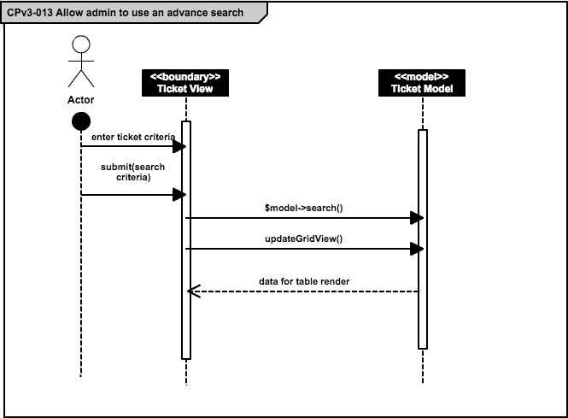AD. 68 Allow admin to use an advance search

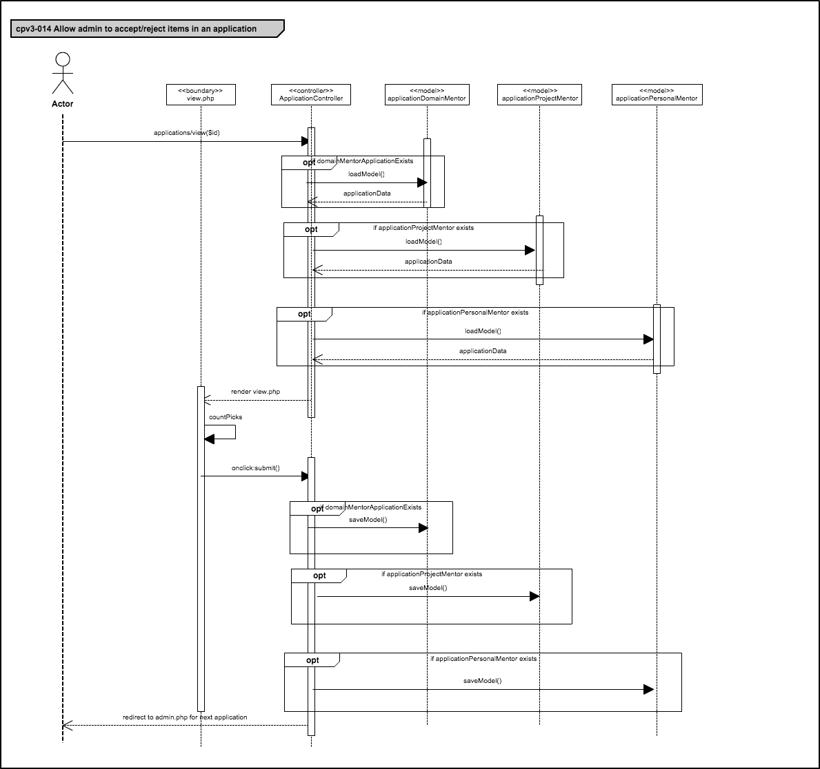

AD. 69 Allow admin to accept/reject items in an application

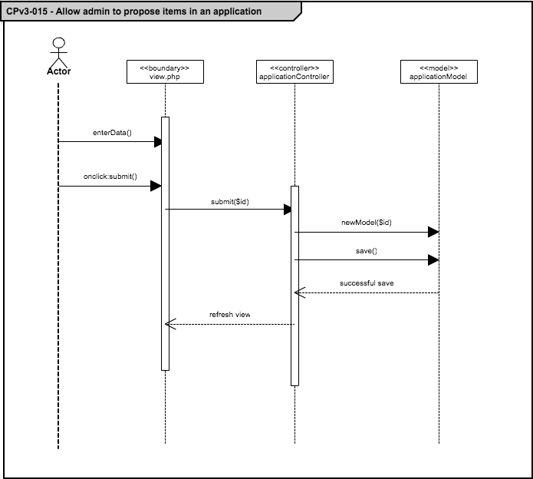

AD. 70 Allow admin to propose items in an application

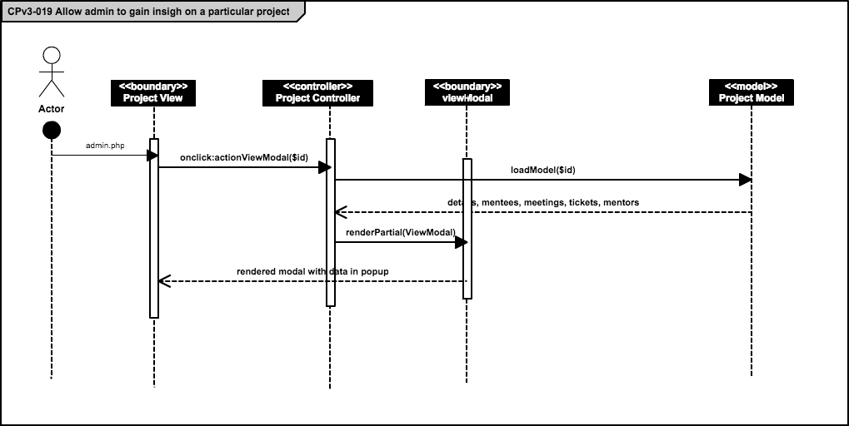AD. 71 Allow admin to gain insight on a particular project

**Mentoring Module: Version 5 - Sequence Diagrams**

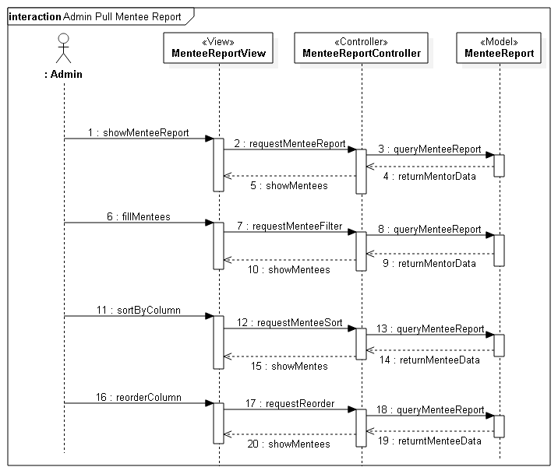AD. 72 Admin pull mentee report

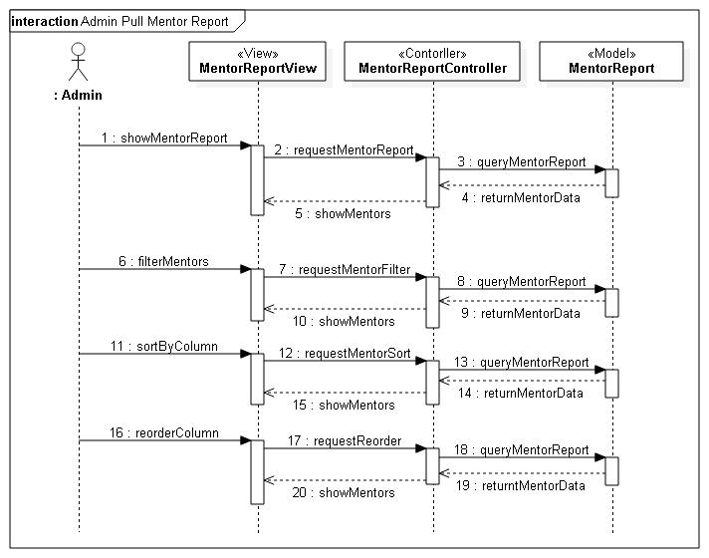AD. 73 Admin pull mentor report

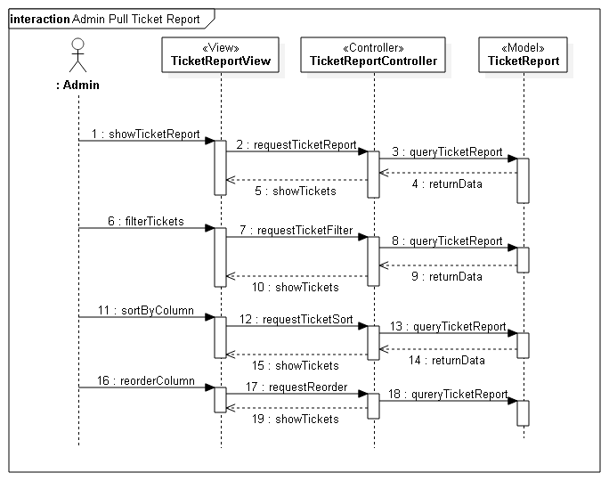AD. 74 Admin pull ticket report

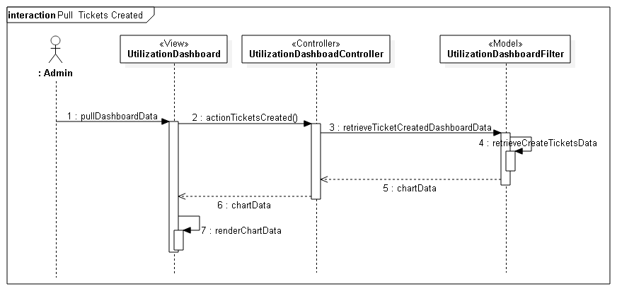AD. 75 Pull tickets created

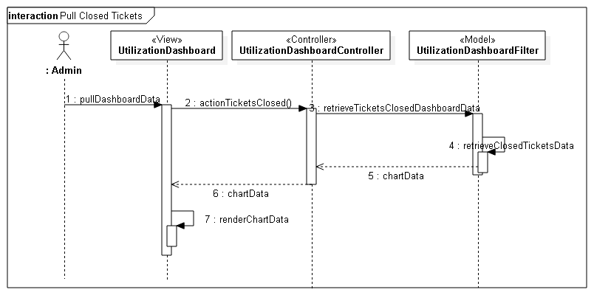AD. 76 Pull closed tickets

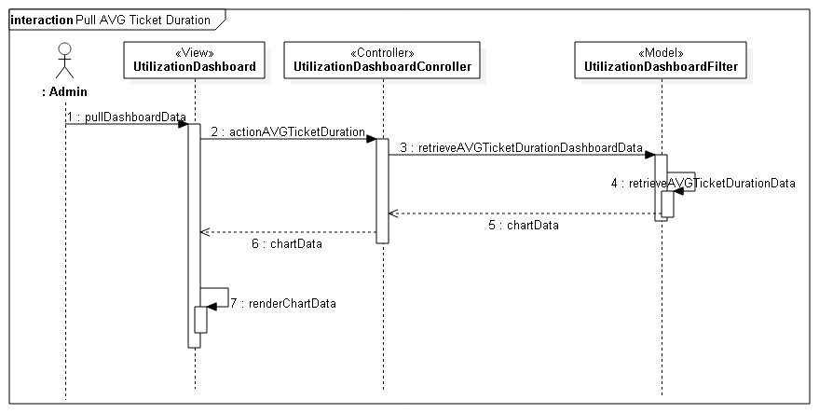AD. 77 Pull Avg ticket duration

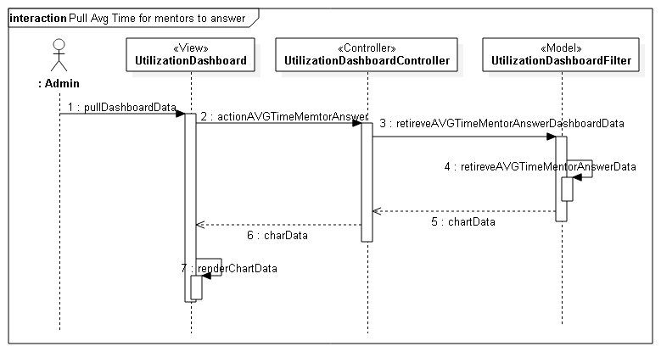AD. 78 Pull Avg time for mentors to answer

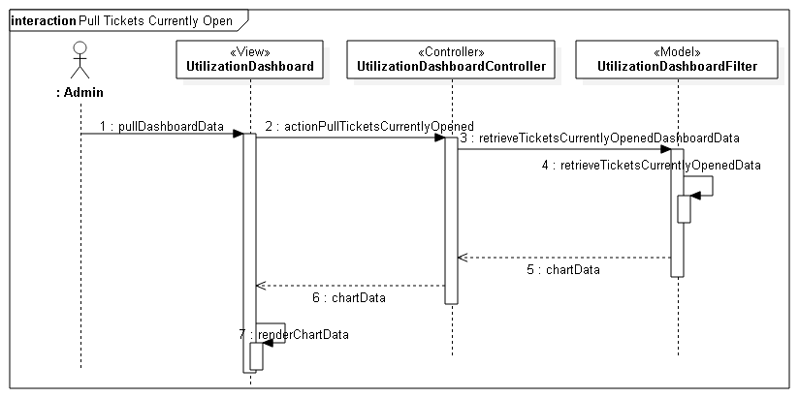AD. 79 Pull tickets currently open

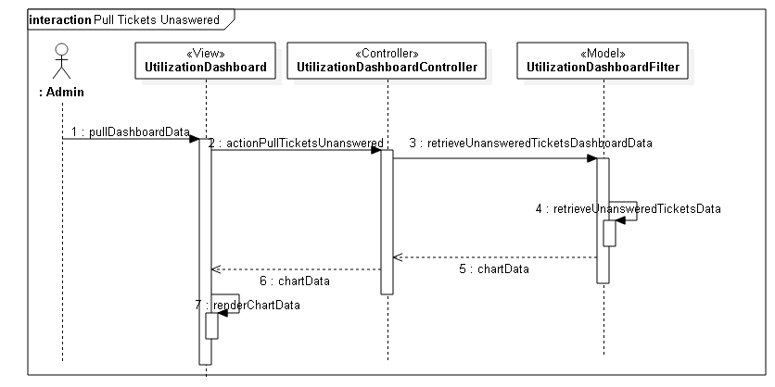AD. 80 Pull tickets unanswered

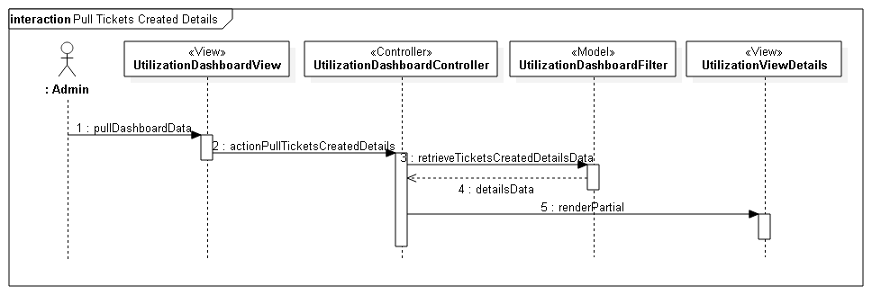AD. 81 Pull tickets created details

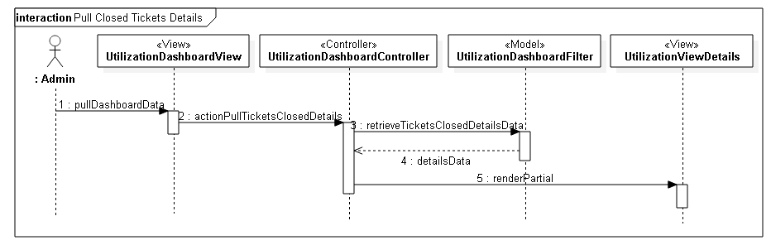AD. 82 Pull closed ticket details

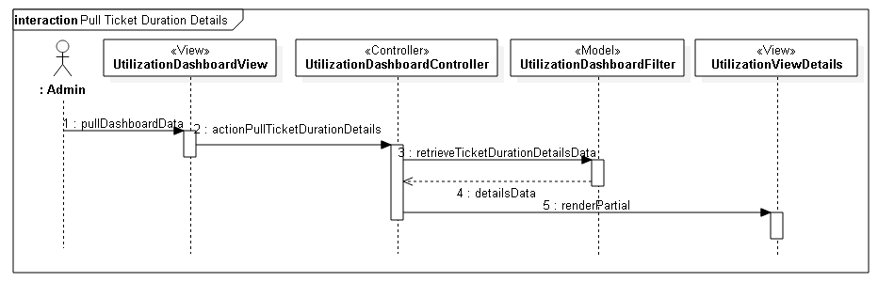AD. 83 Pull ticket duration details

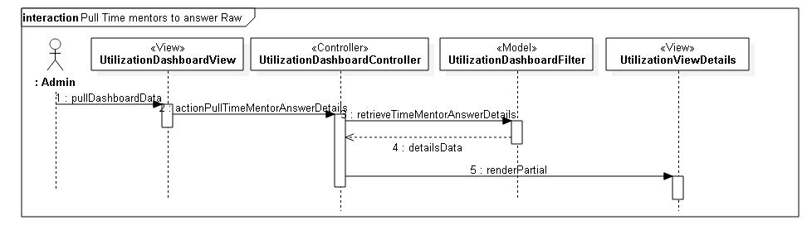AD. 84 Pull time mentors to answer raw

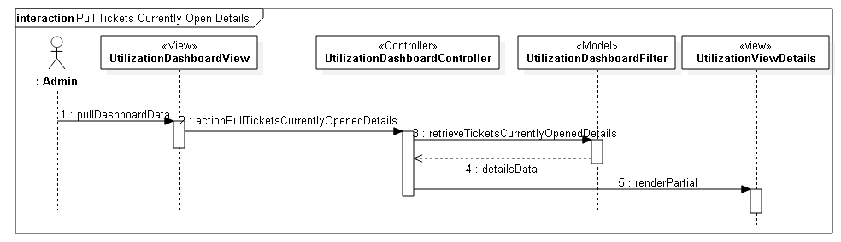AD. 85 Pull tickets currently open details

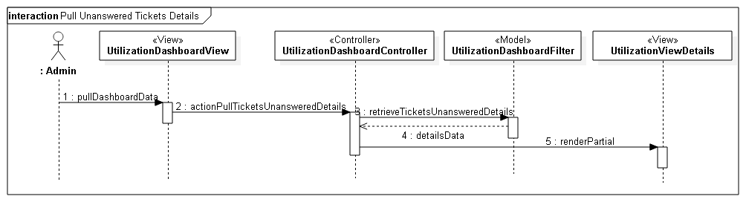AD. 86 Pull unanswered ticket details

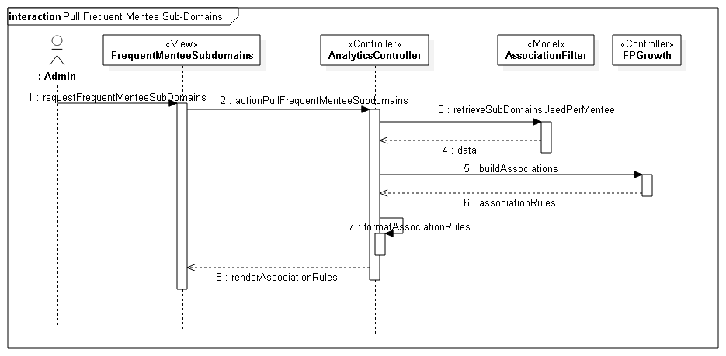

AD. 87 Pull frequent mentee sub-domains

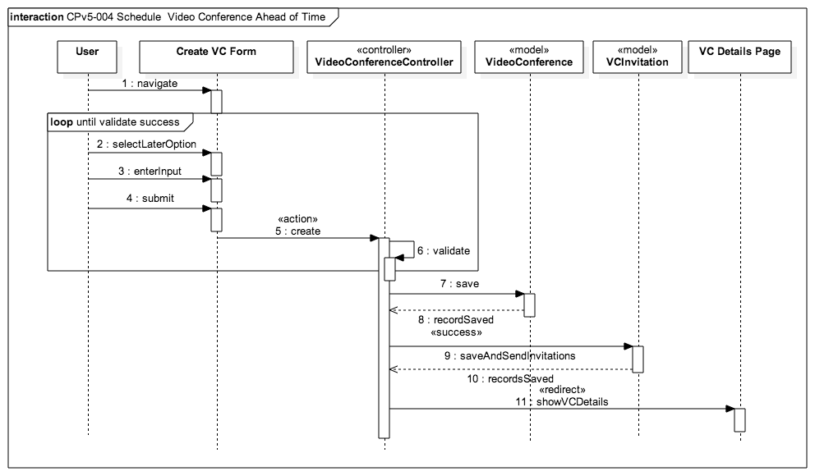AD. 88 Schedule a video conference ahead of time

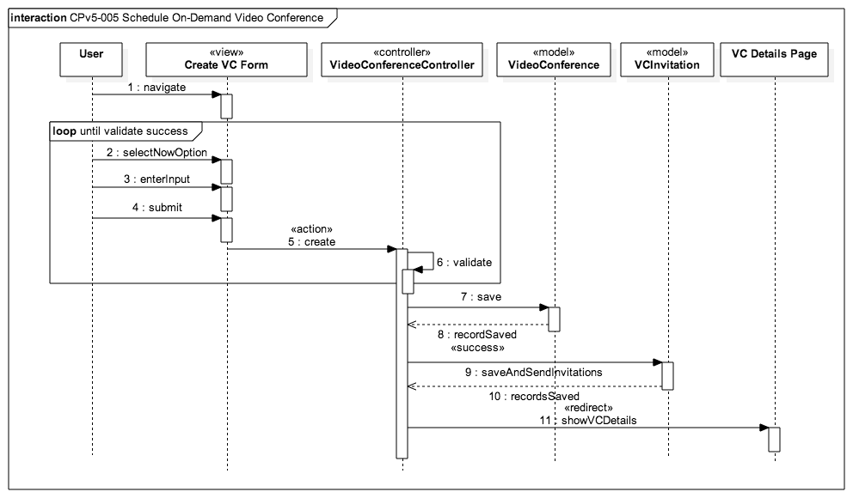AD. 89 Schedule on-demand video conference

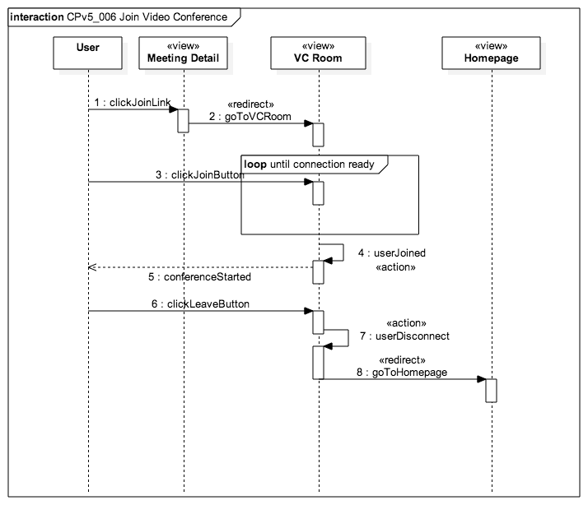

AD. 90 Join video conference

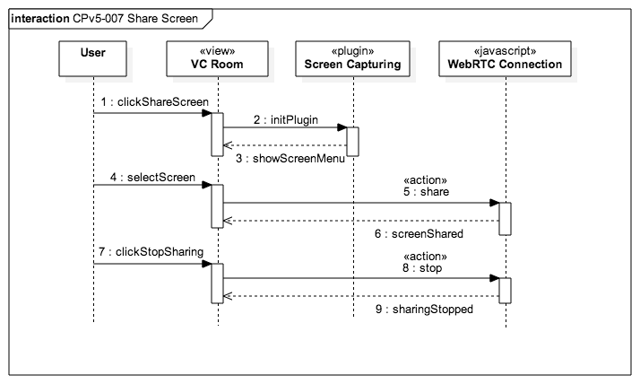AD. 91 Share screen

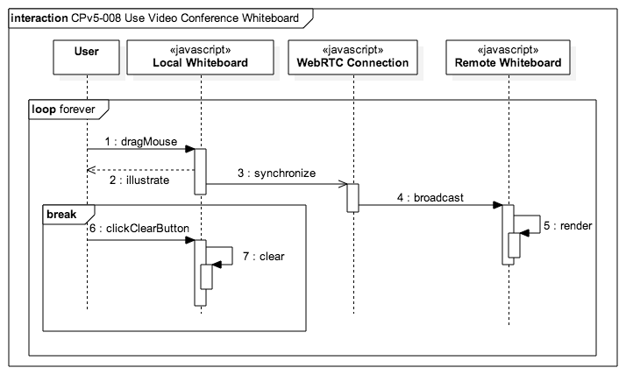AD. 92 use video conference whiteboard

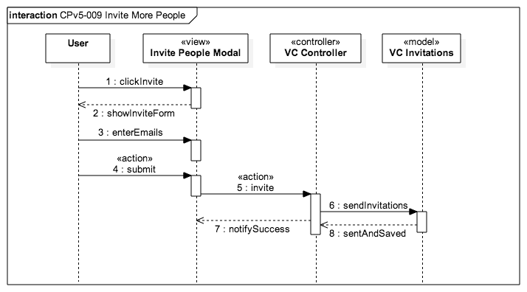AD. 93 Invite more people

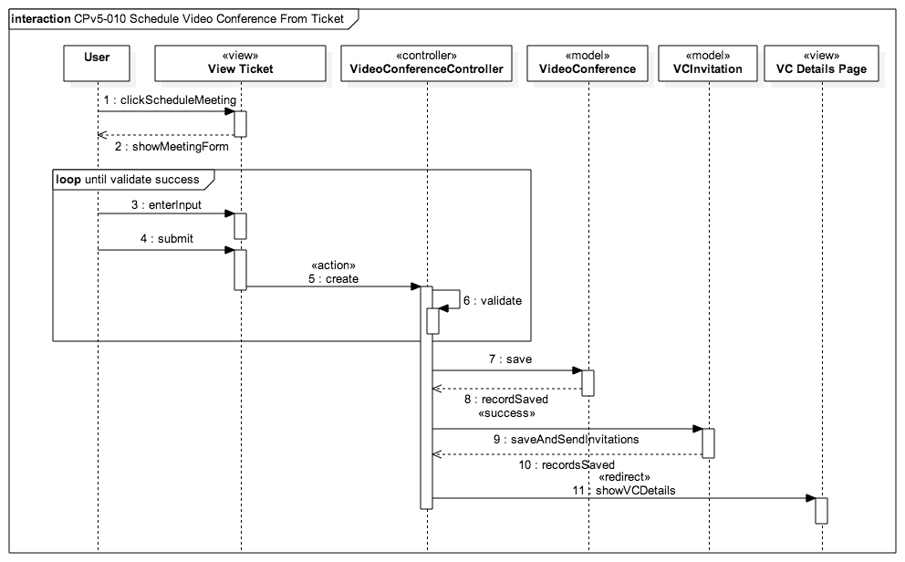AD. 94 Schedule video conference from ticket

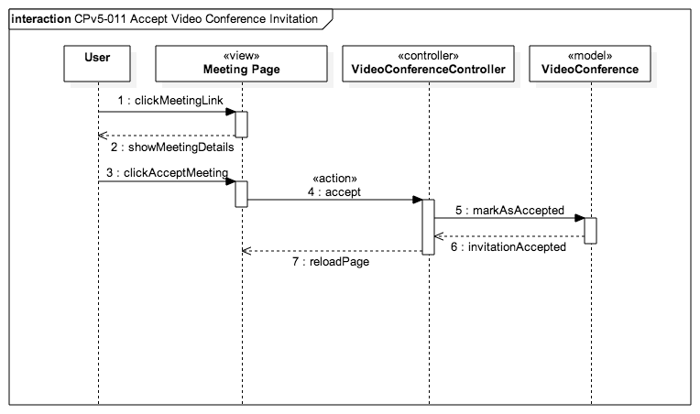AD. 95 Accept video conference invitation

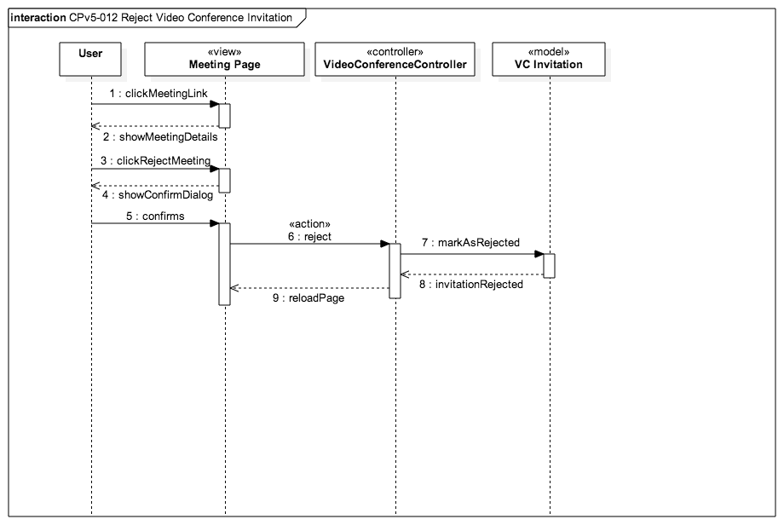AD. 96 Reject video conference invitation

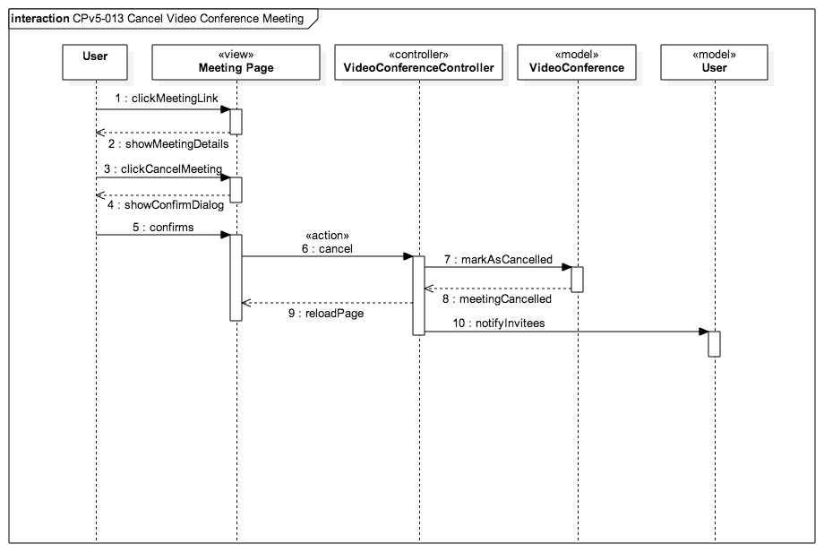AD. 97 Cancel video conference meeting

Appendix B - User Interface Design

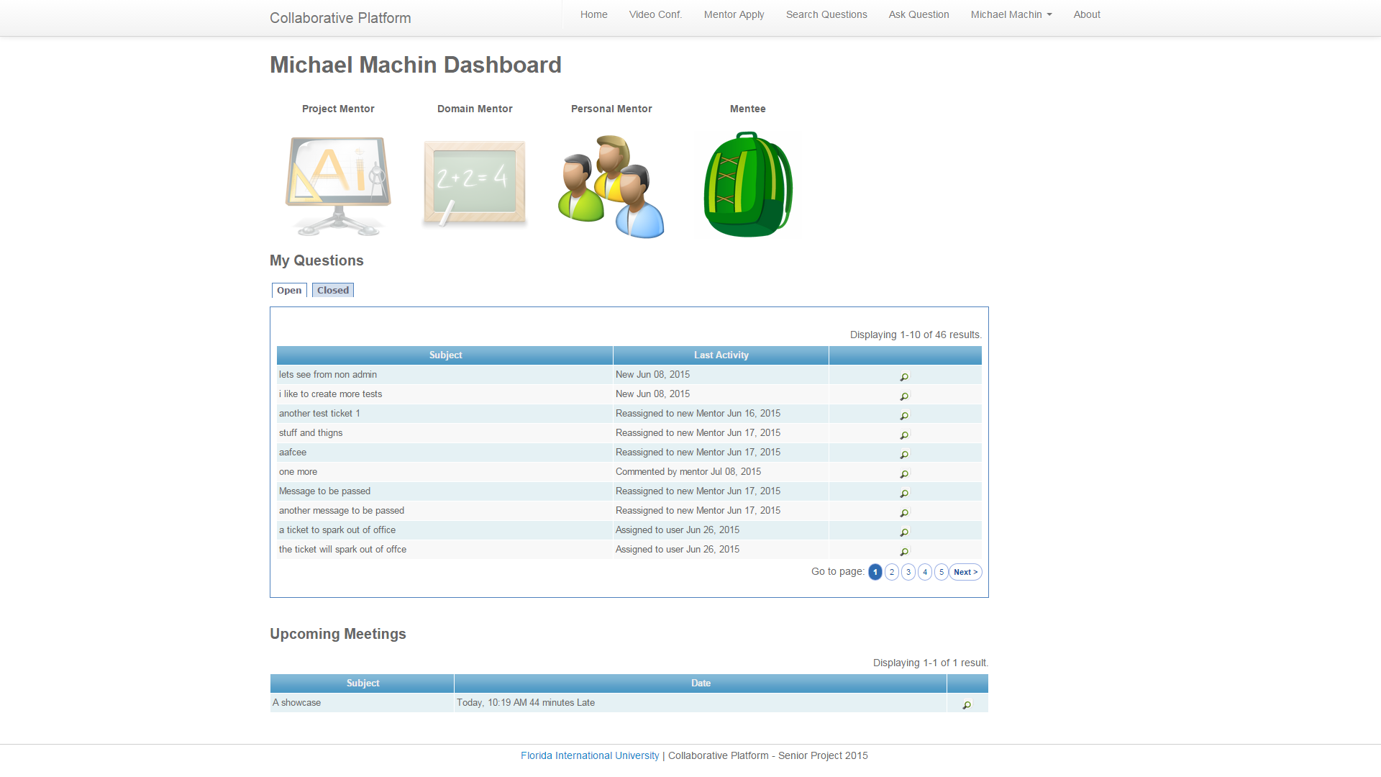

User Home page

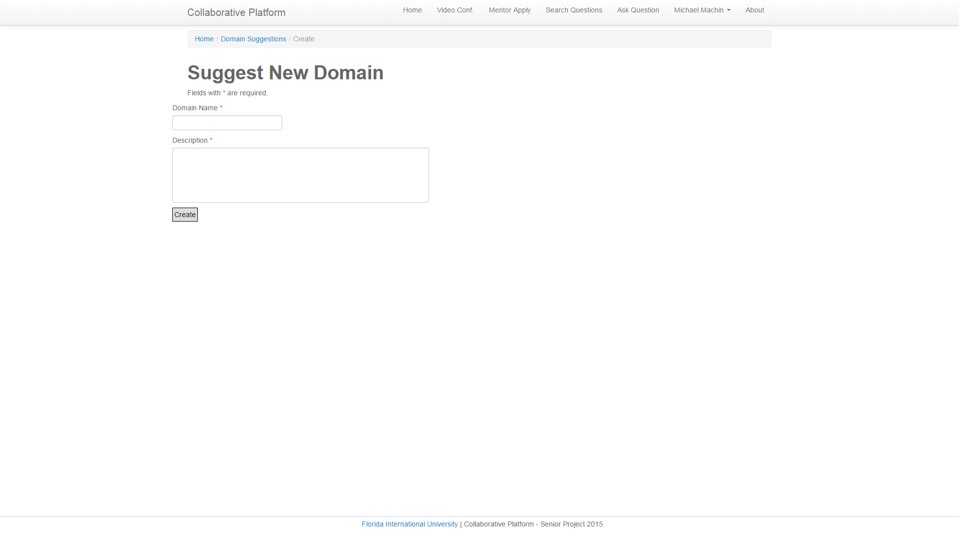Suggest new Domain page

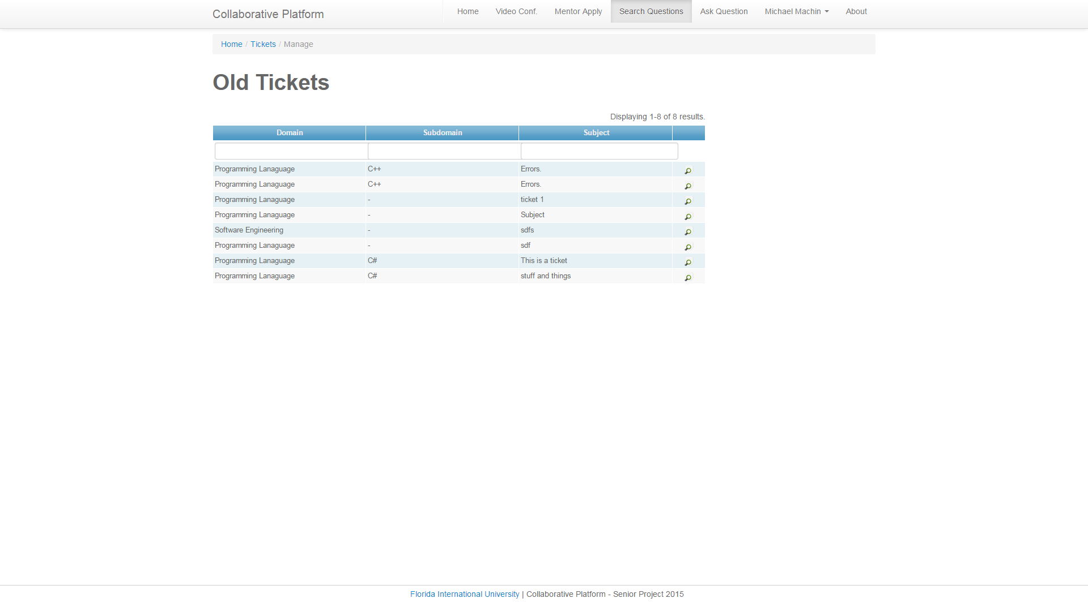

Search closed tickets page

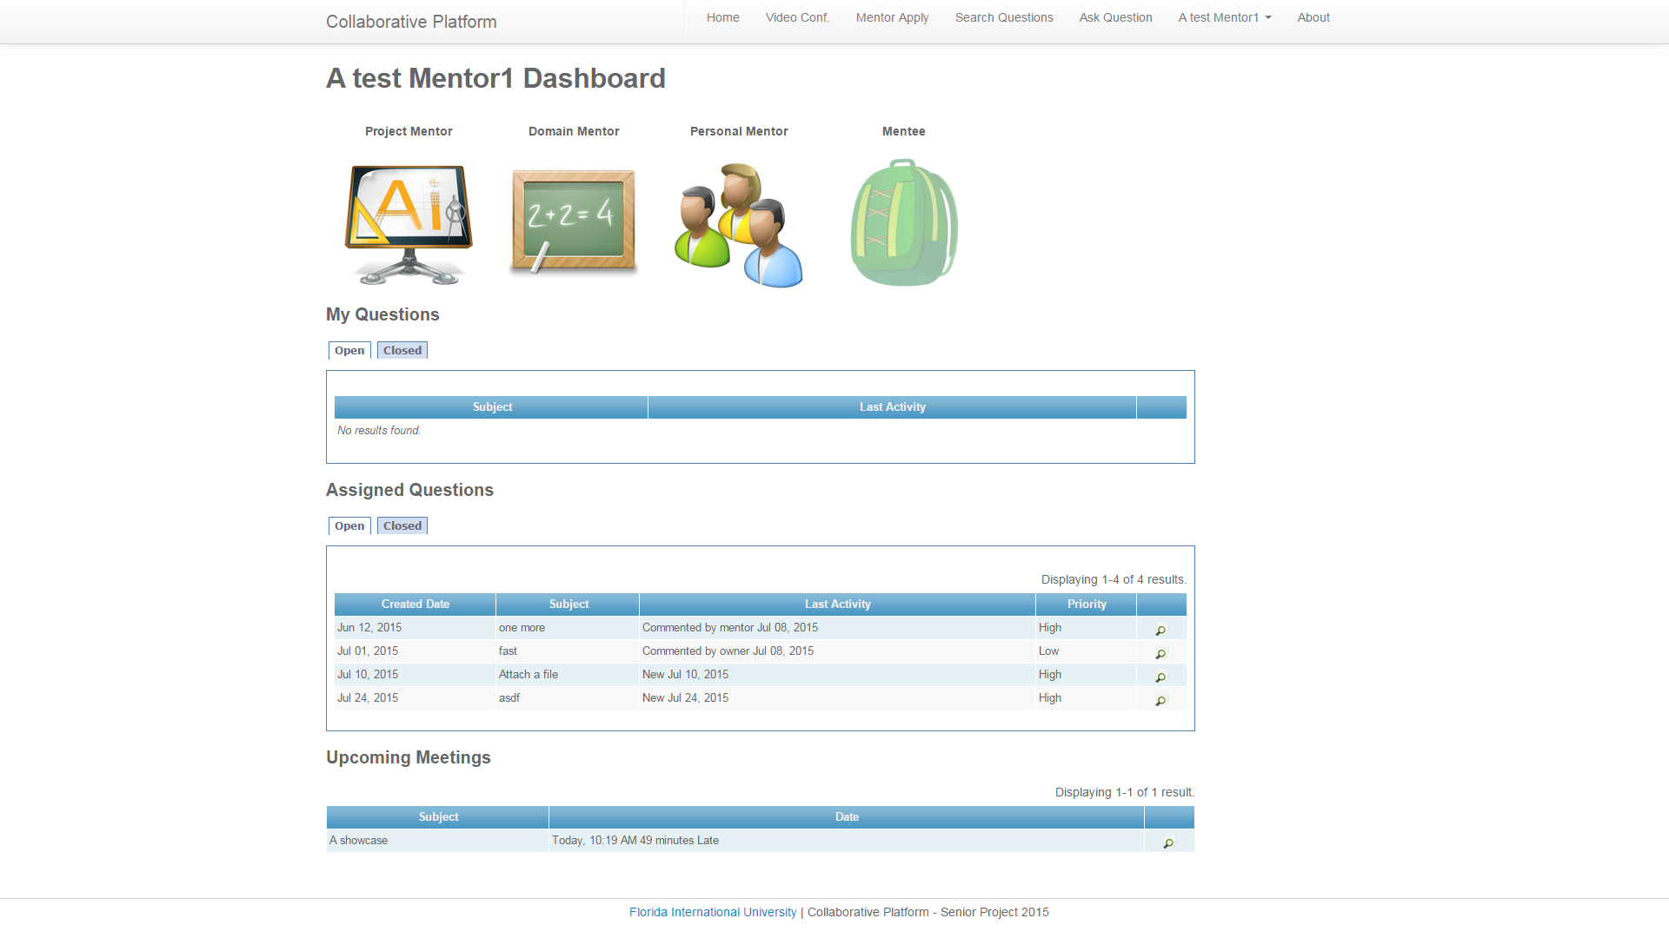

Domain Mentor Home Page

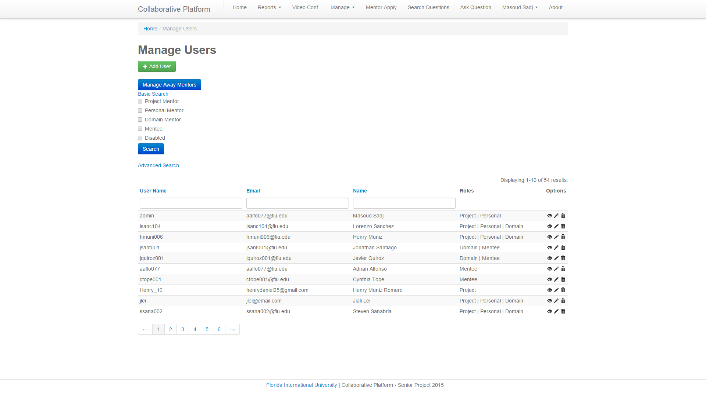

New manage users page

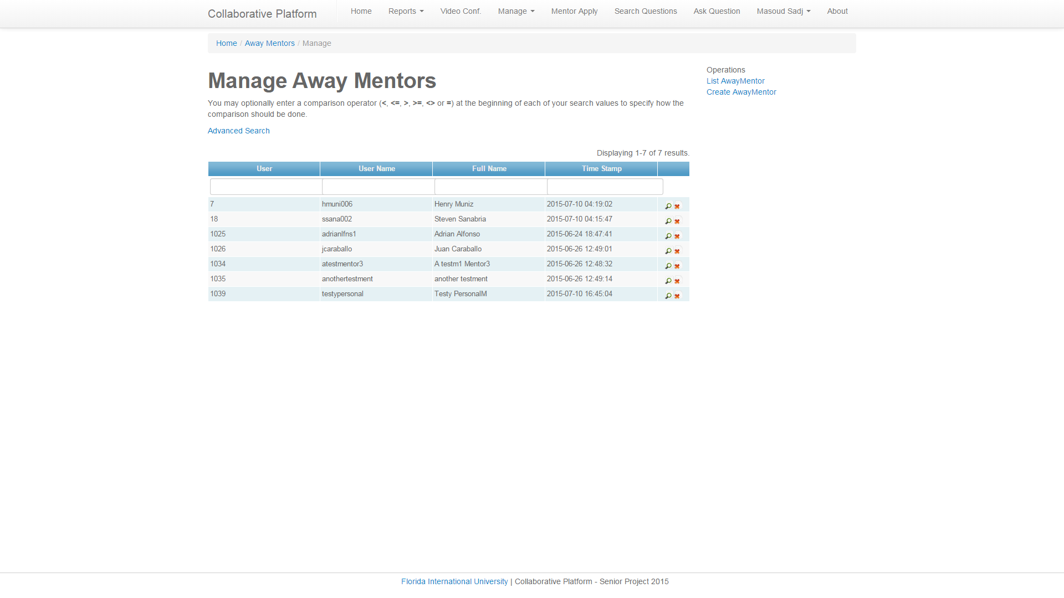

Manage Away Mentors Page

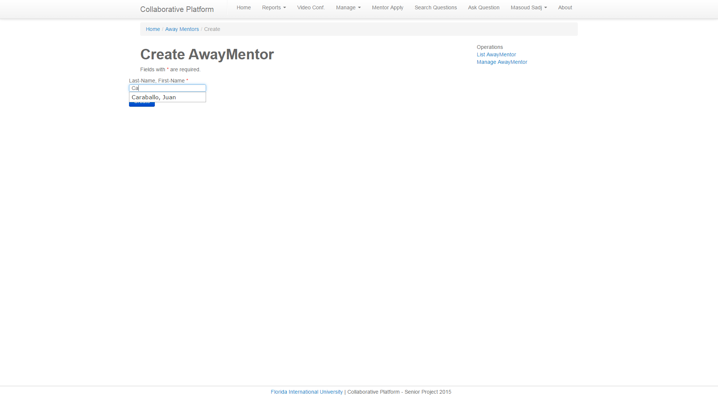

Create away mentors page, autocomplete

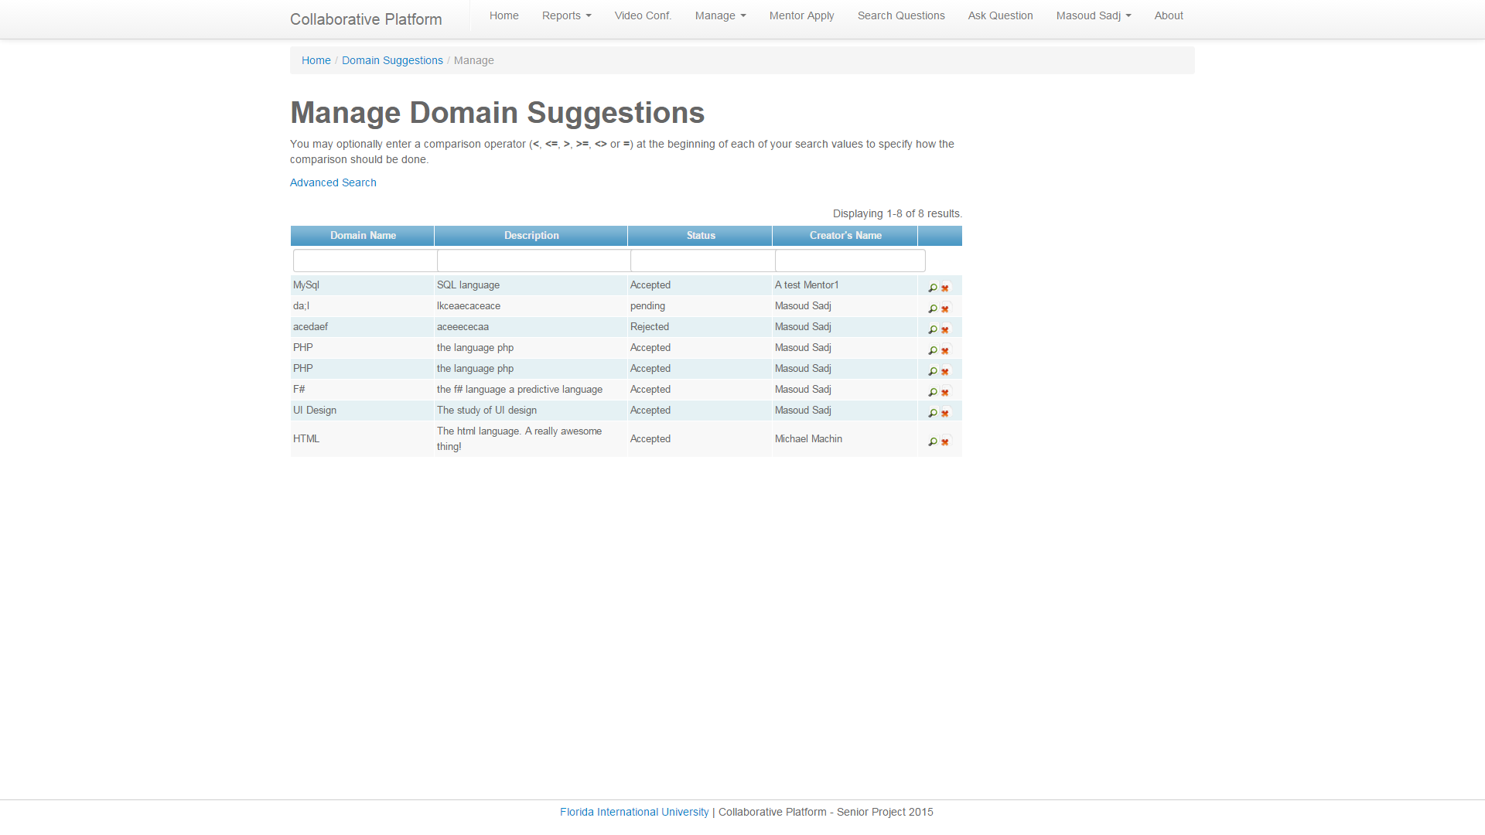

Manage Domain suggestions page

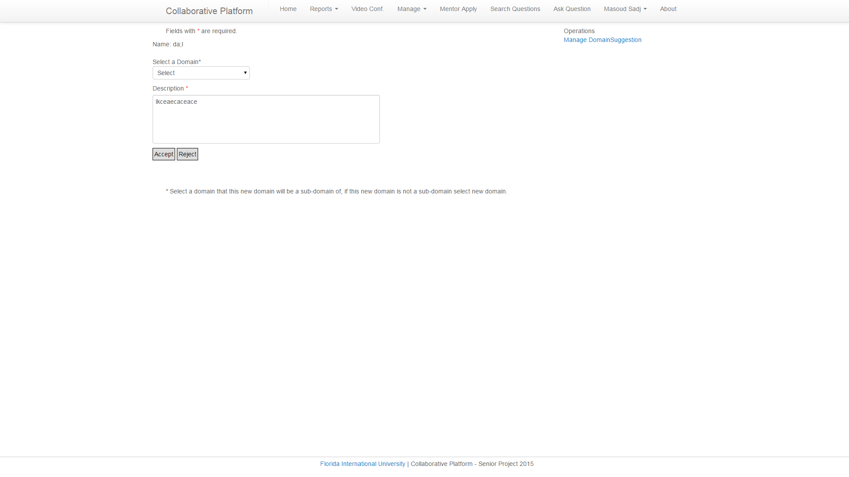

Accept/Reject Suggestion Page

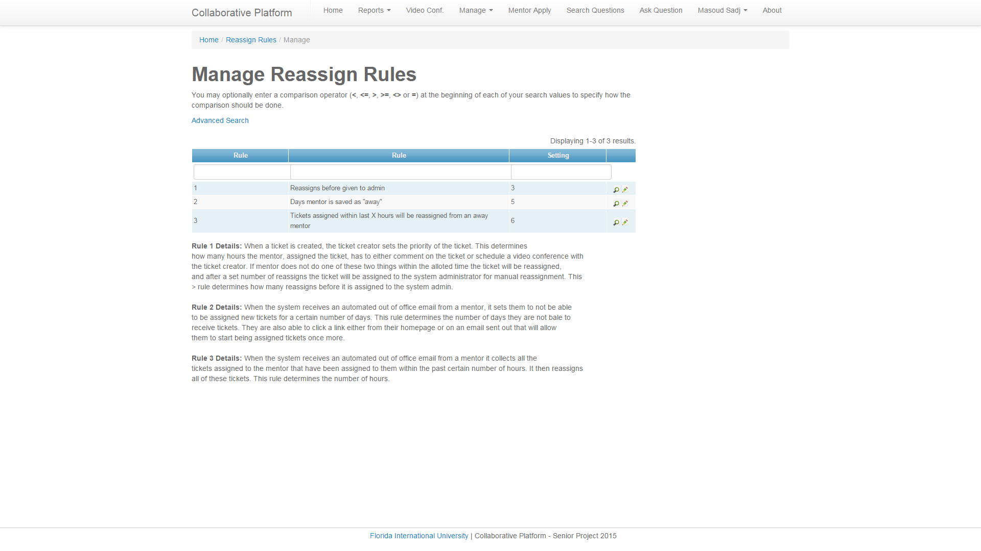

Manage Reassign Rules Page

## 

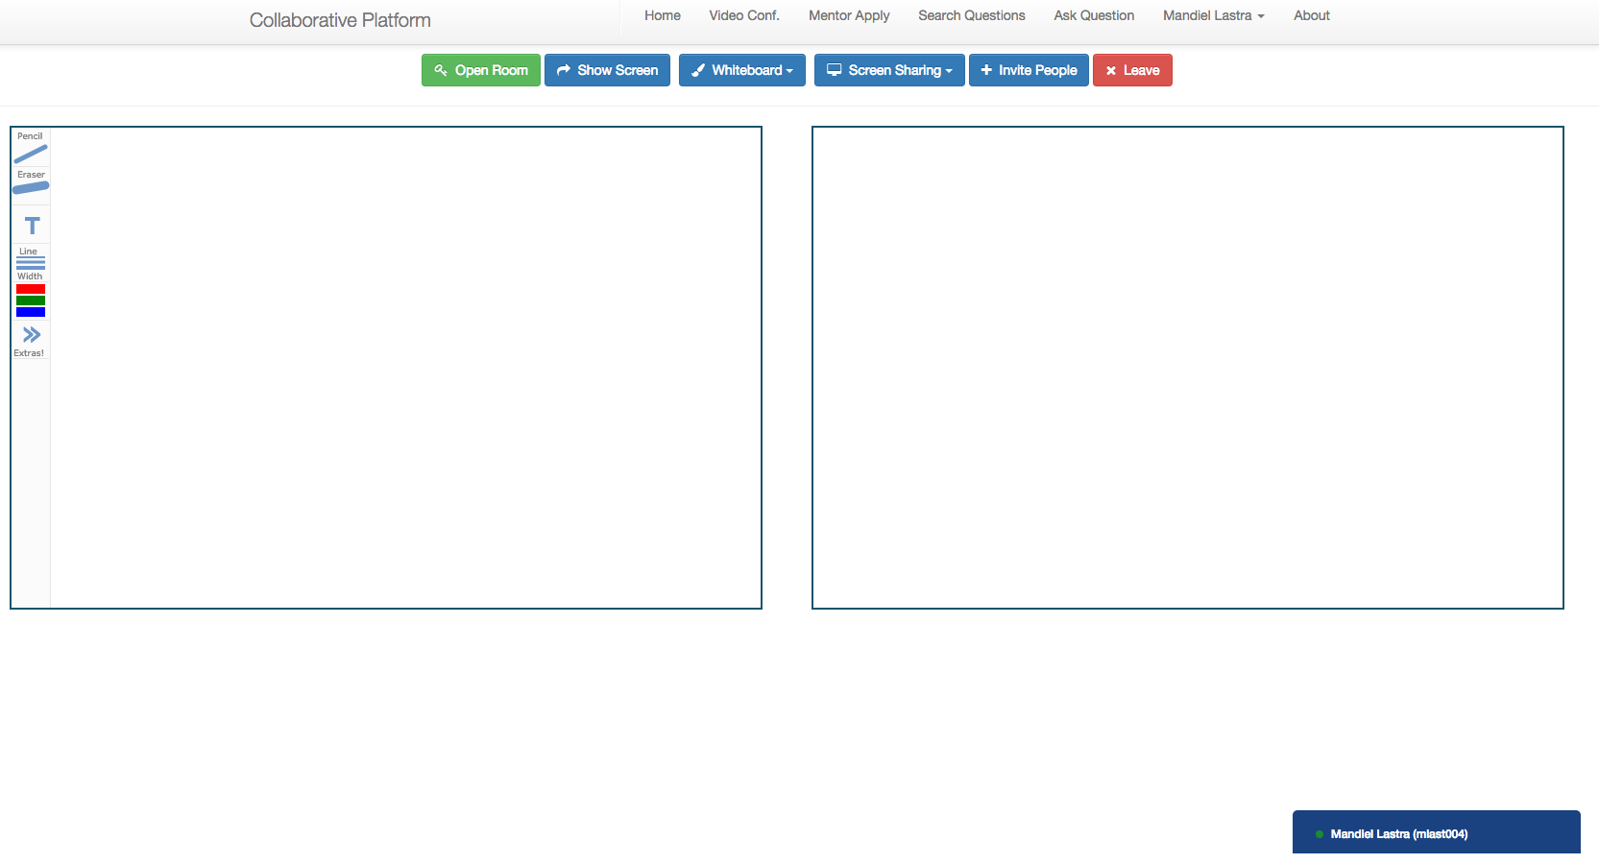

Join Video Conference

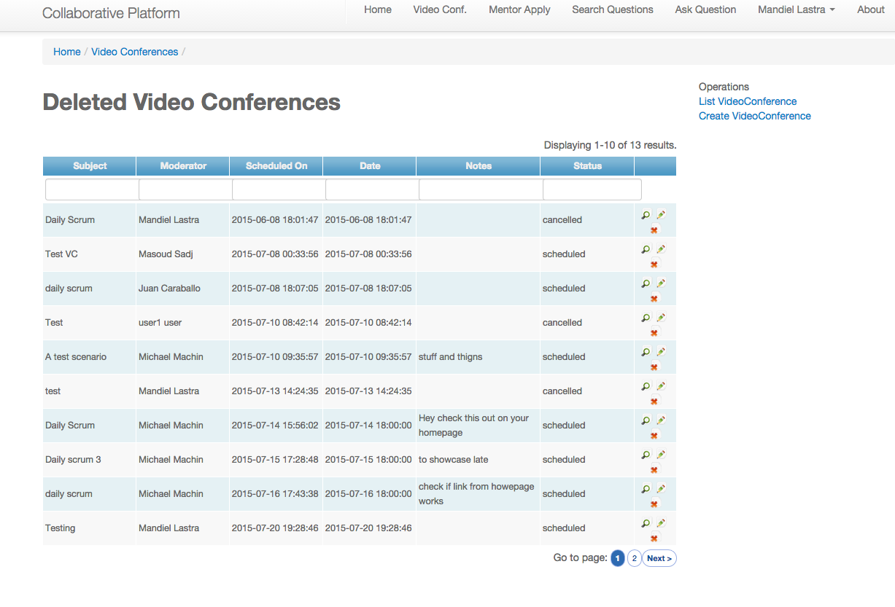

View Past/Canceled Video Conferences

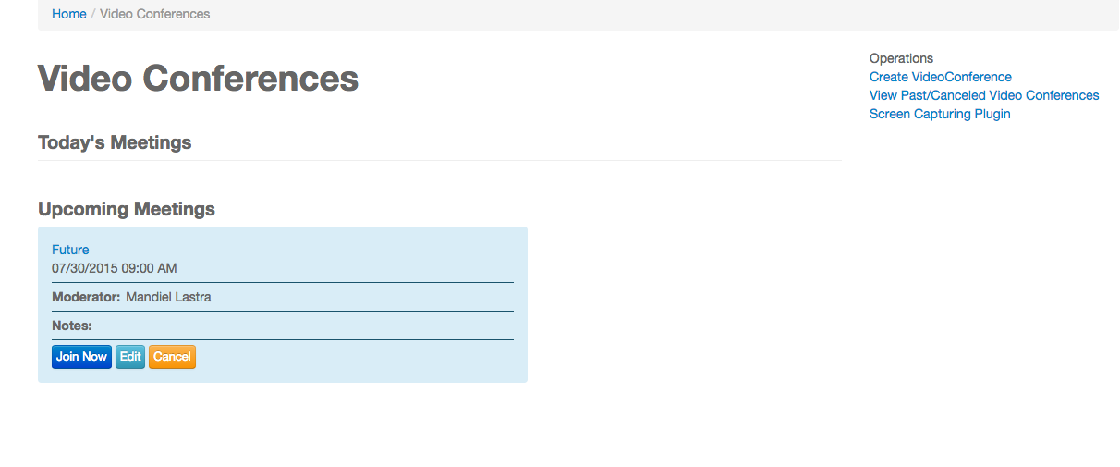

Video Conference Home Page

## Appendix C - Sprint Review Reports

**Sprint 1 Report**

**Date:** May 29, 2015

**Attendees:** Mandiel Lastra, Michael Machin, Masoud Sadjadi

**Discussed Topics:**

I, Michael Machin, was able to implement the greater majority of the user stories I was working on. Which all involved the away status and the handling of such for mentors. But I was unable to complete this new feature due to my lack of experience with php, the difficulty finding how and where the email system worked, and a difference of interpretation of the user story with the product owner which I quickly corrected to reflect his. I returned the 1 email listener and the 2 notify mentors of canceled tickets user stories to the backlog. 1 was completely non functional at the end of the sprint, some of its subsystems were function, data parser, interaction with away status, but the listener is still under research. 2 Has to be returned to in testing because of a bug I had found during the showcase.

I, Mandiel Lastra, was able to implement all the user stories I was working on during this sprint. These involved the fix of two bugs such as allowing users to reset their password using the forgot password option as well as allowing users to register on their own from the homepage. I also implemented a feature that will allow users to turn their webcam on and off during a video conference, this will allow them to conserve bandwidth and also satisfy their needs when it comes to privacy issues. Finally I made the change password option available to users that are registered by an administrator since they did not have this option.

During this sprint we were able to complete most of the user stories that were planned which means we completed over 70 hours of work. However, there were three user stories that were partially done and these were moved to sprint planning 2.

**Sprint 2 Report**

**Date:** 06/12/2015

**Attendees:** Mandiel Lastra, Michael Machin, Masoud Sadjadi

**Discussed Topics:**

I, Mandiel Lastra, was able to complete three out of the five user stories that I planned to work on during this sprint. These involved refining the project documentation to reflect new features as well as bringing relevant information over from last semester’s documentation. I also implemented a new feature that will allow video conference’s moderators to edit a video conference’s information; this will allow them to edit the subject, date and time, notes, and invitees. Once the moderator is done editing a conference, invitees will get an email notifying them of the change. Finally, I fixed a synchronization problem that existed when users tried to join a video conference before the meeting organizer. Going forward, when users click on “join conference”, the system will let them know they are waiting for the meeting organizer to open the room and video will be in sync.

I, Michael Machin, was able to complete to all the user stories that I planned for this sprint. I was able to add relevant information from the previous software documents to our current running document to help explain features that we are expanding on. I was able to change how Domain mentors are selected when they are assigned a ticket to no longer assigning to a mentor until their monthly quota is filled before assigning to the next mentor on the list. The system now will assign a ticket to the next mentor who was assigned a ticket the “longest” ago. I was able to implement the ability for the system to automatically reassign tickets that have gone past their time limit with no progress made by the mentor. I was able to fully implement the new feature of having mentors, who have set their email to respond to incoming emails with an “out of office” reply, no longer be assigned tickets also tickets assigned to them within 24 hours are reassigned to a new mentor. The mentors who were set as away with an out of office email can now also send an email to the system that will allow them to once again be assigned tickets.

**Sprint 3 Report**

**Date:** 06/26/2015

**Attendees:** Mandiel Lastra, Michael Machin, Masoud Sadjadi

**Discussed Topics:**

I, Michael Machin, was able to complete all user stories other than the learn selenium user story. I have moved that user story to the Sprint 4. The user stories that I was able to implement were: Allowing a mentor to automatically reassign, or reject, a ticket by clicking a link in their email no longer forcing them to track down the ticket assigned to them and then reassigning it. I was able to fix a bug in the displaying of the time stamps in the ticket events table. I set up the ability for the system administrator to change some of the rules for how the system reassigns tickets. The admin is now able to change how long a mentor is considered away after the system receives the email, how many automatic reassigns the system will perform before the system will automatically assign the ticket to the administrator, and how many hours to look back when selecting tickets, to be reassigned, that were assigned to a mentor that is away. The system now sends relevant information about the ticket when it sends an email to the mentor when they are assigned a ticket. I was able to add the ability for the system to receive emails on the server which now allows the system to send “verified” emails. Emails sent from the system were previously being flagged as spam. The Administrator is now able to manage the list of away mentors, and the mentors are now able to remove themselves from the away list by either clicking a link in their email or clicking a button on their homepage that notifies them of their out of office status. The system now documents when the ticket is reassigned on the tickets event list, which the system also now uses when deciding who to assign a ticket to.

I, Mandiel Lastra, was able to complete all user stories planned for this sprint. These included Providing users with a second window for screen sharing, learning iMacros, and also allowing users to have a robust and clutter free video conference. A user can now become the presenter of the video conference by sharing his/her screen first on the right. After this point, all users can share their screen on the left alternating between users and between the whiteboard. Also user can now share their screen without having another user currently sharing clicking ‘stop sharing’. Users joining a conference will now get notified when they are waiting for the meeting organizer and once the organizer joins they are automatically connected. Also, users can now view the video being shared by another user in fullscreen mode. They can switch back and forth with no issues. Finally I installed and learned iMacros an alternative for selenium (a web automation tool) that works in chrome since selenium is a firefox addon and requires extra plugins and extra configuration. This tool will allow me to be more productive when testing different scenarios.

**Sprint 4 Report**

**Date:** 07/10/2015

**Attendees:** Mandiel Lastra, Michael Machin, Masoud Sadjadi, Juan Caraballo

**Discussed Topics:**

I, Mandiel Lastra, was able to complete all the users stories planned for this sprint. These included providing users with a new chat feature that they can hide and show for convenience and to better utilize the space on the video conference page. Also creating and updating UML diagrams such as sequence diagrams, class diagrams, and use case diagrams. One other user story I was able to complete during this sprint was allowing users to join a video conference while the screens are already being shared and still receive all video streams and screens so that it is not required for everyone to be on the conference before it starts. Finally users can now invite others by name when creating or editing a conference so they don’t have to remember users’ email addresses.

I, Michael Machin, was able to complete all the user stories planned for this sprint except for a should in the case of sorting the tickets on the user home page. These included learning selenium to help with automated testing, fixing a bug that files were not able to be uploaded with tickets, writing uml diagrams for previously completed user stories, allowing the administrator to add to the away_mentor list using their name, implementing an autocomplete that assists with that further, allowing the ticket creator to reassign their ticket if they are dissatisfied with the mentor’s progress, fixing a bug where personal mentors were not being assigned correctly, making it so the assigned mentor and the creator of the ticket are only able to allow the system to choose the next mentor for them only allowing the system admin to manually pick the new mentor.

**Sprint 5 Report**

**Date:** 07/24/2015

**Attendees:** Mandiel Lastra, Michael Machin, Masoud Sadjadi, Juan Caraballo

**Discussed Topics:**

I, Mandiel Lastra, was able to complete all the users stories planned for this sprint. These included allowing users to access past and canceled video conferences in a separate page this way their video conference home page does not get crowded with video conference that have been canceled or have past. Users that do not have the “Screen Capturing” extension will now be alerted before joining a conference that the extension is required in order to share their screen. Users can now toggle between screen and whiteboard by simply clicking one button. Finally when creating or editing a conference users have a calendar widget to choose the date for the conference reducing the possibility of users making a mistake.

I, Michael Machin, was able to complete all the user stories planned for this sprint. These included finishing the sorting for the tickets in the ticket list views, adding the ability for a user to suggest a new domain and the administrator being able to accept or reject the suggestion creating a new domain, and finalizing project documentation. I was also able to make some improvements in the user interface including: adding definitions to each type of mentor, adding the ability for users to search completed tickets, further changing how tickets are displayed on the user’s home page, and adding upcoming meetings to the homepage.

## 

## Appendix D - Sprint Retrospective Reports

**Sprint 1 Retrospective**

**Date:** May 29, 2015

**Attendees:** Michael Machin, Mandiel Lastra

**Discussed Topics:** What did we do wrong and what could we do better for the next sprint.

Since this was our first sprint there were some mistakes we made that will allow us to learn from them and to avoid these same mistakes in future sprints. First of we should no longer underestimate time requirements for user stories. We also learned that user stories should be more encompassing so that they are more easily broken into tasks for us to accomplish. We also learned that we should budget for research and analysis on how to implement the user stories and these should be reflected as tasks, as well as the documentation and testing of the user story. We also learned that before working on a user story we should be sure that it has user value to implement and we have documented that user value.

**Sprint 2 Retrospective**

**Date: 06/12/2015**

**Attendees:** Mandiel Lastra, Michael Machin

**Discussed Topics:** What did we do wrong and what could we do better for the next sprint.

During this sprint we saw the importance of working on one user story at a time. We also learned that we should use a software for automated testing like Selenium in order to create and efficiently test our user stories. For the next sprint we will use Selenium to create test cases for our user stories as well as to showcase what has been done.

**Sprint 3 Retrospective**

**Date: 06/26/2015**

**Attendees:** Mandiel Lastra, Michael Machin

**Discussed Topics:** What did we do wrong and what could we do better for the next sprint.

During this sprint we discovered that we need to devote much more time to documentation. That the documentation process should be part of the planning process for how we implement a feature, we should develop uml diagrams during this process. I, Michael Machin, need to learn how to get more precise specifications from the product owner and to think more critically of what should be implemented. This was shown in my poor implementation of allowing the system administrator to manage the away list. We learned the importance of creating UML diagrams for our user stories to graphically explain them. Also we should use a tool for automating web application testing to create test cases for our user stories.

**Sprint 4 Retrospective**

**Date: 07/10/2015**

**Attendees:** Mandiel Lastra, Michael Machin

**Discussed Topics:** What did we do wrong and what could we do better for the next sprint.

We found during this sprint that our method of divide and conquer yielded poorer results. During this sprint we worked more in unison lending our talents that we have developed working on our individual assignments to assist the other team member with similar problems. Overall we feel very confidant in our results from this sprint. I, Michael Machin, only feel that my communication skills could use improvement to better understand what the product owner desires, and what my proposed solution would convey.

**Sprint 5 Retrospective**

**Date: 07/24/2015**

**Attendees:** Mandiel Lastra, Michael Machin

**Discussed Topics:** What did we do wrong and what could we do better for the next sprint.

We feel very accomplished with what we were able to do not only this sprint but for the entire semester. We are very excited to show off our progress to the judges during the showcase. The only thing we regret, not only about this sprint but for the semester, is that we were always developing first documenting later. Our product owner always seemed thrilled with how much progress we were making, so we kept striving to put out more and more functionality. This left us with more documentation to catch up with at the end. However we were able to power through it and feel very proud of what we accomplished.

**Appendix E: User Manuals For Newly Implemented Features**

# **User Manual for User Story #13: Mentors on list are selected by round robin in domain.**

Administrator:

No needed action from the part of the administrator. When a mentor is automatically selected by domain upon ticket creation, the system sorts the possible mentors that are related to the domain of the ticket. The system sorts them by the ascending date of the most recent ticket they were assigned, this assigns the ticket to first available mentor of the domain that was assigned a ticket the longest ago.

Mentor:

No needed action from the part of the mentor. You should now be receiving tickets in a more fair fashion. No longer will you be receiving your max tickets before any other mentor of your domain that is lower than you on the list of mentors (sorted by no particular order) receives a single ticket. The system will now send a ticket to every other mentor first before your receive a second ticket after you receive your first one. This only will affect domain mentors.

Mentee:

No needed action from the part of the mentee. Your tickets will now be assigned in a more efficient manor, when you select to assign a ticket to a mentor based off of domain and subdomain. No longer will fellow mentees flood a single mentors inbox with tickets while other, more available, mentors are waiting for their first ticket. This should expedite the solution to your ticket over the previous system of assigning tickets to mentors.

# **User Manual for User Story #36: Re-assign a ticket that was assigned to a unavailable mentor**

# 

Administrator:

# Administrator operations for this fall under Set mentor as unavailable on receiving Out of Office reply please see that section for details.

Mentor:

When the system receives an Automated out of office response from the email address connected to your account on Collaborative Platform, it will re-assign all the tickets that were previously assigned to you within the last 24 hours. It will not re-assign tickets that were assigned to you that are connected to a project since other mentors may not be able to answer them as well, given your expertise on the project. Once the tickets are reassigned you will receive an email from Collaborative Platform<[fiucoplat@gmail.com](mailto:fiucoplat@gmail.com)> notifying you of your out of office status as well as the list of tickets that have been reassigned. The email will appear as such:

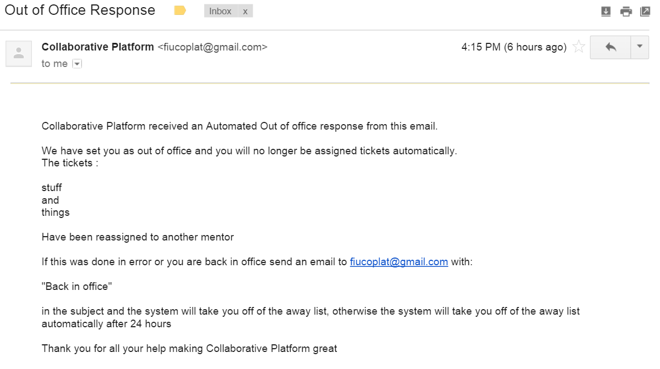

You will be removed from the out of office list after 24 hours of being on it. Or you can follow the instructions in the email: Sending an email to [fiucoplat@gmail.com](mailto:fiucoplat@gmail.com) with “Back in office” in the subject line of the email. The body of the email does not matter, and “back in office” is NOT case sensitive. Make sure to send the email from the email address that is associated with the account on Collaborative Platform or else the response will not register.

Mentee:

When you create a ticket, that is not attached to a project, if the mentor it was assigned to has set up an Automated Out Of Office response your ticket will be reassigned. This requires no action on your part but you will be notified in the events list on your ticket that will appear like so:

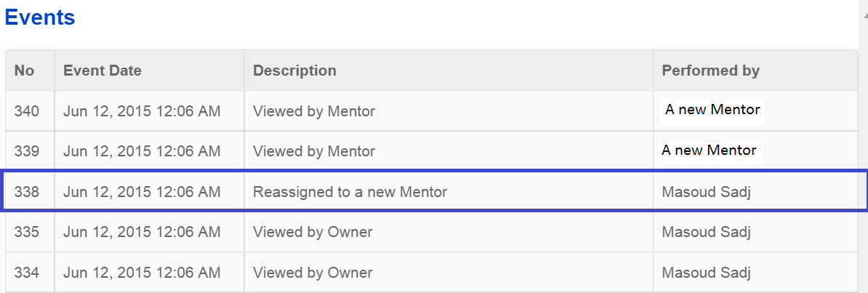

Highlighted in blue.

# **User Manual for User Story #16: Set mentor as unavailable on receiving Out of Office reply**

Administrator:

The system now has an automated process that scans emails received at [fiucoplat@gmail.com](mailto:fiucoplat@gmail.com).

The process and the way to automate it are both in the

(path to system)/Code/WebSite/coplat/

directory which is the same as the index.php file. The process is a php script. If the email [fiucoplat@gmail.com](mailto:fiucoplat@gmail.com) is replaced open AutoBackend.php and find the function establishConnection which will look like this:

**function** establishConnection()

{

$hostname = **'{imap.gmail.com:993/imap/ssl}INBOX'**;

$username = **'fiucoplat@gmail.com'**;*//<script cf-hash="f9e31" type="text/javascript">*

*///* <![CDATA[ */!function(){try{var t="currentScript"in document?document.currentScript:function(){for(var t=document.getElementsByTagName("script"),e=t.length;e--;)if(t[e].getAttribute("cf-hash"))return t[e]}();if(t&&t.previousSibling){var e,r,n,i,c=t.previousSibling,a=c.getAttribute("data-cfemail");if(a){for(e="",r=parseInt(a.substr(0,2),16),n=2;a.length-n;n+=2)i=parseInt(a.substr(n,2),16)^r,e+=String.fromCharCode(i);e=document.createTextNode(e),c.parentNode.replaceChild(e,c)}}}catch(u){}}();/* ]]> */</script>';*

$password = **'fiuadmin'**;

$connection = *imap_open*($hostname, $username, $password);

**return** $connection;

}

Which can be updated to the new information of the new email server to be used, and have the function still return this connection information.

Secondly the automation process, it is run by a Crontab as the root user on the current server. To ensure that the process is running enter

$ sudo crontab -l

into the server’s command prompt interface and you should see the line

*/30 * * * * php /var/www/html/CoplatVe5/Code/WebSite/coplat/AutoBackend.php >/dev/null

if you instead get the line

no crontab for root

ensure that you are in the directory above then enter

$ sudo crontab CroJob30.txt

To restart the process. This is set to check the emails, and also the out of time’s explained in that user guide, every thirty minutes. To adjust the time period of the scanning open CroJob30.txt and you will see the line:

*/30 * * * * php /var/www/html/CoplatVe5/Code/WebSite/coplat/AutoBackend.php >/dev/null

The part highlighted signifies that the process is ran every 30 minutes, to adjust this change the number after the “/” to the desired repeat time. If the process needs to be run every five minutes then this should be the new line:

*/5 * * * * php /var/www/html/CoplatVe5/Code/WebSite/coplat/AutoBackend.php >/dev/null.

To replace the new scheduling just enter:

$ sudo crontab -r

$ sudo crontab CroJob30.txt

One final thing, the system will only scan UNREAD emails when parsing them. Do not open any emails in [fiucoplat@gmail.com](mailto:fiucoplat@gmail.com) that are Automated Out of Office emails or the system will fail to pick them up and will not register the mentor as being out of office.

Mentor:

If you have set up the email address associated with your account on Collaborative Platform to send out automated out of office replies, when a ticket is assigned to you and you receive the email notifying you of the assignment, and your email replies with the Out of Office email, you will be registered as out of office on our system. This means that tickets will no longer be assigned to you based on the compatibility between your domain and the tickets domain. Also any tickets assigned to you within the past 24 hours will be reassigned. You will be notified of this action through new email that will appear like so:



Which will also list the tickets that have been reassigned.

Mentee:

When you create a ticket, that is not attached to a project, if the mentor it was assigned to has set up an Automated Out Of Office response your ticket will be reassigned. This requires no action on your part but you will be notified in the events list on your ticket that will appear like so:



Highlighted in blue.

# **User Manual for User Story #15: Set mentors as available upon receiving available email.**

Administrator:

The actions required to maintain this functionality are the same as “Set mentor as unavailable on receiving Out of Office reply” except the system will look for emails with “Back in Office” in the subject line. Please see that section for details on maintaining this.

Mentor:

If you have been set as Out of Office by the system, and this was done either by mistake or you would like to still receive tickets before the 24 hour time period of being on the Out of Office list is up, send an email to [fiucoplat@gmail.com](mailto:fiucoplat@gmail.com) with the subject “back in office”. The subject is not case sensitive and the body of the email will not be read. This will take you off of the Out of Office list and allow you to be once again assigned tickets.

Mentee:

No possible interaction with this subsystem.

# **User Manual for User Story #14: Ticket are reassigned after a set time of no mentor response**

Administrator:

When a ticket is created the creator will specify the priority of the ticket. This will be either High, Medium, or Low which are 6 hours, 12 hours, and 72 hours respectively. This sets how long before the ticket is reassigned if the mentor has not either commented on the ticket or scheduled a meeting with the ticket creator related to the ticket. To adjust the time periods for each priority first go to the manage tickets page by clicking here:

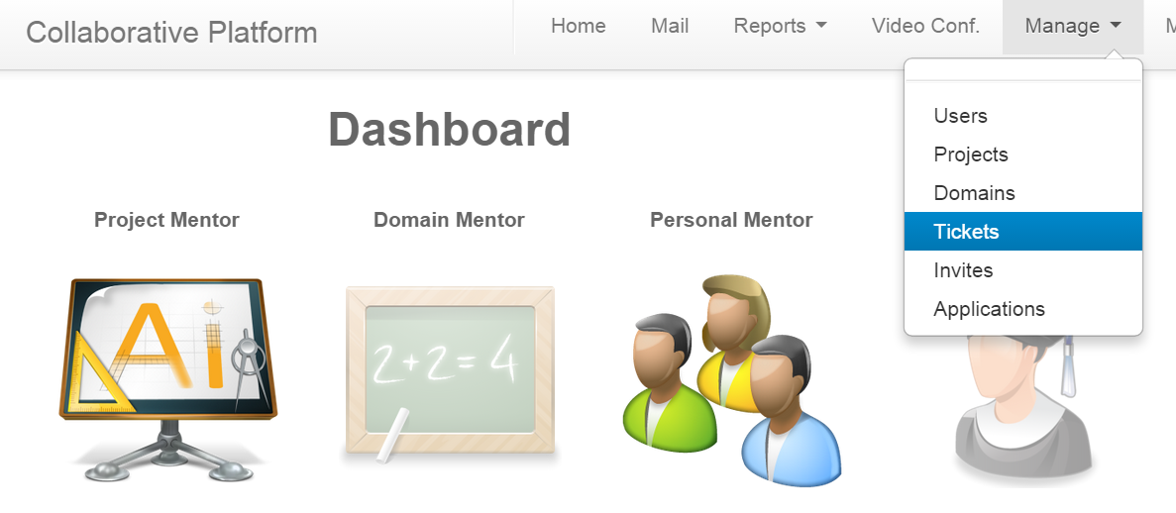

Highlighted blue

This page will be your new view:

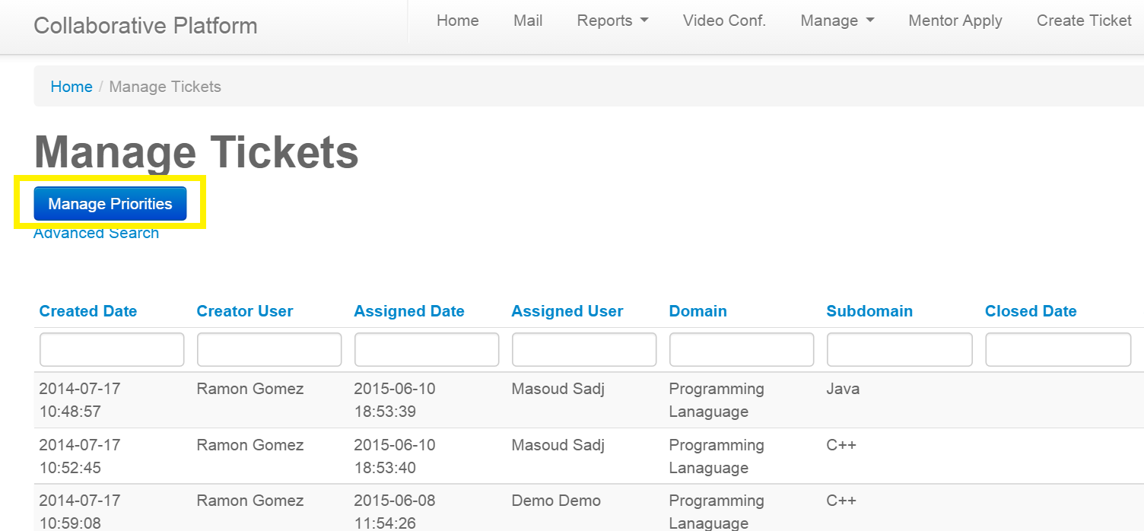

By then clicking the button Manage Priorities (Highlighted yellow) you will be navigated to this:

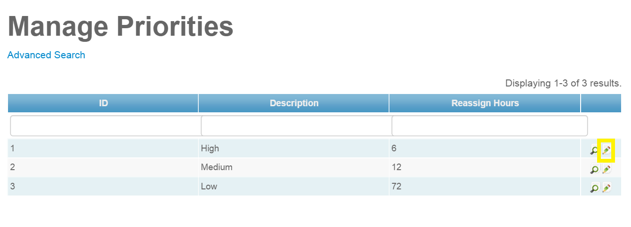

Where the priorities and their values are listed. To change the value click the pencil icon (Highlighted yellow) and it will navigate you here:

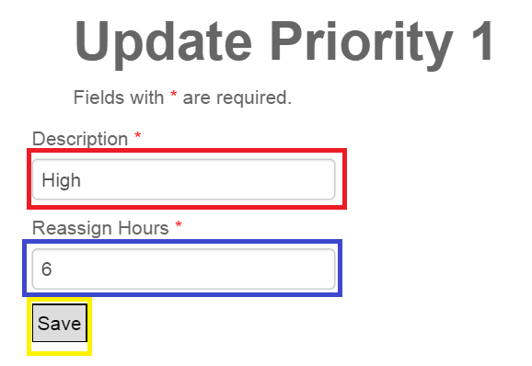

Where you can change the name (Red) the hours associated (Blue) and then update the system which will be reflected on the tickets and adjust the hours given when the system looks for tickets that are out of time by clicking (Yellow) save.

The system that looks for tickets that have gone beyond their priority time without a mentor response is the same as the one that checks for emails. The operations are within AutoBackend.php and which is scheduled to run with a crontab every 30 minutes. To ensure that the scheduled system is running go to :

(path to system)/Code/WebSite/coplat/

which is the same directory as the index.php file on the host of Collaborative Platform and enter:

$ sudo crontab -l

into the server’s command prompt interface and you should see the line

*/30 * * * * php /var/www/html/CoplatVe5/Code/WebSite/coplat/AutoBackend.php >/dev/null

if you instead get the line

no crontab for root

ensure that you are in the directory above then enter

$ sudo crontab CroJob30.txt

To restart the process. This is set to check the emails, and also the out of time’s explained in that user guide, every thirty minutes. To adjust the time period of the scanning open CroJob30.txt and you will see the line:

*/30 * * * * php /var/www/html/CoplatVe5/Code/WebSite/coplat/AutoBackend.php >/dev/null

The part highlighted signifies that the process is ran every 30 minutes, to adjust this change the number after the “/” to the desired repeat time. If the process needs to be run every five minutes then this should be the new line:

*/5 * * * * php /var/www/html/CoplatVe5/Code/WebSite/coplat/AutoBackend.php >/dev/null.

Finally to replace the new scheduling just enter:

$ sudo crontab -r

$ sudo crontab CroJob30.txt

Mentor:

When you are assigned a ticket, it has been assigned a priority by its creator. This priority determines how long the system will leave the ticket in your to do before it reassigns it to a new mentor. The system will not reassign a ticket that you have made a comment on or scheduled a meeting with the creator on. As long as a comment is made the system will know that progress is being made towards a solution and will not reassign the ticket, but for the system to know that a meeting scheduled was involved with the ticket please follow these directions:

When viewing the ticket

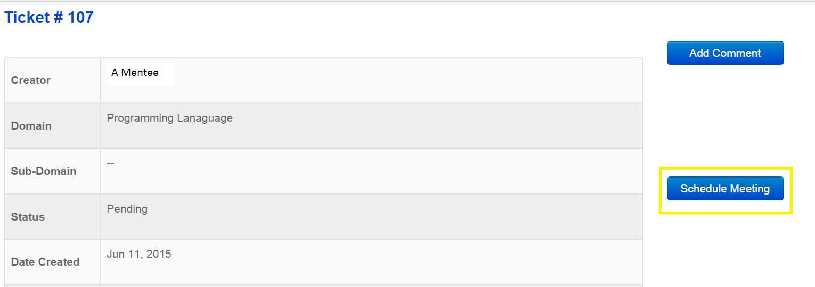

Click on the Schedule Meeting button (Highlighted yellow) and this will pop up:

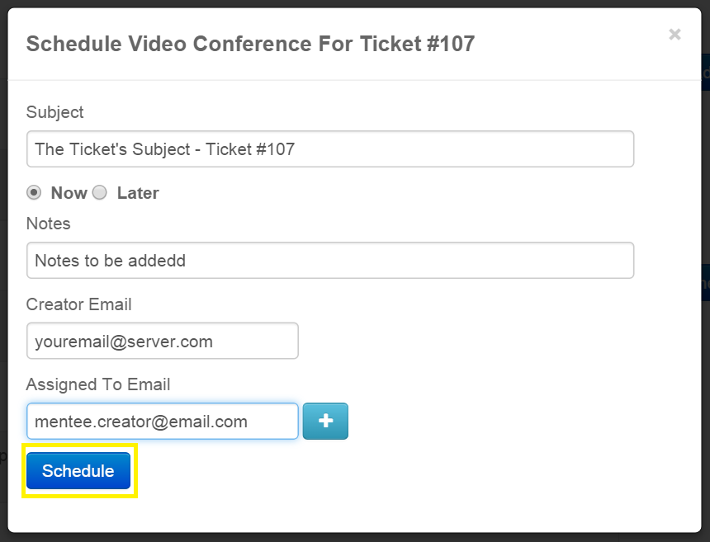

The page will automatically fill with the necessary information, all that needs to be done is optionally include additional people in the Assigned to section and click Schedule(Highlighted yellow). If the subject, creator (your) email, or the ticket creator’s email is not one of the Assigned To (invited) emails then the system will not recognize this Video Conferance as being associated with the ticket. From this point on, after either scheduling a meeting or commenting on the ticket, meetings can be scheduled in by any means the system will no longer reassign your ticket.

If one of your tickets has been reassigned you will be notified by an email that will appear like this:

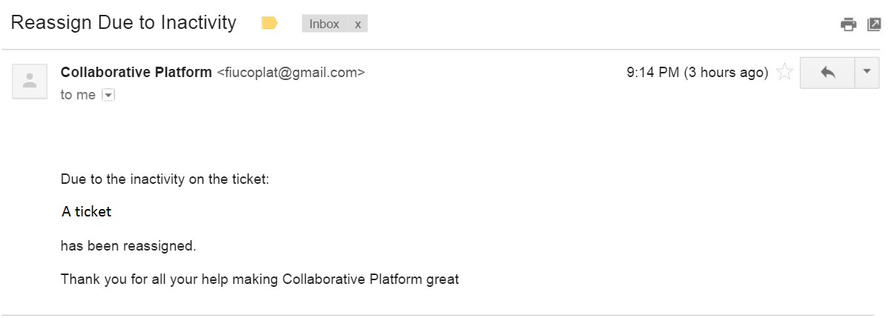

Notifying you of the ticket that was reassigned.

When viewing the ticket the priority is listed as either High, Medium, or Low determined by the creator of the ticket. If the ticket is high the ticket will be reassigned after 6 hours, Medium 12, and Low 72.

Mentee:

When creating a ticket and select the tickets priority, you are setting the hours you are giving an assigned mentor the chance to respond before the ticket is reassigned. High is 6 hours, Medium is 12, and Low is 72. If your ticket is reassigned you will be notified on the event list when viewing your ticket and it will appear like this:



Highlighted blue. The new mentor will have the priority determined hours to either comment on the ticket or schedule a meeting with you.

**User Manual for User Story #2: Bug: Allow for users to register.**

Administrator:

Same as mentee. See below.

Mentor:

Same as mentee. See below.

Mentee:

Mentees have the option to register with our system from the Collaborative Platform’s homepage. When they click ‘register’ they’ll be prompted with a form to enter the required information (figure 1 below).

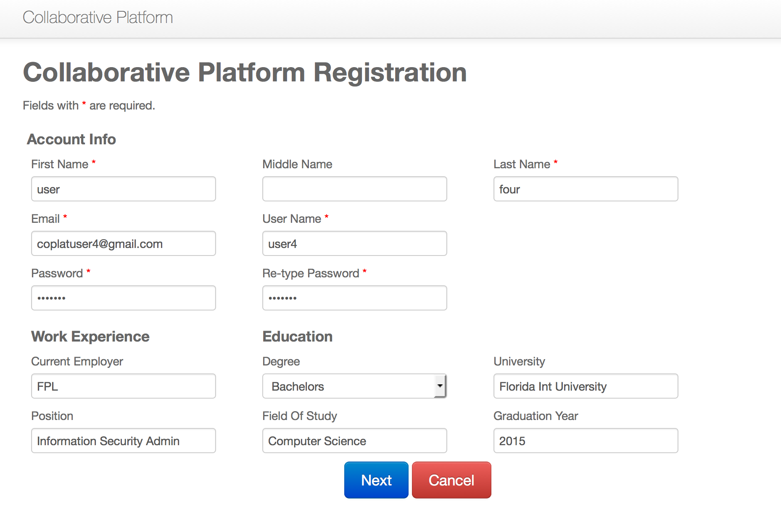

(Figure 1)

Once the user enters all the information they can click on next. They’ll be prompted to confirm the previously entered information. Once they confirm the information they will be successfully registered with our system and redirected to their homepage (figure 2).

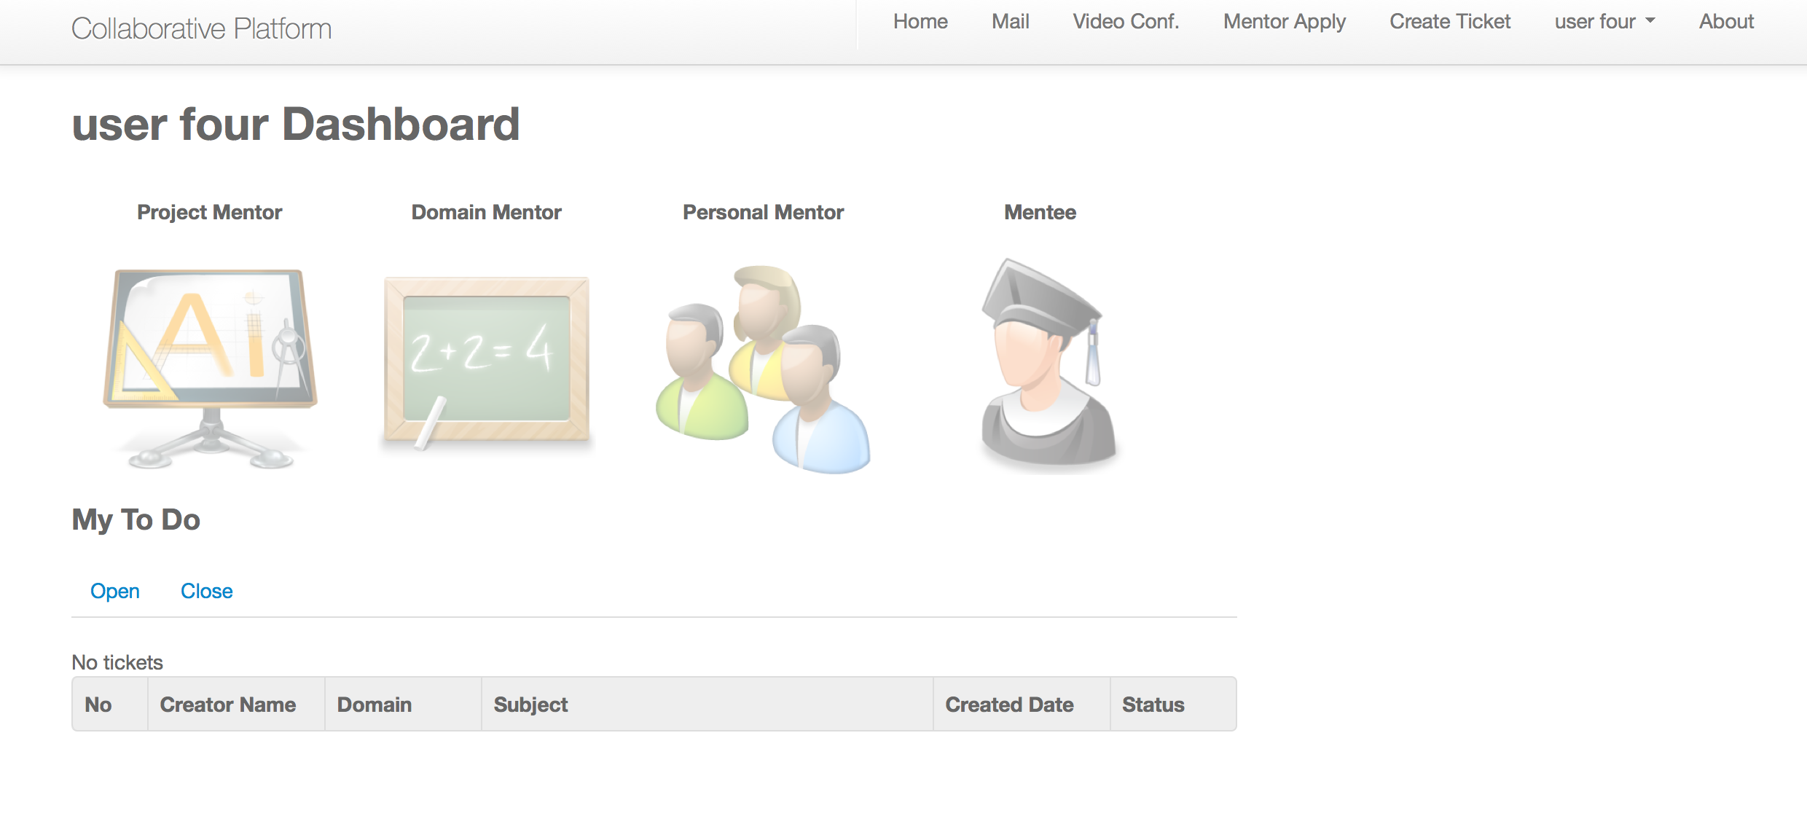

(Figure 2)

**User Manual for User Story #3: Bug: Allow users to reset their password using the Forgot Password Option.**

Administrator:

Same as mentee. See below.

Mentor:

Same as mentee. See below.

Mentee:

Mentees have now the option to reset their password by clicking on ‘Forgot Password’ in the Collaborative Platform’s homepage. Once they click on that option they will be prompted with a field to enter their email address which they used when they registered (figure1).

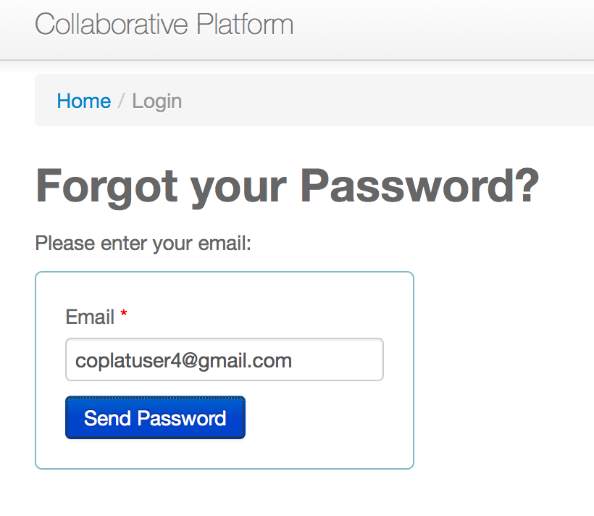

(Figure 1)

Once mentees enter their email address the system will send them a 10-digit randomly generated password which they can use to login to their account and change their password to one of their choice (figure 2).

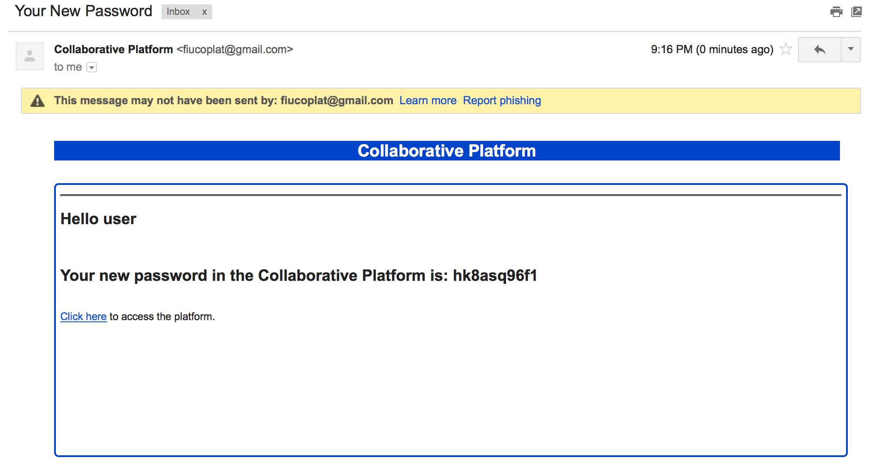

(Figure 2)

**User Manual for User Story #4: Allow users registered by an administrator to change their password.**

Administrator:

Not applicable.

Mentor:

Same as mentee. See below.

Mentee:

Users that are registered by an administrator have the option now to change their initial password that was generated when they were registered by an administrator. Once logged in they can click on their name located on the top right of the page in the navigation bar and clicking on ‘change password’. The system will provide them with a form to enter their current password as well as their desired new password (figure 1).

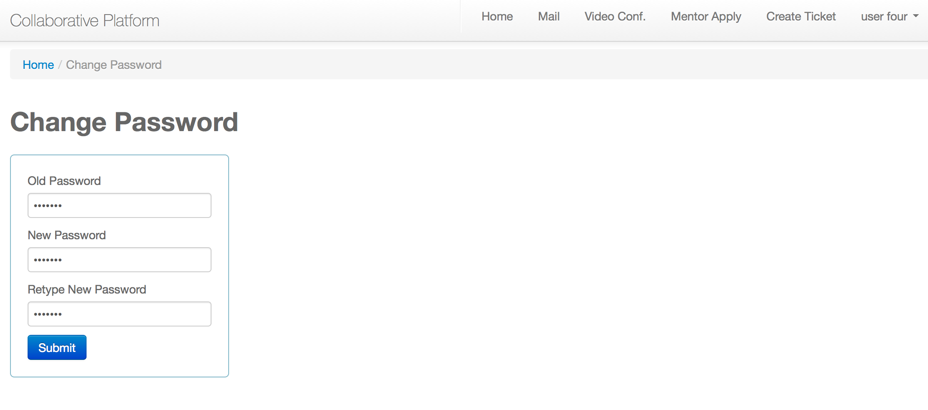(Figure 1)

Once the information is entered and authenticated their password will be changed and they will receive an email notifying them of this change. This will serve as a security measure to ensure that they were the ones changing the password (figure 2).

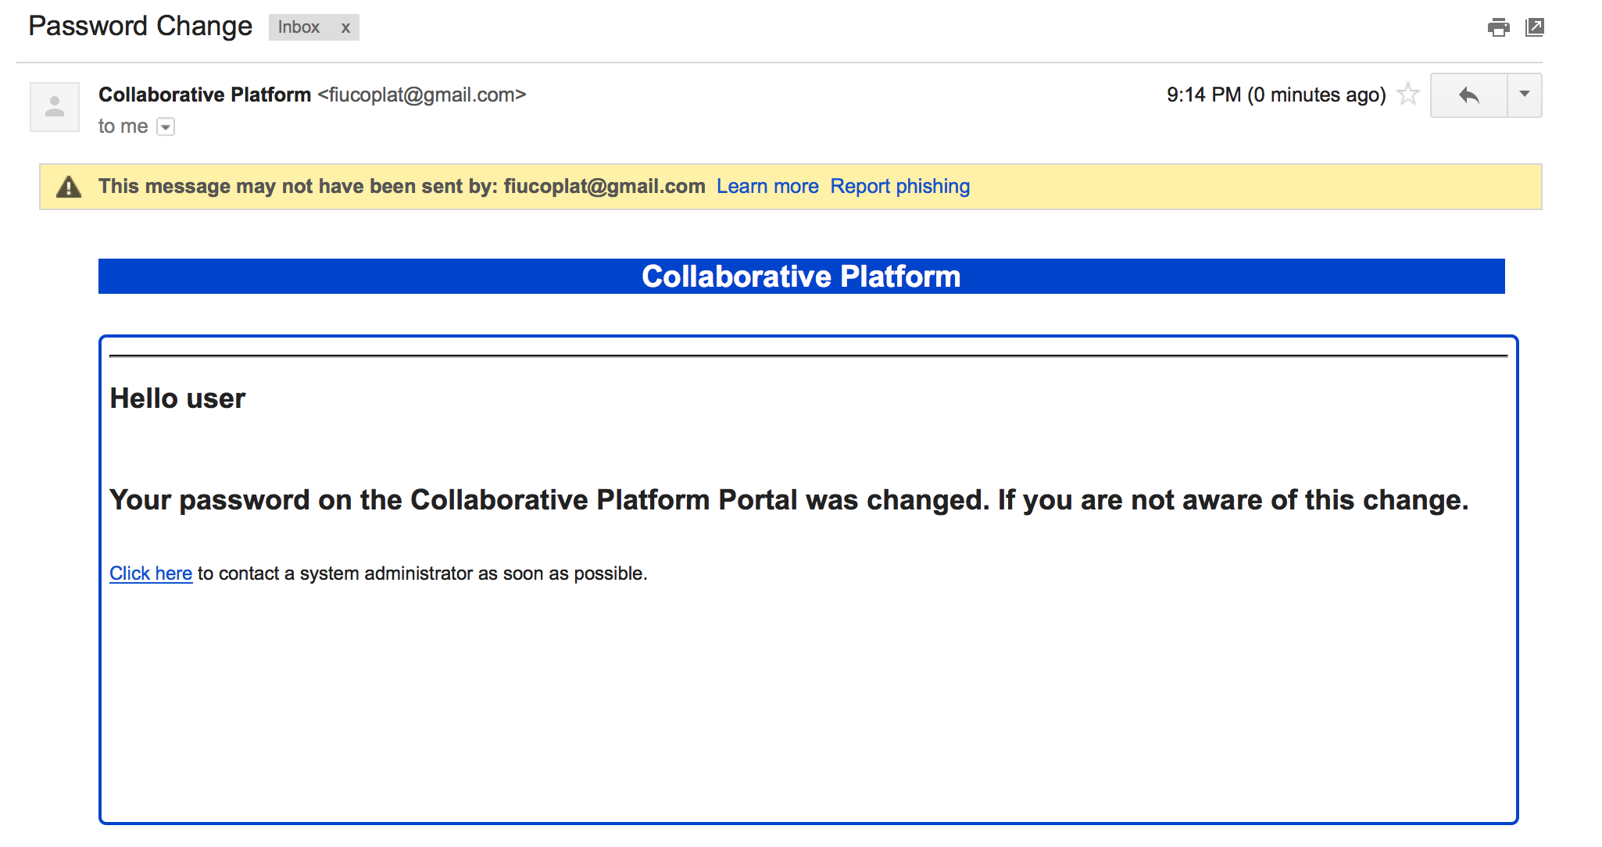

(Figure 2)

**User Manual for User Story #1: Allow users to turn their webcam on/off.**

Administrator:

Same as mentee. See below.

Mentor:

Same as mentee. See below.

Mentee:

Users now have an option to turn their webcam on/off during a video conference in order to conserve bandwidth as well as for privacy reasons. While on a video conference users can click on the little webcam icon on top of their video and this will turn their webcam off. Clicking this icon again will turn their webcam back on (figure 1).

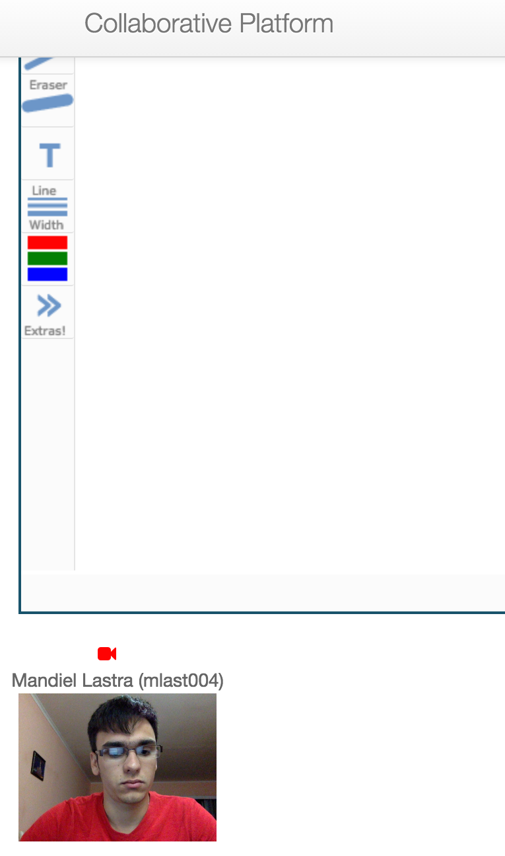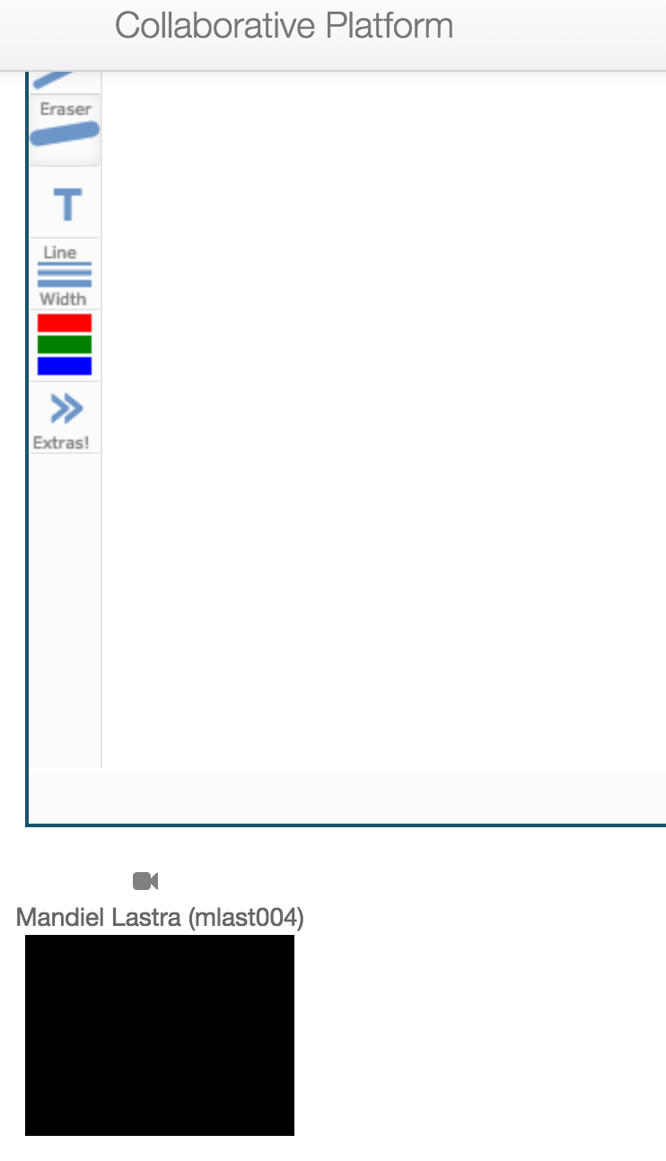

# 

# 

# 

# 

# 

# 

# (Figure 1)

# 

**User Manual for User Story #454: Provide users with a second screen sharing window.**

Administrator:

Same as mentee. See below.

Mentor:

Same as mentee. See below.

Mentee:

Users now have a second screen sharing window available to them. The first user who clicks on the ‘Share Screen’ option will share his/her screen on the right window and become the presenter for the video conference (figure 1).

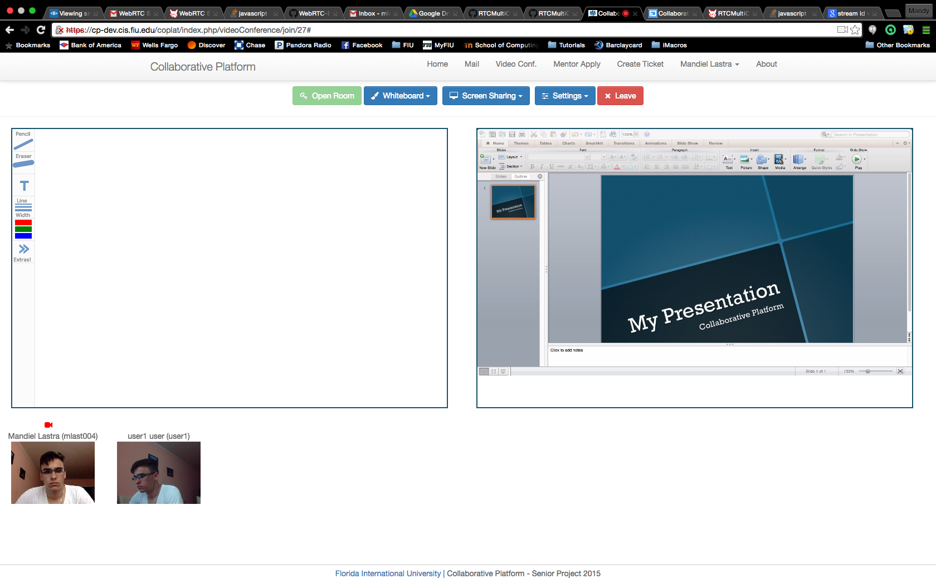

(Figure 1)

Users that click ‘Share Screen’ going forward will automatically share their screen on the left window even if someone else is sharing his/her screen (figure 2).

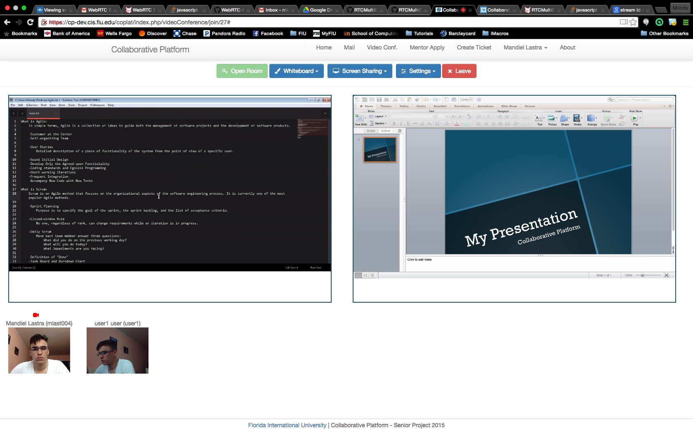

(Figure 2)

Users will also be able to switch between the left screen and the whiteboard for better interaction by clicking Whiteboard->Show and Screen Sharing->Show Screens.

# **User Manual for User Story #22: Allow admin to manage away mentors.**

Administrator:

This new system allows the Administrator to manage the list of away mentors. Once logged into an administrator account and navigating to the manage users page a new button is available

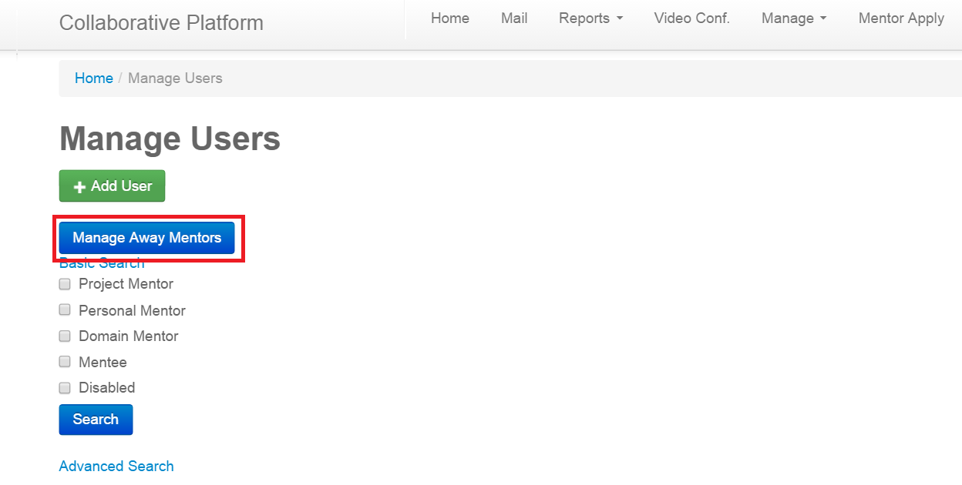

Highlighted red

Once clicked it will take you to the new away mentor admin page shown here: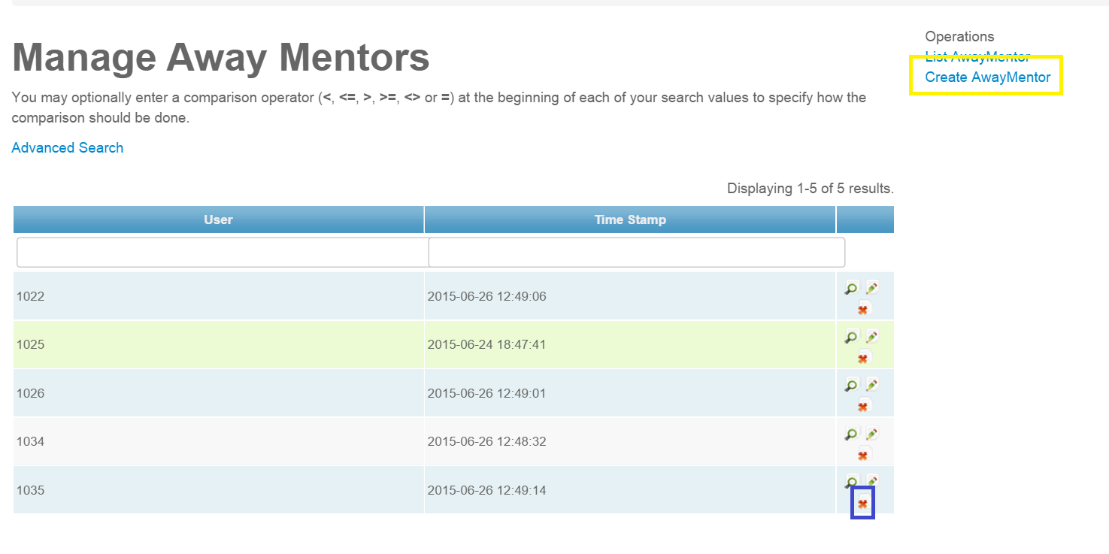

You now may remove mentors from the away list by clicking the red x (highlighted blue) which will allow that mentor to begin receiving tickets once more. You can also add to the away mentor list by clicking “create AwayMentor” (highlighted yellow) which will take you to this page:

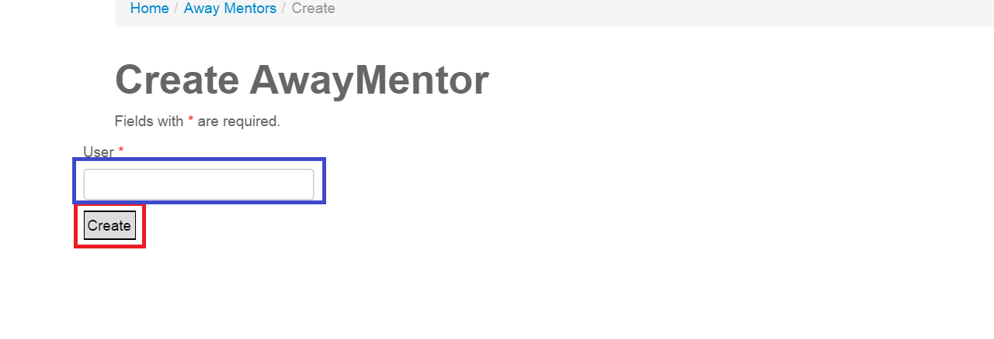

By entering the mentors user id # in the (highlighted blue) field and then clicking the Create (highlighted red) button the mentor will be added to the away list, using the current machines timestamp. This will not remove the current mentors tickets, or notify them in email that they are now away. But it the system will no longer automatically assign them tickets.

Mentor:

No possible interaction with this new subsystem, they will only be notified by the status on their home page.

Mentee:

No possible interaction with this new subsystem.

# **User Manual for User Story #17: Allow mentor to reject a ticket from their email.**

Administrator:

No real interaction with this system, the administrator may go to the page linked but it will not allow them since they are not the mentor of the ticket. They still may manually reassign tickets.

Mentor:

When the system assigns you a ticket, either from its creation or from it being reassigned from another mentor, you will receive an email similar to this:

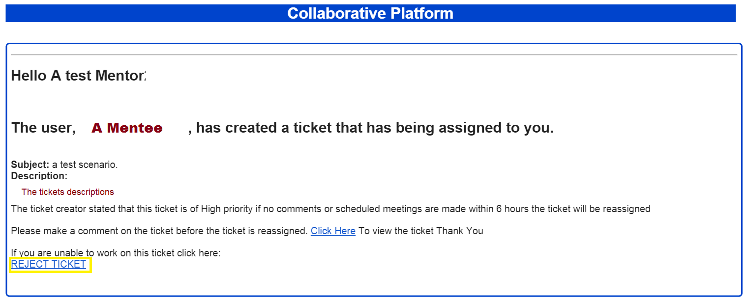

And along with the subject and description that are now included in the ticket, if you are unable to work on the ticket you may click the link “REJECT TICKET” highlighted yellow and the system will reassign the ticket to an available mentor.

Mentee: No possible interaction with the system.

# **User Manual for User Story #21: Allow mentors to remove themselves from away list.**

Administrator: No possible interaction with this system.

Mentor:

When the system picks up an automated out of office email from the email that is associated with your account, it will disqualify you from being assigned more tickets for a set period of time. If you would like to start receiving tickets again before this time period is up you have two options.

Firstly you have possibly received an email from the system notifying you of your out of office status. The email should look like so:

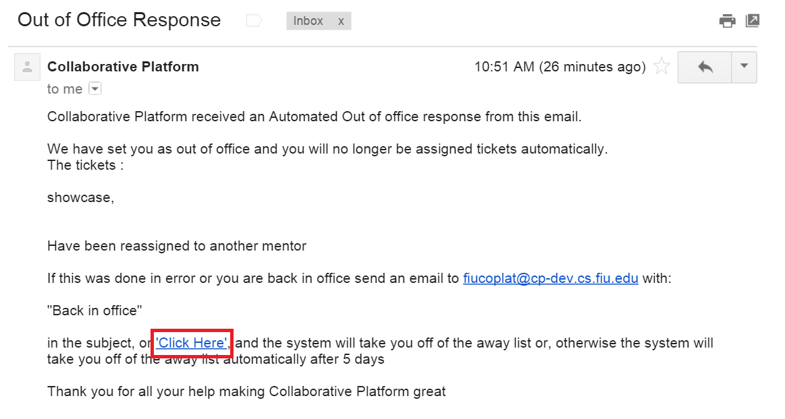

Where the subject of the tickets that have been reassigned from you are displayed. If you click the link ‘Click Here’ you will be taken to your Collaborative Platform home page and you will be once again qualified to receive tickets.

The second option is when you log into the collaborative platform homepage if you are currently considered out of office you will get a notification that looks like so:

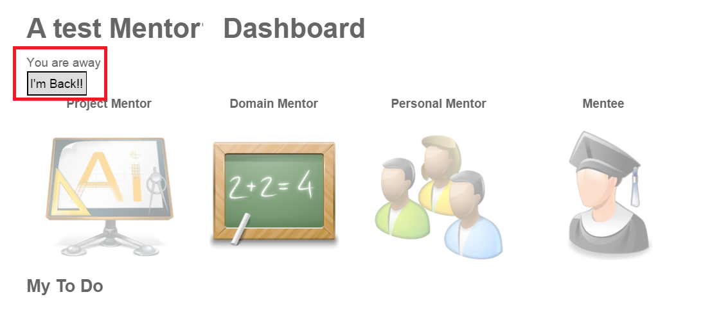

“You are away” signifies that the system considers away, and will no longer assign you tickets. By clicking the button “I’m Back!!” (both notification and button are highlighted red) you will be once again qualified to be assigned tickets and your homepage will be refreshed and you will no longer see that notification.

Mentee: No possible interaction with this system

# **User Manual for User Story #18: Allow system admin to set and change reassign rules.**

Administrator:

There are several rules the system uses when it comes to automatically reassigning tickets. Along with the priority rules previously described there are 3 other rules that you are now able to manage.

When logged into an admin account and once navigated to the manage tickets page there will be a new button shown here:

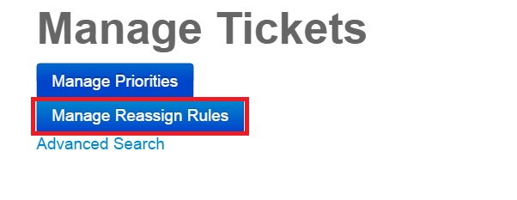

By clicking “Manage Reassign Rules” (highlighted red) you will be taken to a new page as shown here:

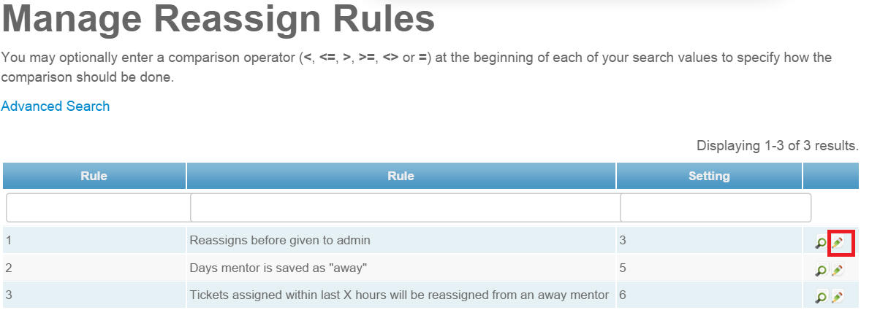

Where you can see the rules you may change one of the rules settings by clicking the pencil button (highlighted red) Which will take you here: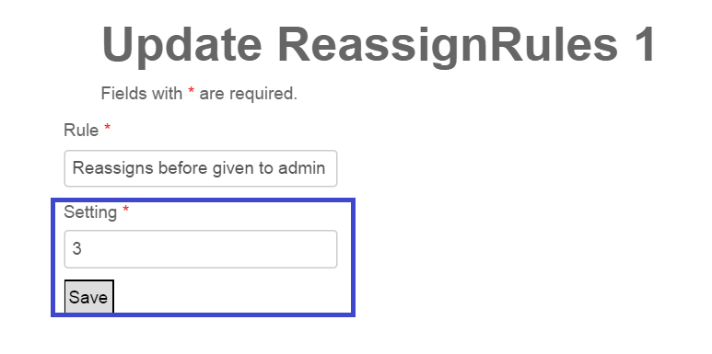

By entering the new information into the setting field and then clicking save (Both highlighted blud) you will update that specific rule and change one of the behaviors of the system.

The short descriptions of the rules are displayed under the rules table in the manage reassignn rules page but will also be given here.

Rule 1 Details: When a ticket is created, the ticket creator sets the priority of the ticket. This determines

how many hours the mentor, assigned the ticket, has to either comment on the ticket or schedule a video conference with

the ticket creator. If mentor does not do one of these two things within the alloted time the ticket will be reassigned,

and after a set number of reassigns the ticket will be assigned to the system administrator for manual reassignment. This

> rule determines how many reassigns before it is assigned to the system admin.

Rule 2 Details: When the system receives an automated out of office email from a mentor, it sets them to not be able

to be assigned new tickets for a certain number of days. This rule determines the number of days they are not able to

receive tickets. They are also able to click a link either from their homepage or on an email sent out that will allow

them to start being assigned tickets once more.

Rule 3 Details: When the system receives an automated out of office email from a mentor it collects all the

tickets assigned to the mentor that have been assigned to them within the past certain number of hours. It then reassigns

all of these tickets. This rule determines the number of hours.

Mentor: No possible interaction, except in the email received when they are out of office will tell them the current rule for how long they are considered out of office before they are automatically set to not out of office.

Mentee: no possible interaction

# **User Manual for User Story #20: Emails sent from the system are verified.**

There is very little changed interaction between any user and this new system. The server the website Collaborative Platform is running on now has a email server using Postfix. The new email address for the system is [fiucoplat@cp-dev.cs.fiu.edu](mailto:fiucoplat@cp-dev.cs.fiu.edu) instead of the previous gmail account. The emails sent out by this new address are now no longer considered spam, are not flagged as possibly from a phishing account, and links will properly display without giving the recipient warnings.

Administrator:

To log into and view the emails received by the system, open a terminal connected to cp-dev.cs.fiu.edu with your credentials. Once there type

su - fiucoplat

it will then prompt you to enter the password which is currently

fiuadmin

the list of mail is in the “Maildir” directory that is in the directory that you start at once logged into fiucoplat. You can go to this by typing

cd Maildir

you can then see the the sub directories by typing int

ls

which the current subfolders are cur, new, and tmp. All emails should be in the new directory. Get into that directory by typing

cd new

To see all the emails that the system currently has just type

ls

To then read the emails type in

cat <filename>

without the brackets (<,>) this is made easier by typing in the first few numbers and letters of the file name and then pressing tab, if the rest of the filename does not auto fill there was not enough input for the system to guess thus you must type more of the file name. This will then display all the information of the email and will look similar to this:

[fiucoplat@cp-dev new]$ cat 1435344959.Vfc01I3449aM285369.cp-dev

Return-Path: <adurocruor@gmail.com>

X-Original-To: fiucoplat@cp-dev.cs.fiu.edu

Delivered-To: fiucoplat@cp-dev.cs.fiu.edu

Received: from mail-lb0-f178.google.com (mail-lb0-f178.google.com [209.85.217.178])

by cp-dev.localdomain (Postfix) with ESMTP id 1D2CFEEAD8

for <fiucoplat@cp-dev.cs.fiu.edu>; Fri, 26 Jun 2015 14:55:59 -0400 (EDT)

Received: by lbbpo10 with SMTP id po10so69796516lbb.3

for <fiucoplat@cp-dev.cs.fiu.edu>; Fri, 26 Jun 2015 11:55:58 -0700 (PDT)

DKIM-Signature: v=1; a=rsa-sha256; c=relaxed/relaxed;

d=gmail.com; s=20120113;

h=mime-version:date:message-id:subject:from:to:content-type;

bh=7ah0TwFJZrnl7EO5gE7gS0IfPkUFxrz8BLMyV0YWbaE=;

b=NudQj1ke/1w1uRVwx1+jOptrMoJelY6g4KehIdLajgLva5ojQlMw1slNlGX8ObYHEI

dU5wLJfyFlRk/1TjcQQsLWl+AkLGtQO3ltmUR8epJJHFsOrwFZ4Nzp3CzvwoAST2+0+b

TMle7C0Vv8FYpNIH/5md5ZIh+If8rHqdOCchGKYWzdkoxorWowF8EUfvkQNXInUh5oQ7

oFWFOiPUwxmvqHgcyDSgX+Pav8+HF7eogLfQ+sA3N7BtyJnXMYaPg2rvnK6fBWNRsgCM

YjLcxBtUSrRsPVsSDD1dydpoL3wu7MgYhfHbiuB+6GLJWK2Ow62SA8QF5BNYo6tzbF6L

+1HQ==

MIME-Version: 1.0

X-Received: by 10.152.26.67 with SMTP id j3mr2943451lag.7.1435344957869; Fri,

26 Jun 2015 11:55:57 -0700 (PDT)

Received: by 10.112.25.98 with HTTP; Fri, 26 Jun 2015 11:55:57 -0700 (PDT)

Date: Fri, 26 Jun 2015 11:55:57 -0700

Message-ID: <CALNjaigiCJzA_JwEE9HyPohORW5Rxnrgh6-9OfarL1RG=oeZ+Q@mail.gmail.com>

Subject: A show case email

From: Michael Machin <adurocruor@gmail.com>

To: fiucoplat@cp-dev.cs.fiu.edu

Content-Type: multipart/alternative; boundary=089e0158be3c5812990519704a34

--089e0158be3c5812990519704a34

Content-Type: text/plain; charset=UTF-8

here is the body this is the message off the email the system received

--089e0158be3c5812990519704a34

Content-Type: text/html; charset=UTF-8

<div dir="ltr">here is the body this is the message off the email the system received</div>

--089e0158be3c5812990519704a34--

The subject, from, and to headers are highlighted yellow here to show what to look for and the body of the message is highlighted green.

Mentor:

The new address of the system is [fiucoplat@cp-dev.cs.fiu.edu](mailto:fiucoplat@cp-dev.cs.fiu.edu) , it is no longer [fiucoplat@gmail.com](mailto:fiucoplat@gmail.com), and you should no longer see “potential spam”’ flags on emails from the system.

Mentee:

The new address of the system is [fiucoplat@cp-dev.cs.fiu.edu](mailto:fiucoplat@cp-dev.cs.fiu.edu) , it is no longer [fiucoplat@gmail.com](mailto:fiucoplat@gmail.com), and you should no longer see “potential spam”’ flags on emails from the system.

# **User Manual for User Story #19: Send information of ticket through email.**

Administrator: No needed or possible interaction with the new system, mentors are now sent the information of the ticket in the emails they receive.

Mentor:

When you receive an email regarding a ticket that was just assigned to you it will now look like this:

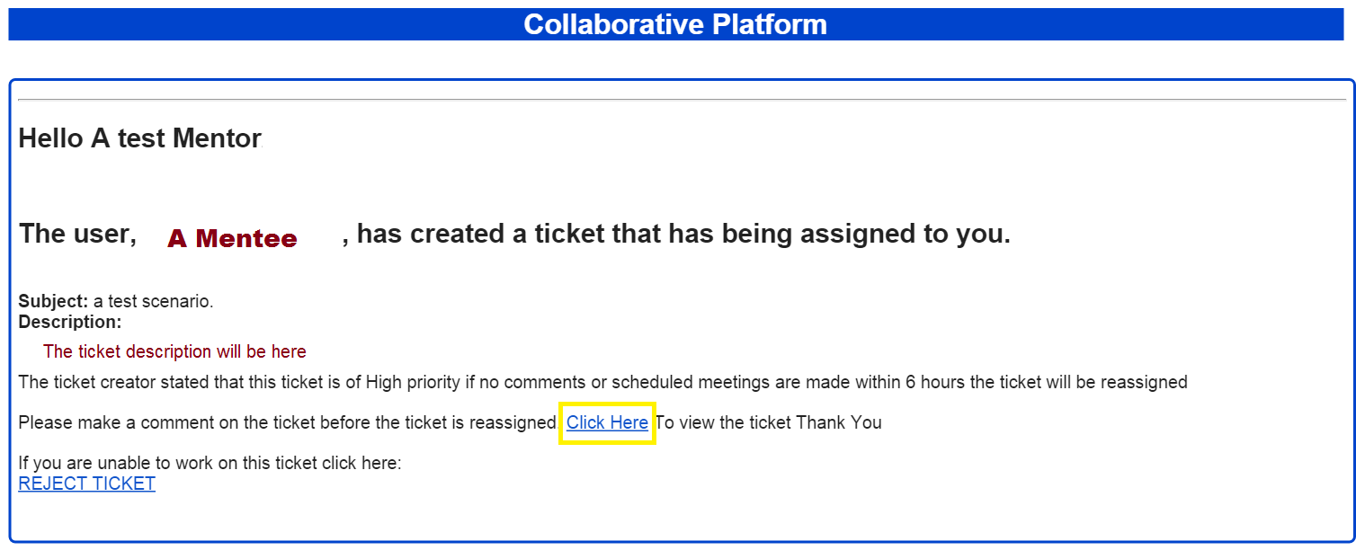

or this:

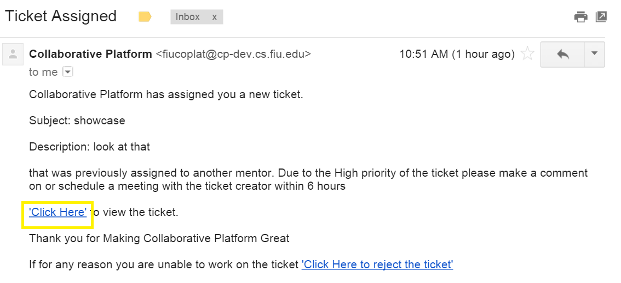

Depending on whether it is a new ticket or a ticket that has been reassigned. The email now contains the subject of the ticket, the description of the ticket, and the priority of the ticket and what that means. The priority again is how long the ticket creator wishes to wait before the ticket is reassigned if the assigned mentor does not make a comment on or schedule a video conference with before the time is up. You may also now click the link “Click Here” to be taken directly to the ticket from the email message. As well as let the system reassign the ticket if you are unable to work on it by clicking the reject ticket link, this was explained further in the user story 511 guide.

Mentee: No possible interaction with this system.

# **User Manual for User Story #23: Display reassignments on the ticket events.**

Administrator:

On the ticket view page in the events table you will now have an event displayed whenever the ticket has been reassigned, manually or automatically

The events look like so:

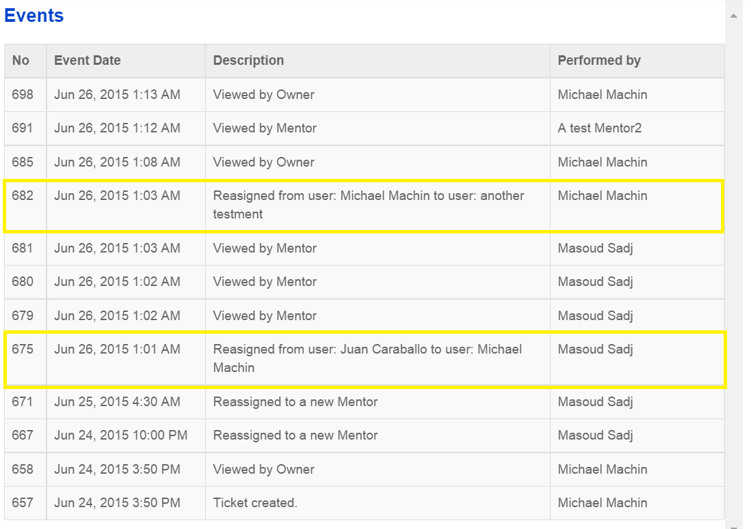

**(highlighted yellow)**

When there are as many or more events of these type equal to the rule set in the Reassign rules page the ticket will be assigned to you for manual assignment.

Mentor:

When you are assigned a ticket that was previously assigned to another mentor, you will see the documentation of that event displayed in the event table on the ticket view like so:



(Highlighted Yellow)

if you were the previous mentor you will see that it was assigned away from you as well as your name will no longer be in the assigned mentor box if you are viewing this ticket.

Mentee:

When you create a ticket, it is assigned to a mentor. If for any reason this ticket is assigned to a new mentor, say from the priority time elapsing, the mentor sending the system an automated out of office email, or personally rejecting the ticket, you will see that the ticket has been reassigned in the ticket events table like so:



(Highlighted Yellow)

You will also see the new mentor in the “assigned mentor” view of the ticket. Know that when a ticket is reassigned the priority time is reset. In other words the new mentor has (6, 12, 72: or whatever the new times are that have been changed by the system admin) hours for the priority (High, Medium, Low) before the ticket is assigned to a new mentor, from the time of the ticket being assigned to the new mentor, if the current mentor does not make a comment or schedule a video conference with you.

# **User Manual for User Story #24: Provide users with a chat feature.**

Administrator:

Same as mentee. See below.

Mentor:

Same as mentee. See below.

Mentee:

When a mentee joins a conference they have a chat feature available to them. This new chat feature can be shown or hidden by clicking on the chat header providing the user with more control of the page and for better utilization of the space (Figure 1).

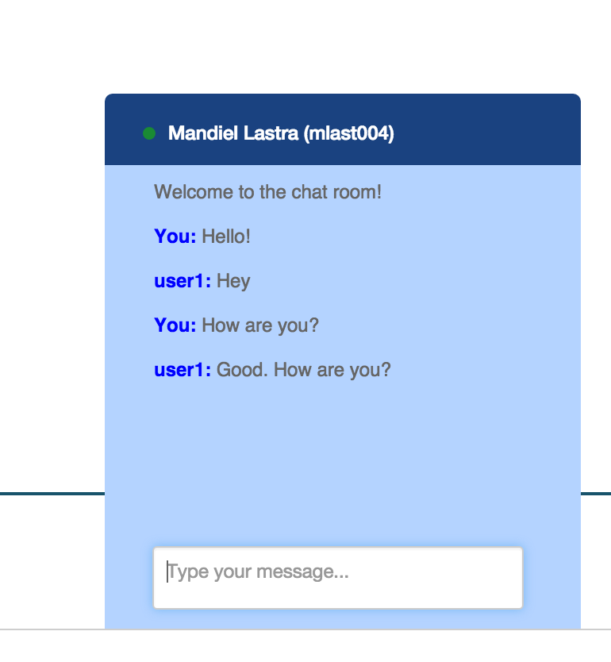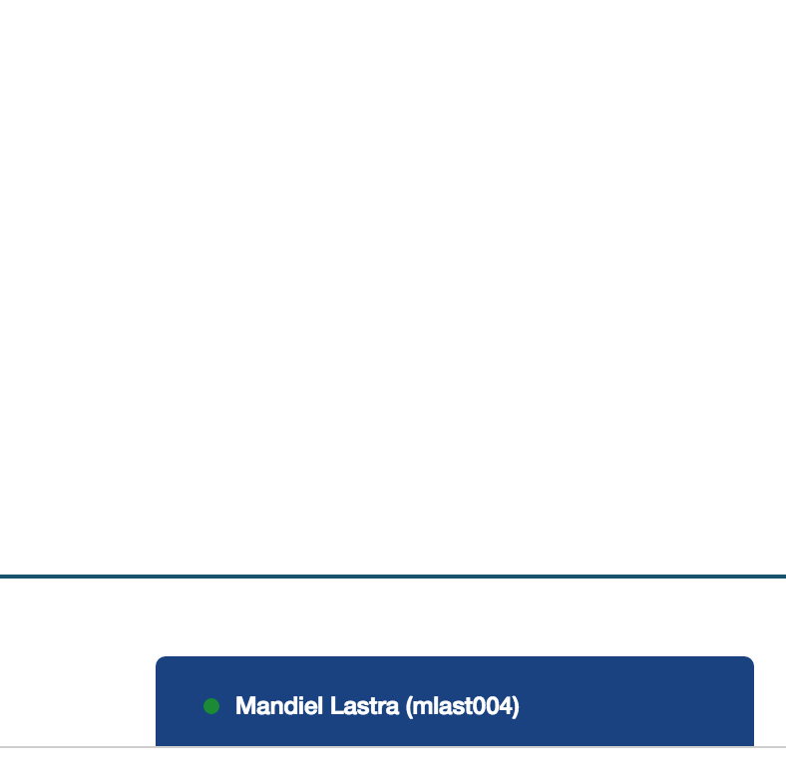

# 

# 

# 

# 

# (Figure 1)

Also when the chat is hidden and users receive a new message they will be notified as shown in figure 2.

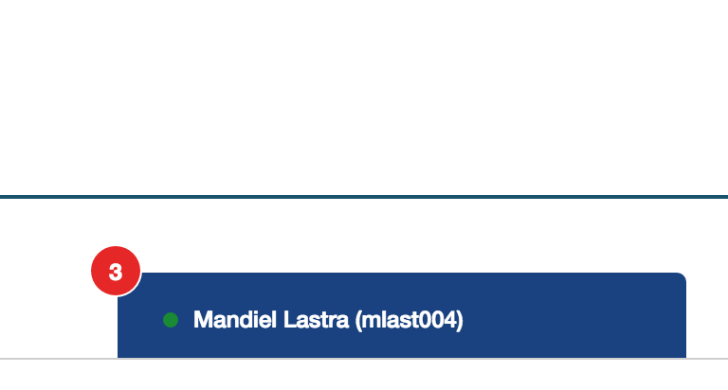

# (Figure 1)

**User Manual for User Story #26: Allow users to invite others by name when creating or editing a conference.**

Administrator:

Same as mentee. See below.

Mentor:

Same as mentee. See below.

Mentee:

When creating or editing a video conference, users no longer have to remember or look up other users’ email address. Now users can enter either first or last name of invitees and a list that matches the entered criteria will be displayed, users will be able to pick invitees from this list (Figure 1).

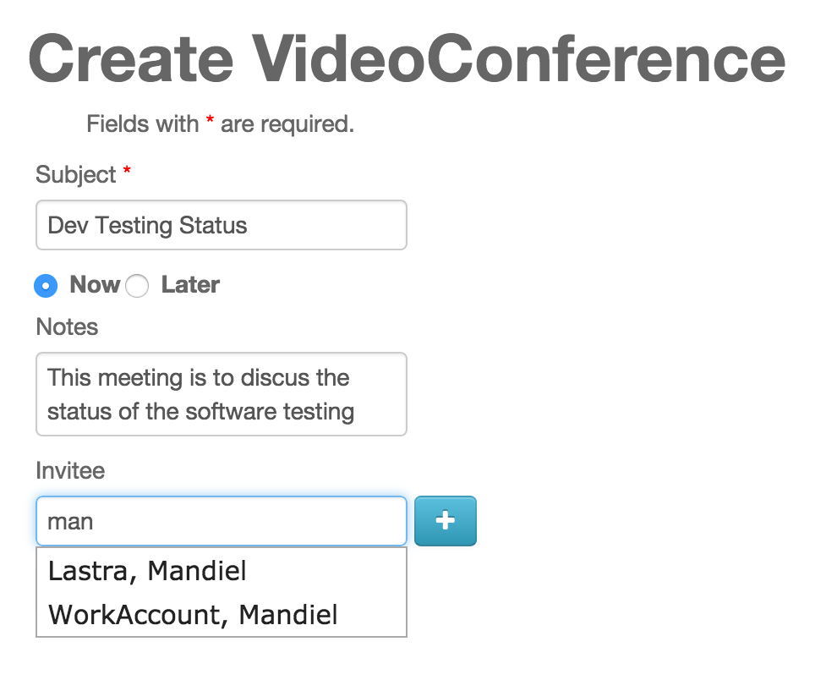

(Figure 1)

**User Manual for User Story #29: Allow System Administrator to Add to Away_Mentor Table by user’s name**

Administrator:

When you, as the system administrator, need to add a mentor to the away list you are able to add them by their “last name, first name”. First navigate to the away mentor create page from the manage away mentors. The new create page looks like this:

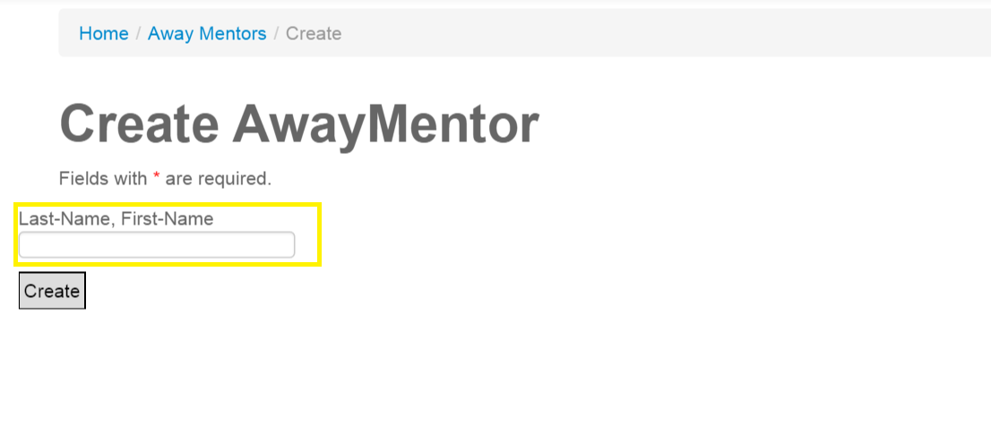

Now by entering the user’s “last-name, First-name” in the (highlighted yellow) field and pressing the create button the system will add the user with that name to the away mentor list. If the addition was successful the system will redirect you to the away mentor admin page and list the new away_mentor. If system could not find the user or the admin is already on the list it will simply refresh the page. Again know that the mentor will not be emailed about their new away status, but they will be notified on their homepage.

Mentor:

Specifically disallowed to interact this process. The mentor’s only interaction with this system is them seeing their away status on their homepage and being able to remove themselves from the away list with a click of a button.

Mentee:

Completely disallowed to interact with this process.

**User Manual for User Story #32: Adding to the away list uses autocomplete**

Administrator:

Along with the new ability to add to the away list using the mentor’s name the system further eases this process with autocomplete. While on the create away_mentor page shown here:



Simply begin typing into the yellow field. A drop down menu will appear using the information you entered to find the users with names similar to what has been typed. Shown here:

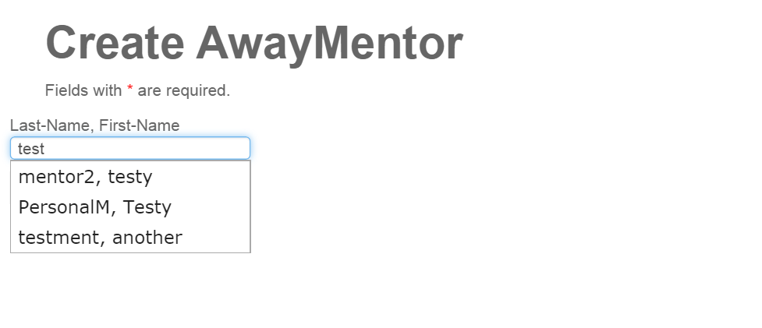

When you hover over one of the items in the drop down the field will fill with the hovered over item like so:

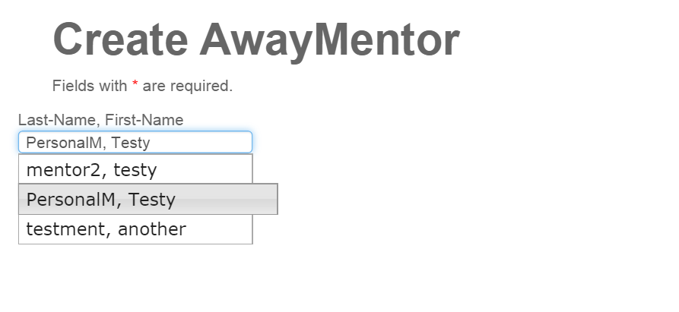

By Clicking on the item, the drop down will disappear and the field will have the correctly formatted name of the user you wish to enter into the system as an away mentor. By then clicking create you will add this user to the away mentor list, which again will no longer allow them to be automatically assigned tickets.

Mentor:

Disallowed to use this system.

Mentee:

Disallowed to use this system.

**User Manual for User Story #30: Allow ticket Creator to reassign their ticket to a new mentor.**

Administrator:

New functionality was already available to administrator, the mentor and mentee users have a limited version of this functionality.

Mentor:

Functionality was already available to mentor, it now is reduced.

Mentee:

If for any reason you feel that the current Domain Mentor assigned to your ticket is not making meaningful progress towards solving the ticket’s issue you are now able to have the system pick a new mentor for you.

While viewing your ticket in a page like so:

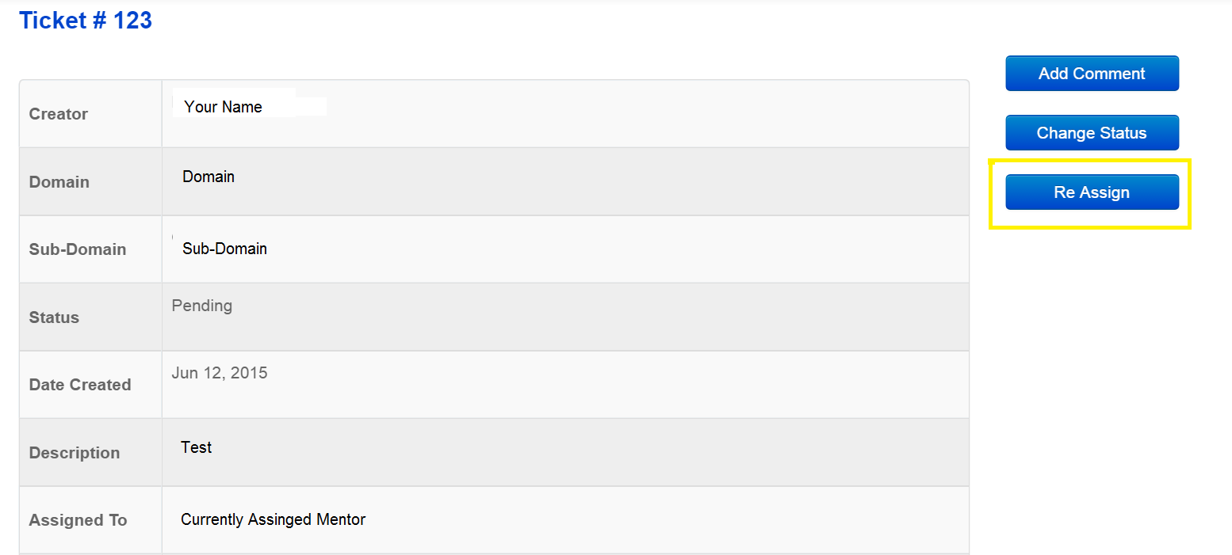

By clicking the Re Assing button (highlighted yellow) a popup will display like so:

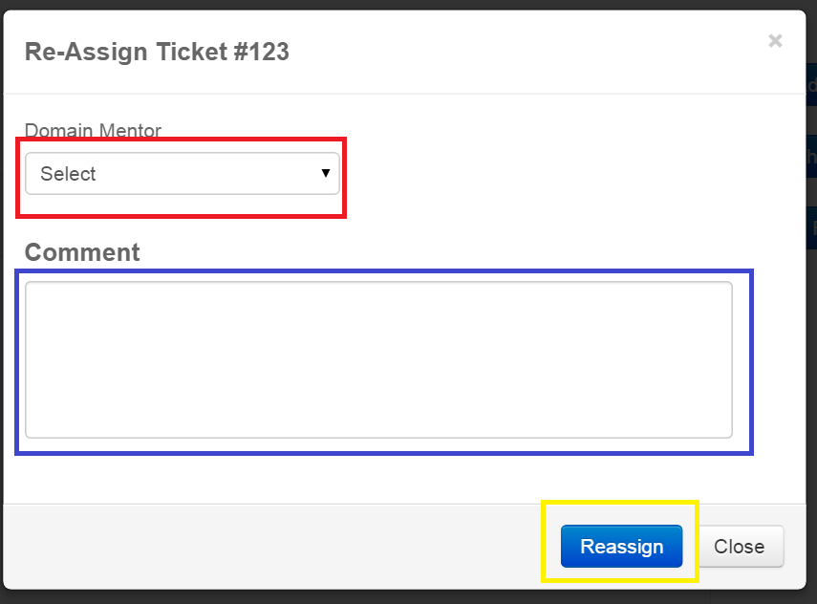

by selecting “Automatically Reassignment” in the drop down menu (highlighted red), which is the only available option, and clicking reassign (highlighted yellow) the system will choose a new domain mentor for you and assign your ticket to that mentor. Please make sure to explain the reasoning behind the reassignment in the (blue) comment box for administrative purposes. The system will then redirect you back to your homepage.

**User Manual for User Story #33: Only allow system administrator to manually select the mentor when assigning a ticket to a new mentor.**

Administrator

None of your selections have changed, but now you are the only one that is able to select a specific mentor when reassigning a ticket. Mentors who were previously able to do so are now no longer able to, they may only select “Automatically Reassignment” which allows the system to pick the new mentor.

Mentor:

In order to facilitate a working environment you are now only able to allow the system to automatically reassign the ticket when you want the ticket reassigned. You may still reassign the ticket assigned to you at any time, but you are no longer able to choose the mentor that receives it.

When you Click the reassign button on the ticket and the reassign pop up appears like so:

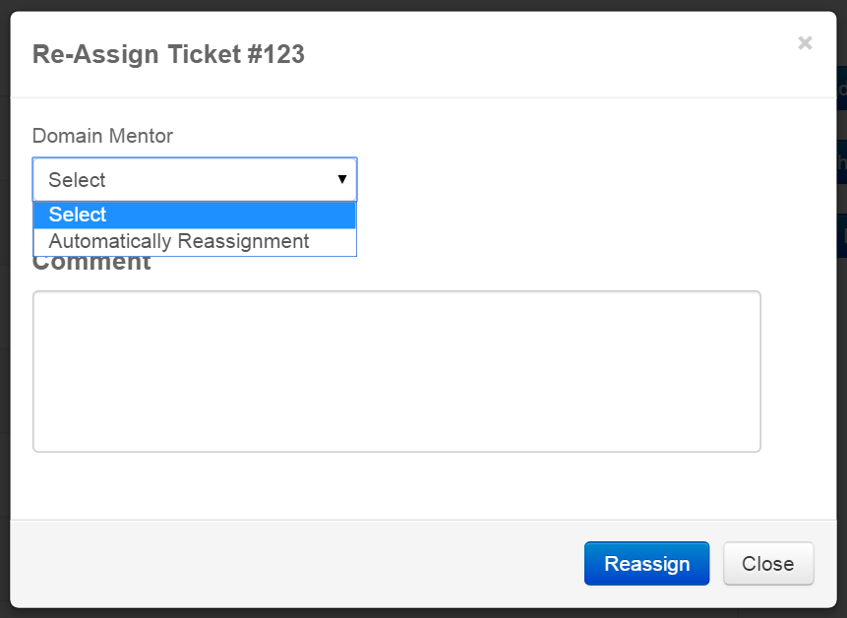

The only available option in the drop down is “Automatically Reassignment” which informs the system to pick a new mentor for this ticket to be assigned to. Please still do leave a comment regarding the reason of the reassign before clicking the reassign button.

Mentee: See user story Guide 569

**User Manual for User Story #38: Sort the tickets in ticket list views.**

Administrator:

No Change.

Mentor:

In the Domain Mentor, Personal Mentor, And Project Mentor pages the tickets in the list are now sorted from newest to oldest so you may now see all the new tickets first helping notify you of when a new ticket is present.

The My To Do and Closed Tickets have had a radical change they now appear like so:

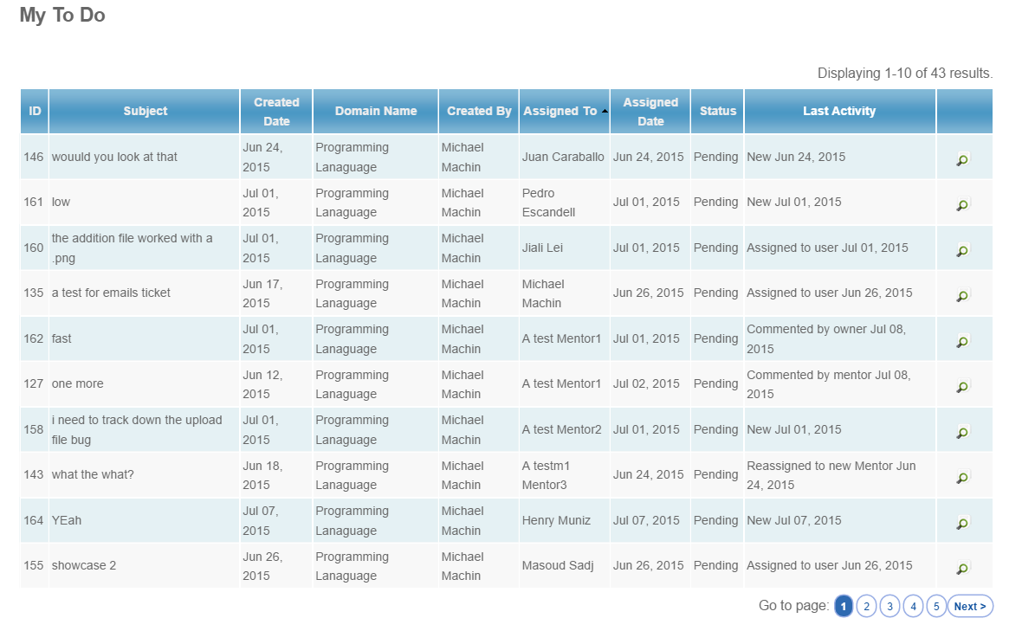

The default order of the sorting is from oldest to newest, but now you may change the order of the sort by clicking on any of the column heads and the list will be resorted. At the bottom of this list you will see a page bar you may see the rest of your tickets by clicking the next page or going directly to the page you desire. New information is now displayed on the list. On the list it will display who created the ticket, if perchance you have created a ticket, and who is assigned to the ticket which will be you, unless you created the ticket. The newest column, and one that is currently unable to be sorted by, is the Last activity column. This displays the type of activity that was last seen on the ticket as well as the activities date. This will inform you if there has been any new activity that was not performed by you.

The closed tickets follows in the same fashion as shown here:

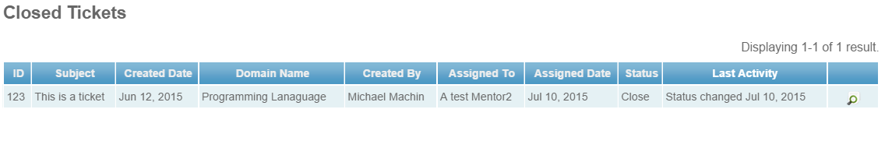which follows the same rules for sorting.

Mentee:

The My To Do and Closed Tickets have had a radical change they now appear like so:



The default order of the sorting is from oldest to newest, but now you may change the order of the sort by clicking on any of the column heads and the list will be resorted. At the bottom of this list you will see a page bar you may see the rest of your tickets by clicking the next page or going directly to the page you desire. New information is now displayed on the list. On the list it will display who created the ticket which will most likely be you, and who is assigned to the ticket which might be you if you are also a mentor. The newest column, and one that is currently unable to be sorted by, is the Last activity column. This displays the type of activity that was last seen on the ticket as well as the activities date. This will inform you if there has been any new activity that was not performed by you.

The closed tickets follows in the same fashion as shown here:

which follows the same rules for sorting.

**User Manual for User Story #39: Improve the usability of the system**

Administrator: No new interactions with this user story

Mentor:

On your homepage if will see a few new things. Shown here:

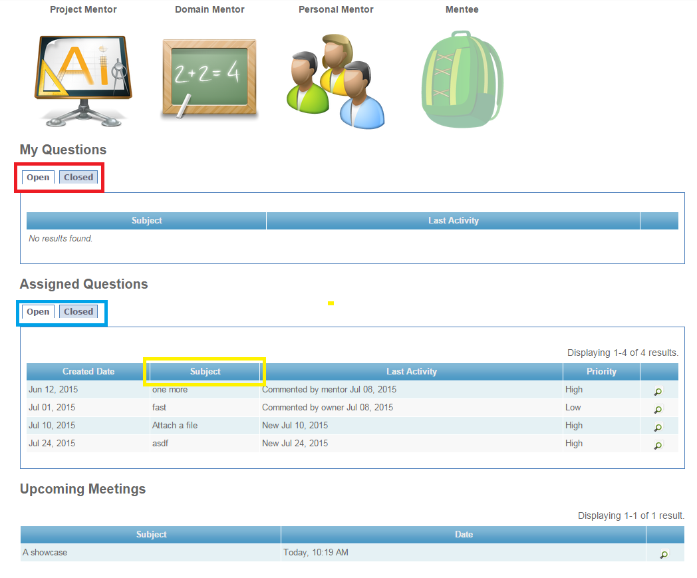

as you can see the dashboard has been majorly changed. Now you have separate tabs for open and closed questions that you have created and been assigned (red and blue respectively) and you can now sort any question by the displayed columns by clicking on them. For example if you were to click on the subject (yellow) it would sort the tickets by their subject.

Also on the bottom you can see the upcoming meetings where it will display the meetings subject and then the time and date. If you are late for the meeting it will even let you know!

In the new look for the mentor application hub the mentors are now defined as shown here

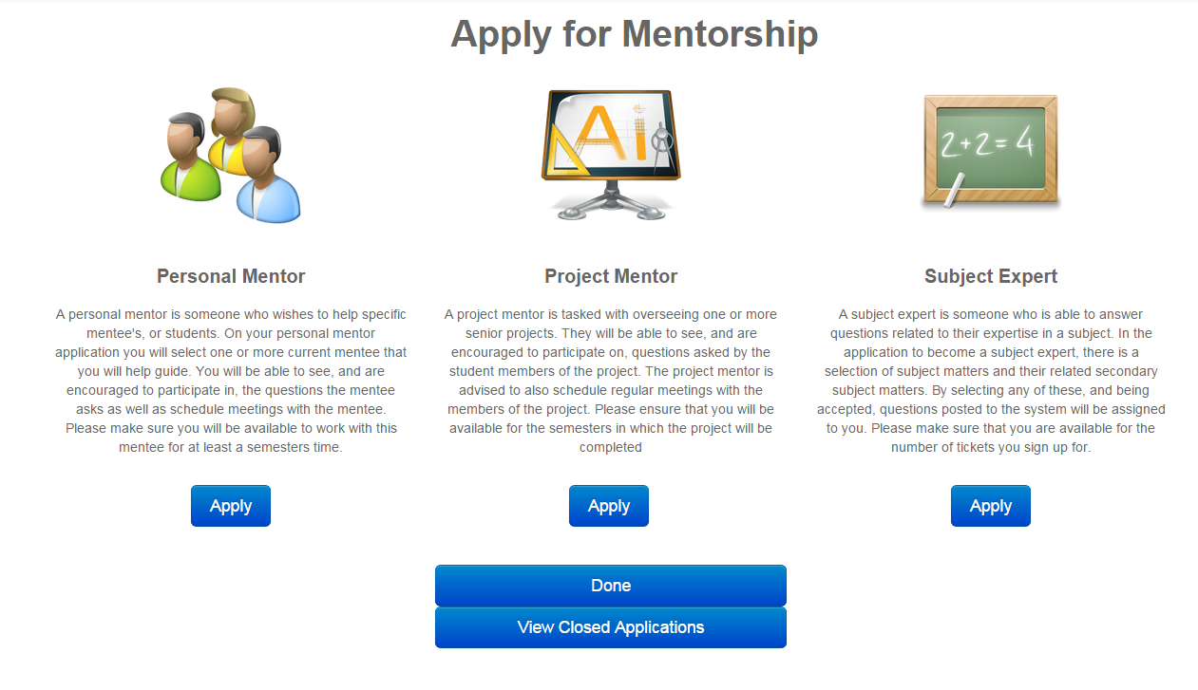

Also if you would like to view everyone’s closed tickets to possibly find some insight on how to answer a question you have been assigned simply click here (highlighted red)

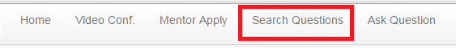

which will bring you here:

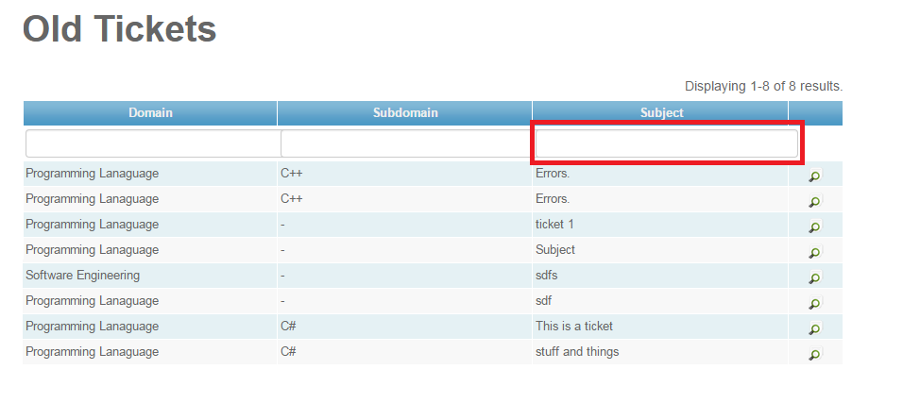

you can search through this list by entering a term in the one of the bars there and it will search for that term in that column like so

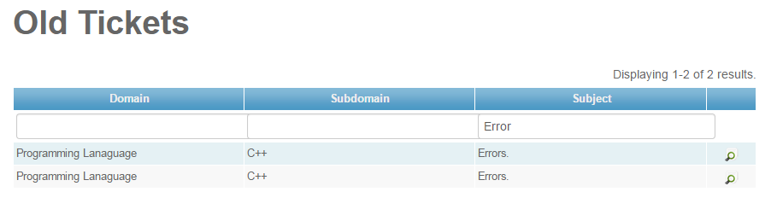

Mentee:

The dashboard on the homepage has been changed to this:

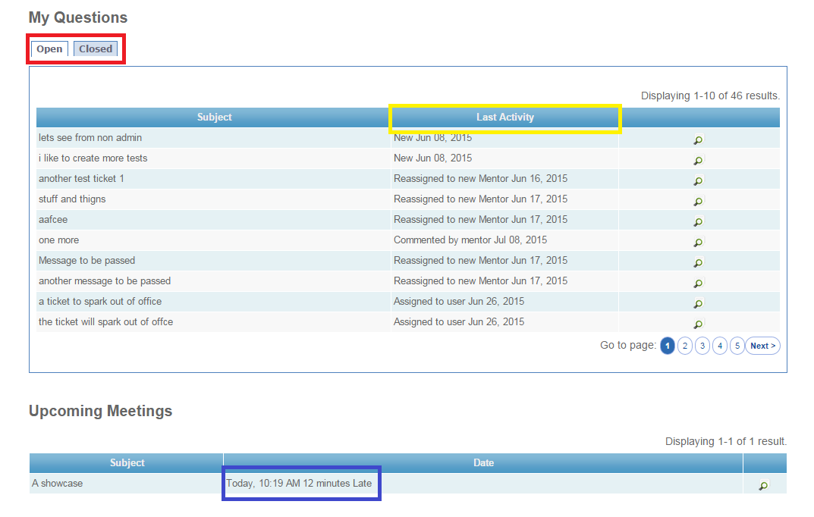

You can now view all of your open and closed tickets by clicking on one of the tabs (highlighted red). You may still sort the tickets by clicking on any of the columns for example last activity (highlighted yellow). Additionally there is a new list of upcoming meetings on the dashboards. As you can see it displays the date and time, and if you are late to the meeting it displays how late you are. (highlighted blue)

If you would like to look at already answered questions to see if you need to ask a new question simply click here (highlighted red)



which will bring you here:



you can search through this list by entering a term in the one of the bars there and it will search for that term in that column like so



**User Manual for User Story #40: User is able to suggest new domain**

Administrator:

Users are now able to suggest new domains for your approval. To view the suggestions first navigate to the manage domains page. Once on this button click the “Manage Domain Suggestions” button shown here (highlighted red)

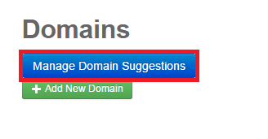

Which will take you here.

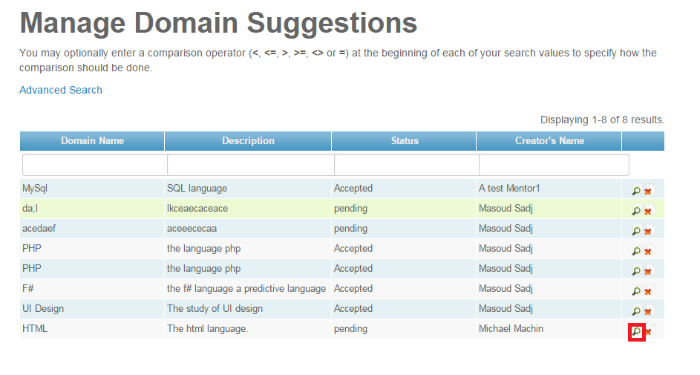

As you can see there are a few suggestions currently lets start with one that looks good. HTML, by clicking the magnifying glass you will be brought here.

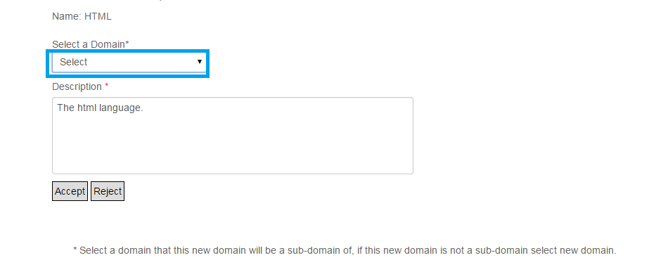Start off by selecting something from the drop down menu, this looks like it would be a good subdomain of programming languages.

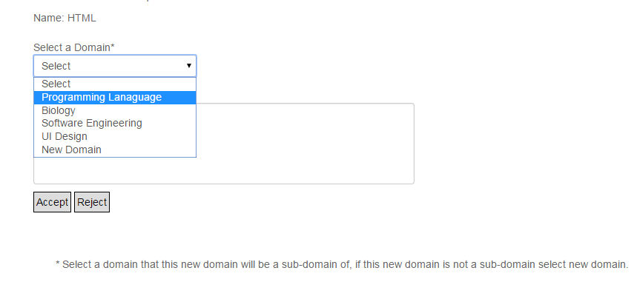

Once selected you can fill in any extra information you think should be included in the description, and then hit accept.

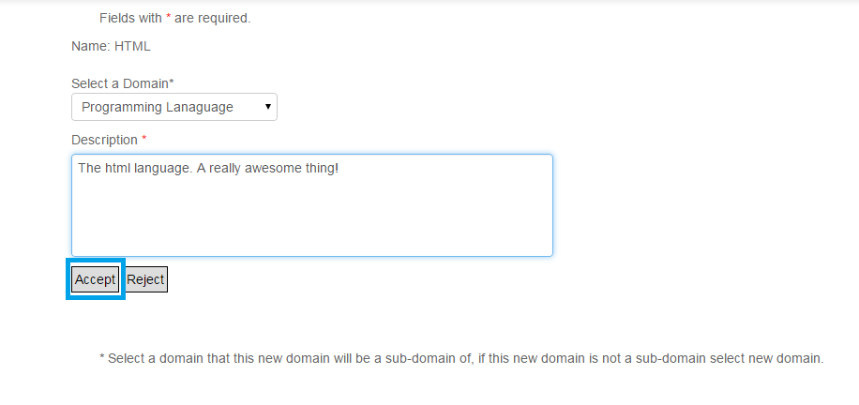

Now once you hit accept you are no longer able to view this page the suggestion is saved as being accepted (but it is still possible to delete the wrongly created domain).

This will create a new sub-domain of programming languages, HTML. Now if you wanted this suggestion to be its own domain then simply select “New Domain” from the drop down menu

Now lets look back and the list.

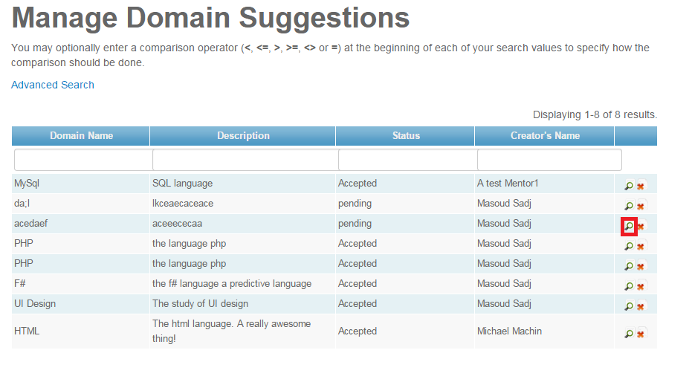

now it’s bound to happen that people will submit junk. Either click the red x to delete it or hit reject on this page. 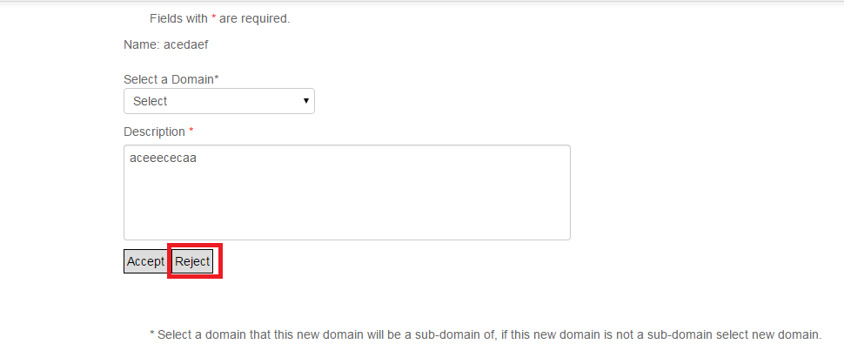

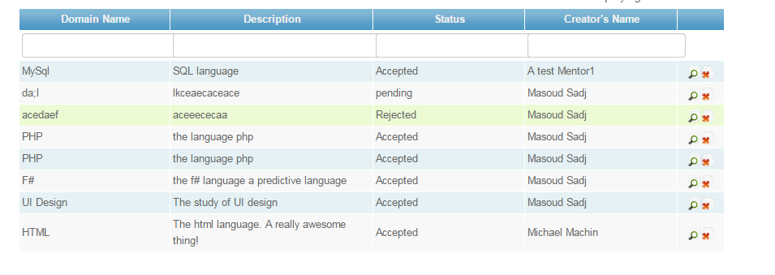

and as you can see the suggestion is now considered rejected.

Mentor/Mentee who wished to become a mentor.

If you do not see your area of expertise on the subject matter expert application page, you may now suggest a new domain to us by clicking here

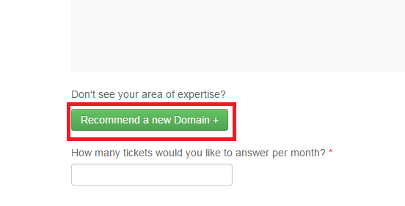

which will take you here:

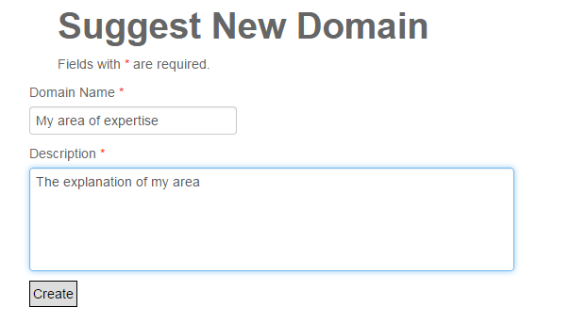

by just filling out the information and clicking create you will let us know that it might be a good idea to add your area of expertise to our list of subject domains. Check back again shortly to see if your new area of expertise is on the Subject matter expert application page.

# 

# **User Manual for User Story #34: Allow users to access Past/Canceled Video Conferences**

Administrator:

Same as mentee. See below.

Mentor:

Same as mentee. See below.

Mentee:

Users can now access past as well as canceled video conferences from the video conference home page by clicking on the “View Past/Canceled Video Conference” link on the operations menu (Figure 1).

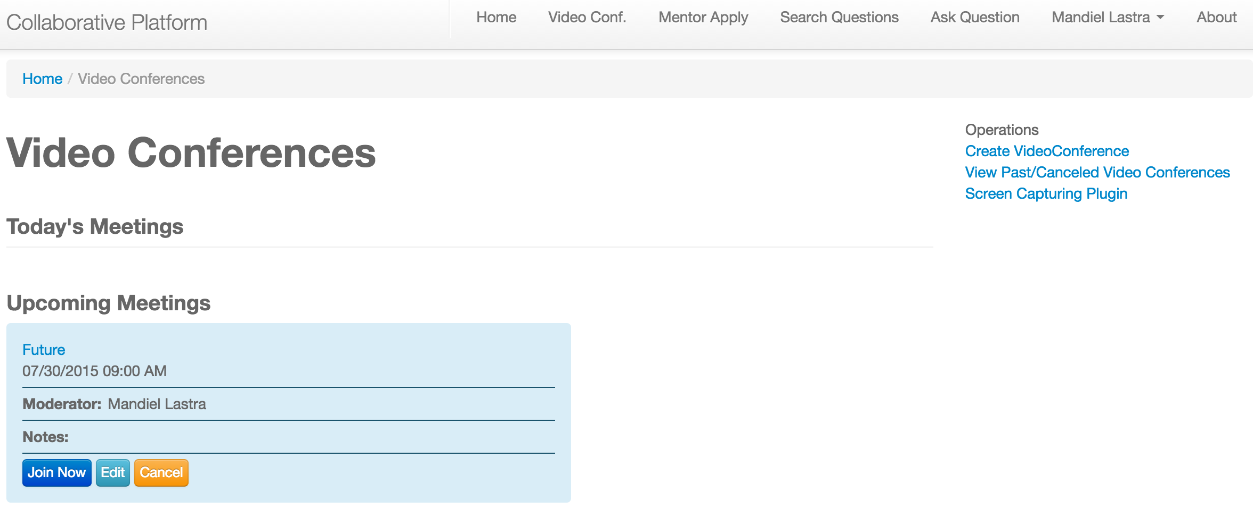

(Figure 1)

On this page users will be able to see all the past conferences that they have created or have been invited to as well as conferences that have been canceled. They can also sort by the different columns as well as search for specific fields (Figure 2).

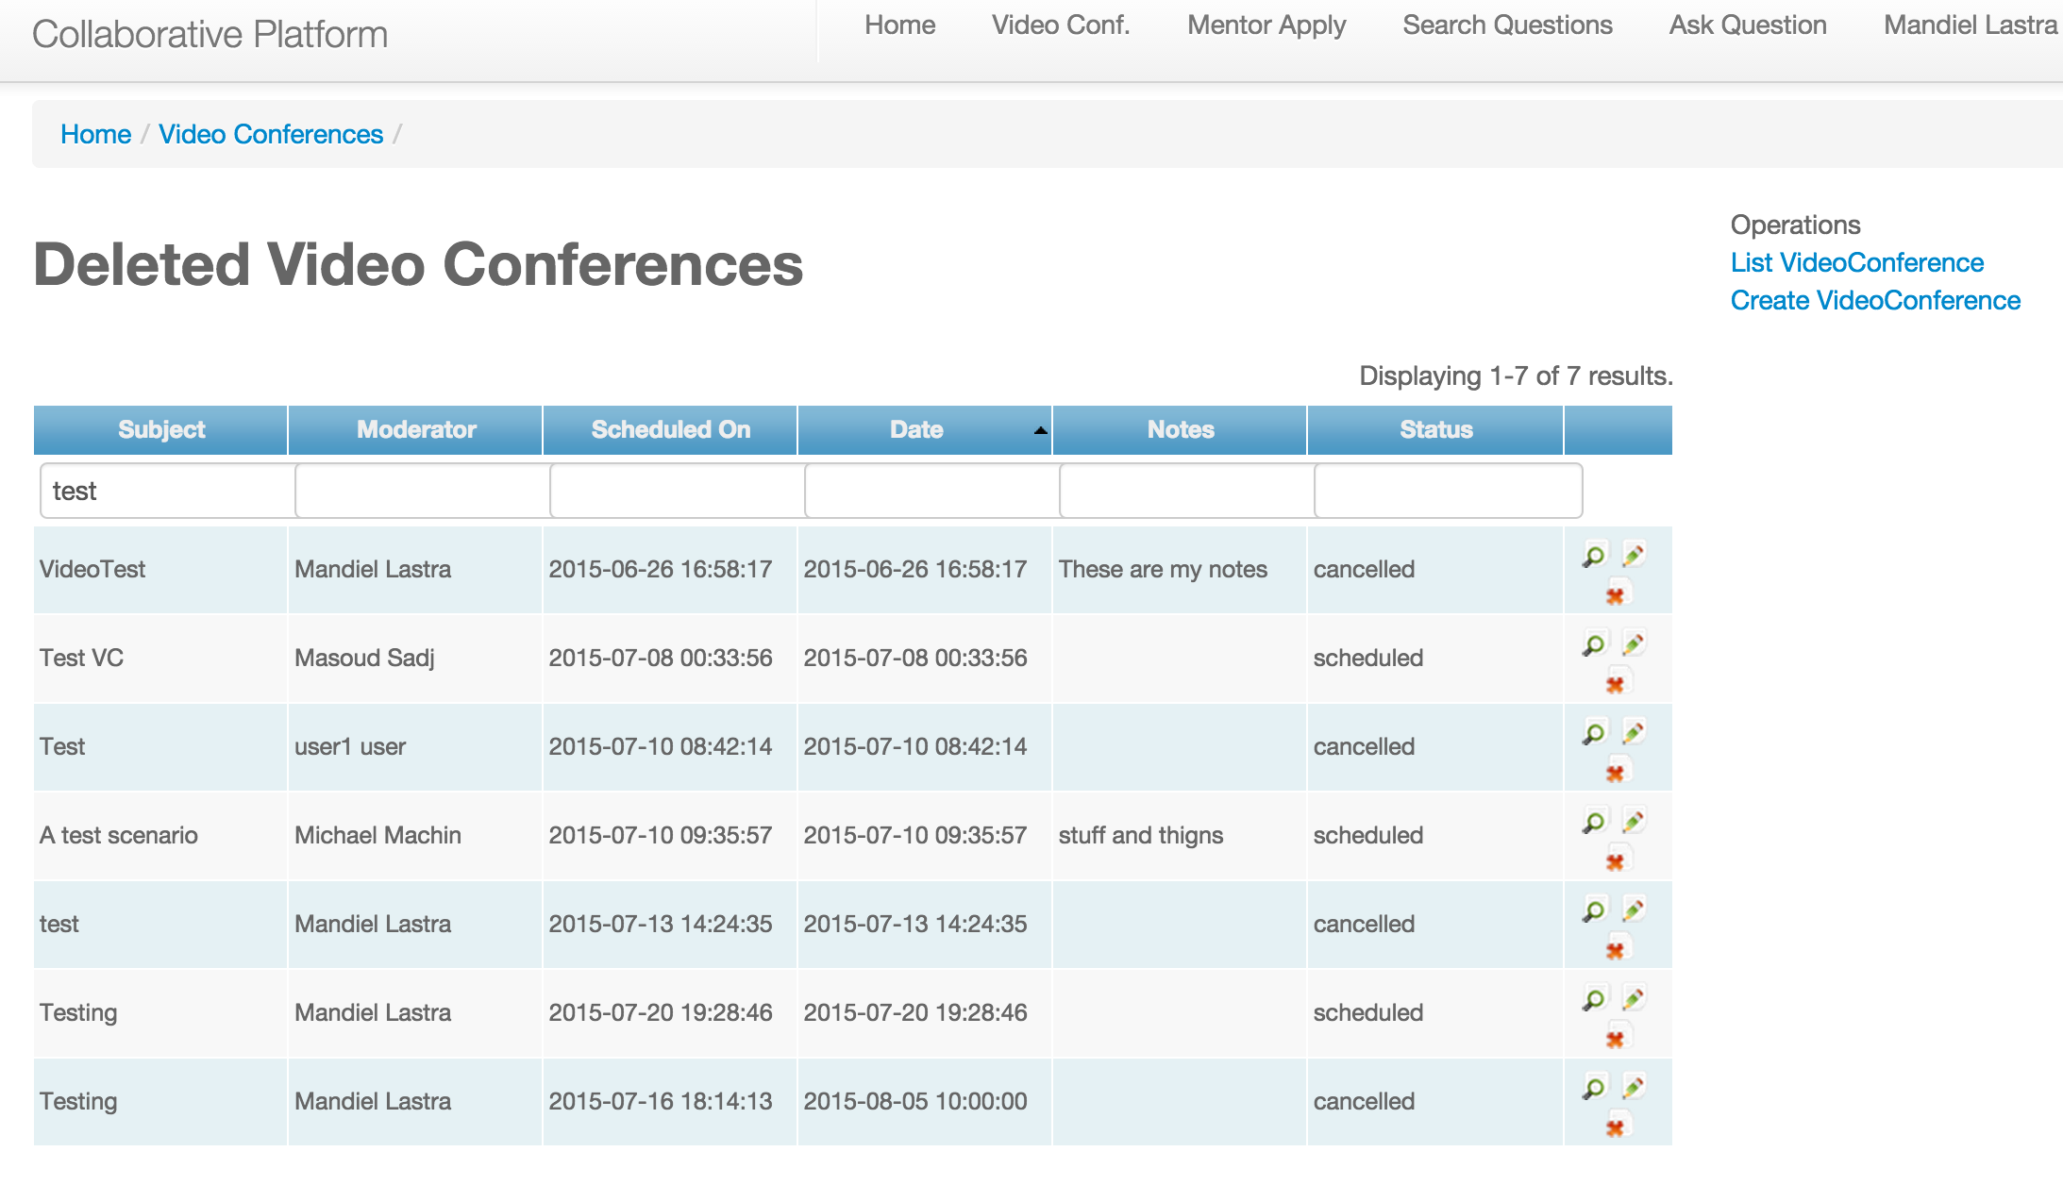

(Figure2)

# **References**

**Mentor Module V1**

<http://users.cis.fiu.edu/~sadjadi/Teaching/SeniorProject/Deliverables/SP14/02-CollaborativePlatform.rar>

**Mentor Module V2**

<http://users.cis.fiu.edu/~sadjadi/Teaching/SeniorProject/Deliverables/SU14/02-CollaborativePlatformV2.zip>

**Mentor Module V3**

[**http://users.cis.fiu.edu/~sadjadi/Teaching/SeniorProject/Deliverables/FA14/2014-Fall-FinalDeliverable-CollaborativePlatform-v3.zip**](http://users.cis.fiu.edu/~sadjadi/Teaching/SeniorProject/Deliverables/FA14/2014-Fall-FinalDeliverable-CollaborativePlatform-v3.zip)

Mentor Module V5

[**http://users.cis.fiu.edu/~sadjadi/Teaching/SeniorProject/Deliverables/SP15/02-CollaborativePlatform-Ver5.zip**](http://users.cis.fiu.edu/~sadjadi/Teaching/SeniorProject/Deliverables/SP15/02-CollaborativePlatform-Ver5.zip)